# Abstract

My graduation project comprises developing both a management dashboard and a mobile application for searching and visualizing of natural, bio, vegan, eco, and allergen free products. Based on personal preferences such as skin type, allergens, and personal search history, the app users can search for their desired products.

I developed this project in 7 sprints. First, a mobile application using Flutter, the open-source Google’s UI toolkit, that manage different screen interfaces for the app. And second, I created a back-end web server with NodeJS in order to manage the client search requests and others different functionalities. And Last the Management Dashboard using AngularJS to manage the content of the mobile app.

Working in this project started from interviewing natural and allergen free real consumers, product manufacturers, product retailers, and consultants to gather information about their right needs in the eco-friendly environment and to optimize their user-experience, then the development and implementation of the requested solution and finished with ambition hopes to optimize this project for better user-experience of the app users and further features.

I analysed, designed, and developed this project within L’Atelier, the Marketing, training and merchandising division of Kilani Group.

© 2021  
Sadok Laouissi   
ALL RIGHTS RESERVED

# Dedication

Sadok Laouissi

# Acknowledgements

I would like to express my deep gratitude to our corporate supervisor Mrs. Ridha Leila and my faculty supervisor Mr. Ben Ahmed Zied, for their patient guidance, enthusiastic encouragement and useful critiques of this work.

I would like also to extend my thanks to the product consultant of L’Atelier Mrs. Dhahri Olfa for her help in providing the professional information about the skin type, ingredients and allergies and also helping in the interview process.

Finally, I wish to thank ARGANIA IT Support Division for their help during this project.

# Table of Contents

Abstract i

Dedication iii

Acknowledgements iv

Table of Contents v

List of Figures viii

List of Tables xiii

General Introduction 15

Chapter I: Situation analysis of the project 18

1. Introduction 18

2. Presentation of the host organization 18

3. Presentation of the organization 18

4. Study of the existing 24

5. Conclusion 27

Chapter II: Specifications and methodology 29

1. Introduction 29

2. Modelling Language 29

3. Software Requirements Specifications 30

4. Global Use Case Diagram 31

5. Global Class Diagram 32

6. Software Development Methodology 33

7. Project Management 39

8. Conclusion 43

Chapter III: State of the art 46

1. Introduction 46

2. Cosmetic Field 46

3. Packaging 48

4. Current Situation 49

5. Conclusion 55

Chapter IV: Sprint Zero - Work Environment 57

1. Introduction 57

2. Work Environment 57

3. Application Architecture 62

4. Conclusion 65

Chapter V: Sprint 1 – Category Management 67

1. Introduction 67

2. Sprint Backlog 67

3. Analysis 68

4. Conclusion 77

Chapter VI: Sprint 2 – Allergens Management 79

1. Introduction 79

2. Sprint Backlog 79

3. Analysis 80

4. Conclusion 89

Chapter VII: Sprint 3 – Ingredients Management 91

1. Introduction 91

2. Sprint Backlog 91

3. Analysis 92

4. Conclusion 99

Chapter VIII: Sprint 4 – Users Management 101

1. Introduction 101

2. Sprint Backlog 101

3. Analysis 102

4. Conclusion 120

Chapter IX: Sprint 5 – Products Management 122

1. Introduction 122

2. Sprint Backlog 122

3. Analysis 123

4. Conclusion 136

Chapter X : Sprint 6 – Favourite & History Management 138

1. Introduction 138

2. Sprint Backlog 138

3. Analysis 139

4. Conclusion 144

Chapter XI : Sprint 7 – Claims Management & Products Suggestions 146

1. Introduction 146

2. Sprint Backlog 146

3. Analysis 147

4. Conclusion 154

Conclusion & Perspectives 155

Reflection 156

Table of Acronyms and Abbreviations 157

References 158

Appendix A : Gantt Diagram 161

# List of Figures

Figure 1: Kilani Groupe Logo 19

Figure 2: Kilani Groupe Organizational chart 21

Figure 3: Kilani Groupe Missions & Activities 22

Figure 4: L'Atelier’s Activities 24

Figure 5: Yuka Logo 25

Figure 6: INCI Beauty Logo 25

Figure 7: PharmaPocket Logo 26

Figure 8: Think Dirty App Logo 26

Figure 9: UML Diagrams Overview [5] 30

Figure 10: Global Use Case 32

Figure 11: Global Class Diagram 33

Figure 12: Agile Methodology workflow 34

Figure 13: Scrum Methodology Overview 35

Figure 14: Scrum Values 36

Figure 15: Ingredient Transformations Categories 47

Figure 16: The world's most powerful personal care brands in 2020 50

Figure 17: Countries with the highest spending on beauty products in 2017 51

Figure 18: Android Studio Logo 58

Figure 19: VS Code Logo 58

Figure 20: Postman Logo 58

Figure 21: WampServer Logo 58

Figure 22: Visual Paradigm Online Logo 58

Figure 23: Adobe XD Logo 59

Figure 24: Adobe Photoshop Logo 59

Figure 25: GitHub Desktop Logo 59

Figure 26: TeamGantt Online Logo 59

Figure 27: Dart Logo 60

Figure 28: TypeScript Logo 60

Figure 29: MySQL Logo 60

Figure 30: Angular Logo 60

Figure 31: Node JS Logo 61

Figure 32: Flutter Logo 61

Figure 33: JSON Logo 62

Figure 34 : Application's Physical Architecture 63

Figure 35 : Logical Architecture 64

Figure 36: Security Middleware 64

Figure 37: Categories Management Use Case Refinement 68

Figure 38: Add Category Sequence Diagram 70

Figure 39: Screen Capture Add Category Interface 71

Figure 40: Edit Category Sequence Diagram 72

Figure 41: Screen Capture Edit Category Interface 73

Figure 42: Delete Category Sequence Diagram 74

Figure 43: Screen Capture Delete Category 75

Figure 44: Screen Capture List Categories Interface 76

Figure 45: Home Screen Implementation 77

Figure 46: Home Screen Design 77

Figure 47: Allergens Management Use Case Refinement 80

Figure 48: Screen Capture Add Allergen Interface 81

Figure 49: Screen Capture Edit Allergen 82

Figure 50: Screen Capture Delete Allergen 83

Figure 51: Sequence diagram of the use case "Associate Ingredient/Allergen" 85

Figure 52: Screen Capture Associate Ingredient/Allergen Interface 86

Figure 53: Sequence Diagram Edit Personal Allergen Scenario 2 88

Figure 54: Personal Allergen Implementation 89

Figure 55: Design Adobe XD: Personal Allergens 89

Figure 56 : Ingredients Management Use Case Refinement 92

Figure 57: Screen Capture Ingredients Interface 93

Figure 58: Sequence diagram Add Ingredient 95

Figure 59: Screen Capture Add Ingredient 95

Figure 60: Screen Capture Edit Ingredient 96

Figure 61: Screen Capture Delete Ingredient 97

Figure 62: Ingredients Screen Realisation 99

Figure 63: Design Adobe XD Ingredients Screen 99

Figure 64: Users Management Use Case Refinement 102

Figure 65: Authentication Activity Diagram 103

Figure 66: User Authentication Sequence Diagram 104

Figure 67: Splash Screen Adobe XD 104

Figure 68: Login Screen Adobe XD 104

Figure 69: Splash Screen Realisation 105

Figure 70: Login Screen Implementation 105

Figure 71: Sequence Diagram Authenticate Admin 105

Figure 72: Login Web Realisation 106

Figure 73: Sequence Diagram Create Account 107

Figure 74: Activity Diagram Create Account Scenario 108

Figure 75: State Transition Diagram Account 108

Figure 76: Create Account Realisation Part 2 109

Figure 77: Create Account Realisation Part 1 109

Figure 78: Create Account Screen Adobe XD 109

Figure 79: Sequence Diagram Enable Account 110

Figure 80: Enable Account Story XD Design 111

Figure 81: Enable Account Realisation 111

Figure 82: Edit Info Design Adobe XD 113

Figure 83: Edit Info Scenario Realisation 113

Figure 84: List Users Realisation 114

Figure 85: Change Password Scenario Design XD 116

Figure 86: Change Password Scenario Realisation 116

Figure 87: New Password Admin Realisation 118

Figure 88: Take Diagnosis Scenario Adobe XD 119

Figure 89: Take Diagnosis Scenario Realisation 120

Figure 90: Products Management Use Case Refinement 123

Figure 91: Add Product Step 1 125

Figure 92: Add Product Step 2 125

Figure 93: Add Product Step 3 126

Figure 94: Add Product Step 4 126

Figure 95: Add Product Step 5 127

Figure 96: Add Product Step 6 (Optional) 127

Figure 97: List Products Realisation 128

Figure 98: Add/Remove Ingredients Realisation 129

Figure 99: Add/remove Ingredients' Sequence Diagram 130

Figure 100: View Product Details Story Adobe XD 131

Figure 101: View Product Details Story Realisation 132

Figure 102: Search Products Sequence Diagram 133

Figure 103: Search Products Story Design XD 134

Figure 104: Search Products Realisation 134

Figure 105: Filter Story Design Adobe XD 135

Figure 106: Filter Realisation 136

Figure 107: Favourite Management Use Case Refinement Diagram 139

Figure 108: View Favourite Story Design XD 140

Figure 109: View Favourite Story Realisation 141

Figure 110: History Management Use Case Refinement Diagram 142

Figure 111: View History Story Implementation 144

Figure 112: Claims Management Use Case Refinement Diagram 147

Figure 113 : Add Claim Story Realisation 149

Figure 114: View My claims Story Realisation 150

Figure 115: View All Claims Story Realisation 151

Figure 116: Update Claim's State Realisation 152

Figure 117: View Suggestion Home Screen Scenario Sequence Diagram 153

Figure 118: View Suggestion Product Details Screen Scenario Sequence Diagram 154

Figure 119: Gantt Diagram Part 1 161

Figure 120: Gantt Diagram Part 2 162

# List of Tables

Table 1: The Scrum Team 37

Table 2: Product Backlog 43

Table 3: Sprints Planning 43

Table 4: Hardware Environment Characteristics 57

Table 5: Tasks Planning - Sprint 1 68

Table 6: Textual description of the use case “Add Category” 69

Table 7: Textual description of the use case “Edit Category” 72

Table 8: Textual description of the use case “Delete Category” 74

Table 9: Textual description of the use case “List Categories” 75

Table 10: Textual description of the use case “List Categories (User)” 76

Table 11: Tasks Planning - Sprint 2 79

Table 12: Textual description of the use case “Add Allergen” 81

Table 13: Textual description of the use case “Edit Allergen” 82

Table 14:Textual description of the use case “Delete Allergen” 83

Table 15: Textual Description Associate Ingredient/allergen 84

Table 16 : Textual description Edit Personal Allergen 87

Table 17: Tasks Planning - Sprint 3 92

Table 18: Textual description of the use case “View All Ingredients” 93

Table 19: Textual description of the use case “Add Ingredient” 94

Table 20: Textual description of the use case “Edit Ingredient” 96

Table 21: Textual description of the use case “Delete Ingredient” 97

Table 22: Textual description of the use case “View Product's Ingredients” 98

Table 23: Tasks Planning - Sprint 4 102

Table 24: Textual description of the use case “Create Account” 107

Table 25: Textual description of the use case “Enable Account” 110

Table 26: Textual description of the use case “Edit Info” 112

Table 27: Textual description of the use case “List Users” 114

Table 28: Textual description of the use case “Change Password” 115

Table 29: Textual description of the use case “Recover Password Admin” 117

Table 30: Textual description of the use case “Take Diagnosis” 119

Table 31: Tasks Planning - Sprint 5 123

Table 32: Textual description of the use case “Add Product” 124

Table 33: Textual description of the use case “List Products” 128

Table 34: Textual description of the use case “Add/remove ingredients” 129

Table 35: Textual description of the use case “View Products Details” 131

Table 36: Textual description of the use case “Search Products” 133

Table 37: Textual description of the use case “Filter Products” 135

Table 38: Tasks Planning - Sprint 6 139

Table 39: Textual Description Use Case "View Favourite" 140

Table 40: Textual Description Use Case "Add to Favourite" 142

Table 41: Textual Description Use Case "Add to History " 143

Table 42: Textual Description Use Case "View History" 143

Table 43: Tasks Planning - Sprint 7 147

Table 44: Textual Description of use case "Add Claim" 148

Table 45: Textual Description of use case "View My Claims" 150

Table 46: Textual Description of use case "View All Claims" 151

Table 47: Textual Description of use case "Update Claim's State" 152

# General Introduction

Nowadays, many people are thinking about environmental issues and the environmental condition of the Earth. People understand that their irresponsibility hurts the natural environment. Our planet suffers from many problems, which result from excessive human activity.

The entire planet is enduring contamination, worldwide warming, deforestation, and imperilling natural life species. These issues are exceptionally pertinent and require quick and comprehensive arrangements. The arrangement for these problems is the alter within the demeanour of humankind towards nature and the natural assets that are being used unrestrictedly. Individuals got to esteem the environment and nature for their survival. Put, individuals ought to “go green” to spare the Soil.

More and more people are “Going Green” in recent years. The primal inspirations for this development have been the diminished presentation to chemicals additionally natural, bio, and allergen-free items are better for the environment. Hence, this new concept has developed the way buyers see the items they use and purchase. Products producers are driving toward a supportability aim and getting to be “Green Manufacturer”. Product Buyers needs more transparency about the ingredients used in making each product and are more willing to advise approximately this rising concept. Thus, taking part in this global movement comes with a part of struggles, the information about allergies, ingredients, allergen... A few customers brag about the product’s quality and harmful ingredients, and others brag about the diversity of products.

The overarching goal of this project is to set up an innovative solution for searching and visualizing of natural, bio, vegan, eco, and allergen free products based on personal preferences such as skin type, allergies, and personal search history.

During the realization of this project, I used a method of fairly efficient development, resulting from the Agile method, namely the SCRUM. I will try through this report to highlight the steps taken, in which I have used the advantages of said method, in particular the plan of productivity and efficiency.

I composed this report of eleven major chapters. First, I am going to present the situation analysis of the project. Then, the second is about specifications and method. The third chapter is the state-of-the art. The fourth chapter describes the work environment, which is Sprint Zero. And the rest seven chapters are the sprints implemented to develop this application.

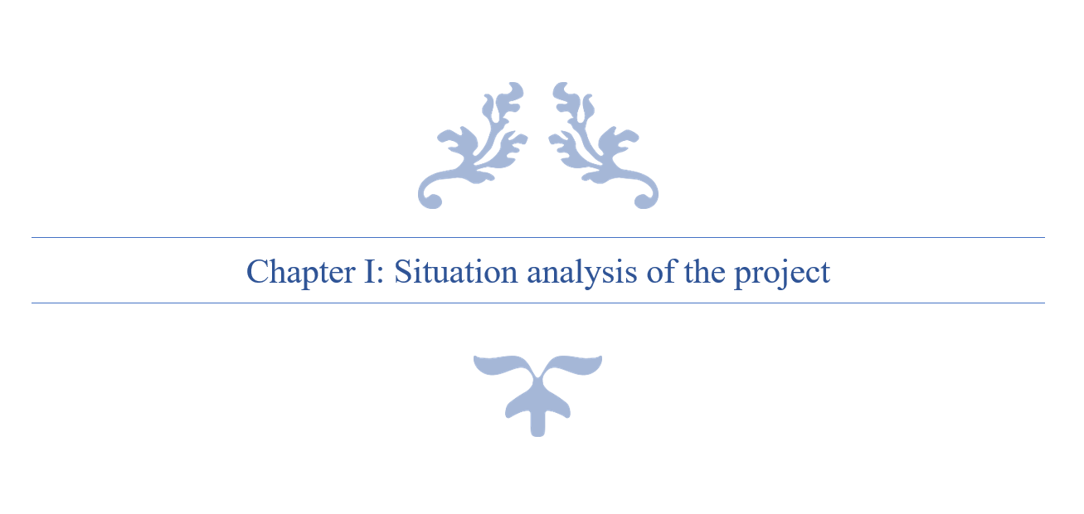

# Chapter I: Situation analysis of the project

## Introduction

In this chapter, I am going to present the host organization first. Then I am going to expose the subject of the project and the work environment. And finally, I will conduct a solution for this problematic.

## Presentation of the host organization

### Introduction

This is a report of the graduation project within the engineer degree majoring in Web & Mobile Software Development at the Private Higher School of Engineering and Technology (ESPRIT). I carried this project out within Kilani Group, the Marketing, training and merchandising department L’Atelier.

## Presentation of the organization

A leading actor in the fields of health, beauty, well-being and hygiene in Tunisia and abroad, Kilani Group is driven by the passion of the profession, the ethics as well as the satisfaction of customers and partners.

Since its creation, Kilani Group has expanded its activities around the world of pharmacy and drugstore including the manufacturing of pharmaceuticals, the import and distribution of healthcare, cosmetics & hygiene brands and medical and paramedical devices. Within a spirit of synergy, a range of service activities have been developed for partners operating in the fields of health & beauty.

The Group is thus well positioned in all sectors: industry, wholesale, direct distribution, retail and services.



Figure 1: Kilani Groupe Logo

### Subsidiaries of Kilani Groupe

Kilani Group started its activities in the distribution sector in 1986. Today, the Group is operating in the import, wholesale and direct distribution. Through dedicated sales teams specialized by sector and a logistic network extended all over Tunisia, the group is specialized in pharmaceuticals, paramedical products, surgical equipment and accessories, reagents and laboratory robots, cosmetics, dermo-cosmetics as well as hygiene products.

* ARGANIA
* KIPROPHA
* PROCHIDIA

Leading actor in Tunisia in the pharmaceutical industry, Kilani Group is a drug manufacturer since 1996 with production sites in Tunisia and abroad. The group innovates by constantly investing in research and cutting-edge technology in order to be at the service of health and participate in the development of the pharmaceutical sector.

* TERIAK

Kilani Group is a leader in retail sales in the beauty sector through a network of self-service outlets throughout Tunisia under its own brand. The Group then expanded into the retail of natural beauty and fashion through franchised brands.

* FATALES
* L’OCCITANE EN PROVENCE
* NINE WEST

KILANI Group also offers a range of complementary services to the medical industry, the distribution and the retail channels. One company is specialized in medical detailing, the management of proprietary and partner brands of drugs and the second company offers consulting in Retail marketing, shops layout; Trade Marketing Activation and Digital Marketing for Retail, entities and brands.

* L'Atelier
* Medicis

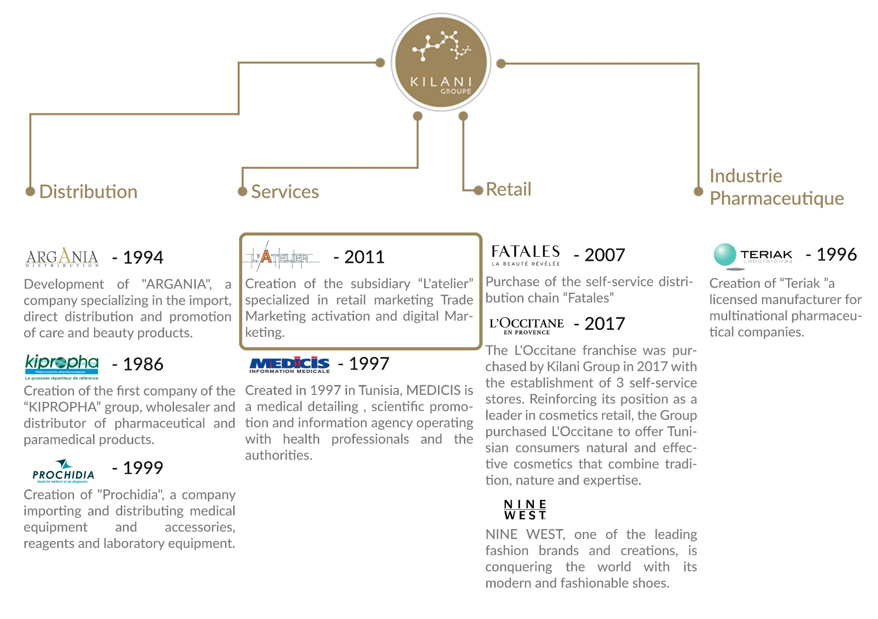

Figure 2: Kilani Groupe Organizational chart

### Missions of Kilani Groupe

Providing well-being and better health to everyone through the development of our brands and those of our partners in drugs, medical devices, care, beauty, hygiene and well-being as well as through our support services for healthcare professionals.

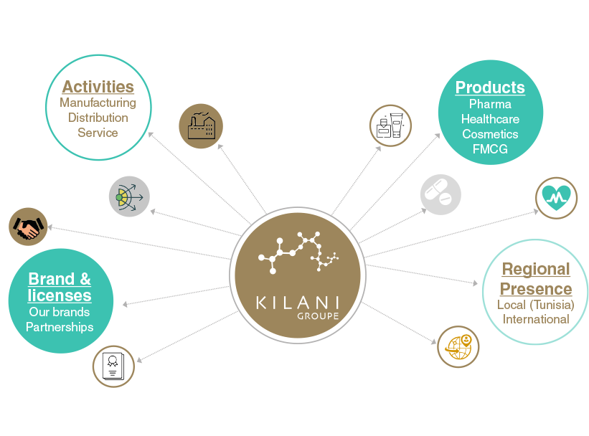

Figure 3: Kilani Groupe Missions & Activities

### Core values of Kilani Groupe

We are driven by a passion, the passion of life. A better life for everyone. Kilani Group has successfully passed on this passion to its subsidiaries and employees who endeavour every day to satisfy all their partners and customers by offering or proposing the best brands, products and services in the fields of health, beauty and well-being.

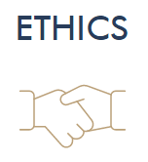

We adhere to the highest ethical standards. This ethics is that of well performed work and a product that meets the highest quality and safety standards. Ethics that is also based on respect and a sense of responsibility towards our partners, our employees and our customers.

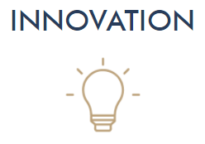As our main ambition is to satisfy our partners and customers, we do our utmost to innovate through cutting-edge processes to bring out the best in all our fields of activity.



Excellence is our leitmotiv and is embodied through our shared vision with our employees and partners to deliver high quality products and reliable services that meet the requirements of our customers.

### L’Atelier’s Presentation

L'Atelier, a subsidiary of Kilani Group, is specialized in the marketing and communication of brands and outlets.

Composed of a **team of experts**, it supports brands and outlets at all the stages of their projects **from ideation, to launching and marketing activation, in store, out of store as well as digitally.**

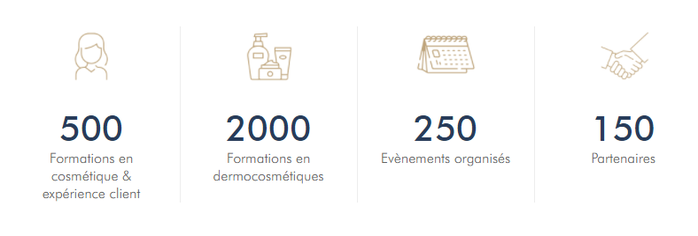

Figure 4: L'Atelier’s Activities

L'Atelier's areas of expertise include Marketing Concept Ideation, Outlet Layout and Optimization, Trade Marketing Activation for brands, Marketing and Digital Communication for brands and entities, and Customer Experience Training.

## Study of the existing

### Problematic

After several interviews with customers, producers and retailers in nutriment and cosmetic fields which use, sell, buy or produce natural or bio products, we concluded that currently, there is a strong diversification of organic consumers. Thus, distributors must put in place marketing strategies in order to remain competitive in their market.

The multiple food crises have encouraged the development of the organic market. Indeed, in recent years, demand has grown steadily. Since the early 1990s, the behavior of these consumers has changed dramatically. Combined with a feeling of uncertainty about the quality of the products they buy, they are now turning to certified products, including organic products.

### Presentation of the existing

Based on running tests on the coming concurrent apps, we realized few problems for each one of them and based on Play Store users’ reviews.

#### Yuka

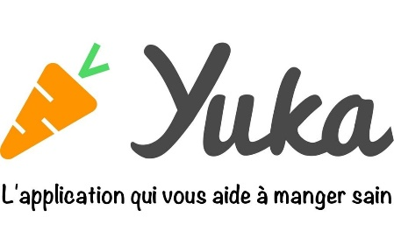Yuka decrypts the labels of your products food and cosmetics and their impact on health.

* Not suitable for people with special needs such as allergies or diabetes

Figure 5: Yuka Logo

#### INCI Beauty

INCI Beauty is an app that allows you to search and scan a product and consult its ingredients.

Figure 6: INCI Beauty Logo

* Fetching data errors
* Unidentified products
* Complicated to use

#### PharmaPocket

The app allows you to scan the barcodes of cosmetic products and decrypt their composition using simple pictograms.

Figure 7: PharmaPocket Logo

* Last update 2017
* App doesn’t start

#### Think Dirty

Think Dirty app allows us to learn ingredients in our beauty, personal care and household products.

Figure 8: Think Dirty App Logo

* Exploit the lucrative potential of its proposed service by “Verified Brand”

### Project Solution

Considering this problematic, I propose to develop a platform (web Dashboard and a mobile app) to resolve all of these challenges.

The mission of this project is to provide a responsive mobile app that allows its users to search and filter natural, bio, vegan and allergen-free products with a friendly user interface to inform the users about various information. Then, create a simple and easy form to identify the skin type of the user with a setting page to select its allergies. And last is to implements an algorithm that assist the user in further researches based on his selected preferences. The Website main purpose is to maintain the data shown in the mobile app.

## Conclusion

My graduation project scope is to develop a website and a mobile application to assist products consumers in their research for the perfect product based on their preferences.



# Chapter II: Specifications and methodology

## Introduction

In this chapter, we’re going to tackle in the first section the modelling language UML, software requirements specifications in the second part, and in the last part, the project management.

## Modelling Language

### Introduction

UML is a standard language for writing software blueprints [4]. UML may be used visualize, construct, and document the artifacts of software. UML is appropriate for modelling systems ranging from enterprise information systems to distributed Web-based applications.

The vocabulary of the UML encompasses three basic terms: **Things**, **Relationships** and **Diagrams**. Things are the abstractions that are firstly build in a model; relationships tie these things together and diagrams group collections of things.

### Unified Modelling Language

A modelling language is a way of expressing building a model, which has been produced during the developing process.

Modelling language defines a collection of model elements. UML, the Unified Modelling language, is the most popular -that will be either by hand or drawing by the tool- needs a number of things that a modelling tool can provide; such as: reporting, integrating with other process model, synchronizations of models and code. Today there are several UML tools on the market that describe the semantics, notations and constructs of UML.

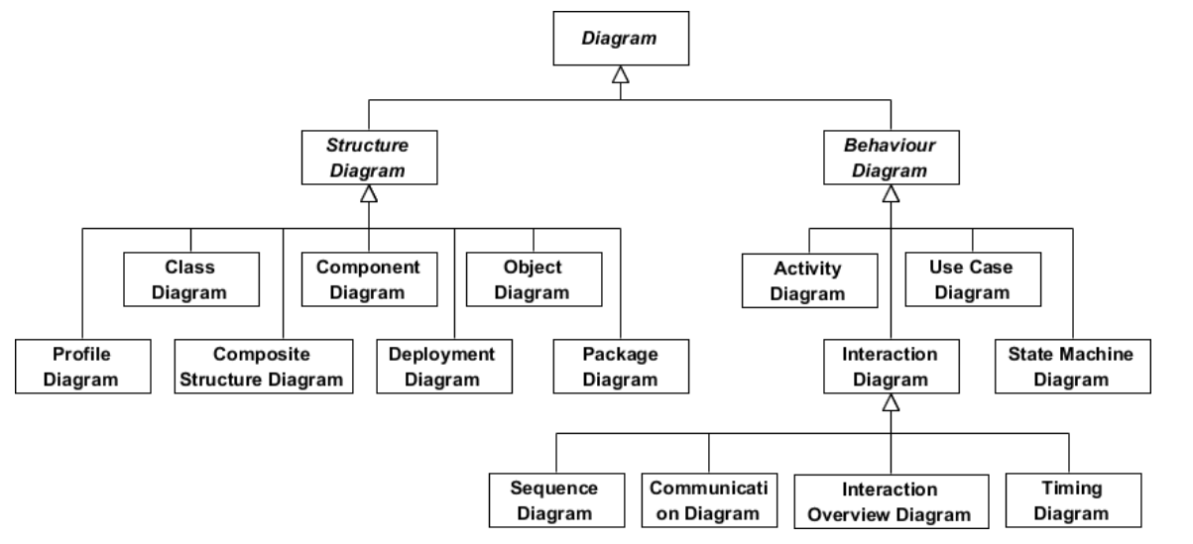

Figure 9: UML Diagrams Overview [5]

## Software Requirements Specifications



### Non-Functional Requirements

Non-functional requirements (NFR’s) cover all the remaining requirements which are not covered by the functional requirements. They specify criteria that judge the operation of a system, rather than specific behaviours.[6]

In other words, NFS define system attributes such as security, reliability, performance, maintainability, scalability, and usability. They serve as constraints or restrictions on the design of the system across the different backlogs.

* Reliability and synchronization
* Extensibility
* Friendly user experience

### Functional Requirements

The projects functional requirements features are shown as below:

* + Users’ management
  + Allergens Management
  + Complaints Management
  + Products Management
  + Categories Management
  + Ingredients Management
  + Search History Management
  + Product Suggestion
  + Favourite Management

## Global Use Case Diagram

The following figure is the global use case diagram of this project which contains the functional requirements with their actors.

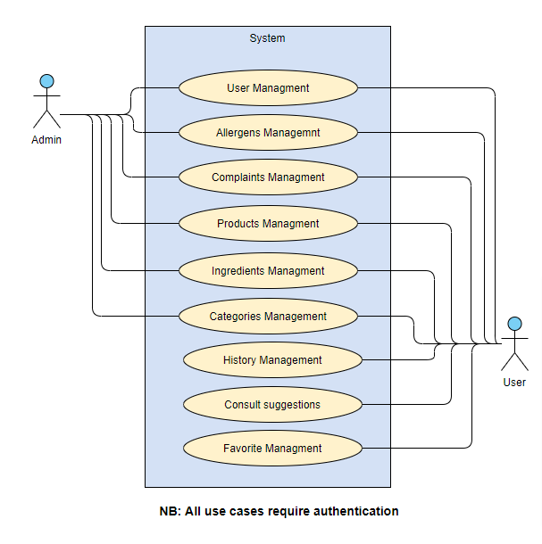

Figure 10: Global Use Case

## Global Class Diagram

In the following figure, I present the global class diagram of this project which present the main elements to implement in this project and their object-oriented data model.

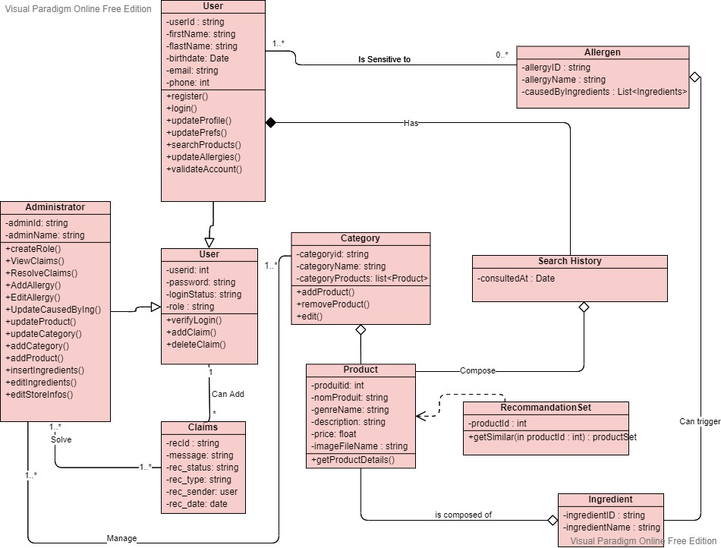

Figure 11: Global Class Diagram

## Software Development Methodology

**Introduction**

A software development methodology or system development methodology in software engineering is a framework that is used to structure, plan, and control the process of developing an information system.[7]

There are the following methodologies:

* Agile Software Development
* Crystal Methods
* Dynamic Systems Development Model (DSDM)
* Extreme Programming (XP)
* Feature Driven Development (FDD)
* Joint Application Development (JAD)
* Lean Development (LD)
* Rapid Application Development (RAD)
* Rational Unified Process (RUP)
* Scrum
* Spiral
* Systems Development Life Cycle (SDLC)
* Waterfall



### Agile Methodology

Agile software development is a conceptual framework for undertaking software engineering projects. There are several agile software development methodologies e.g., Crystal Methods, Dynamic Systems Development Model (DSDM), and Scrum.[8]

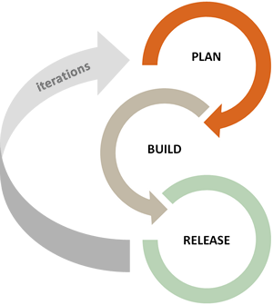We can view agile methods such as Extreme Programming (XP) and Scrum as a reaction to plan-based or traditional methods, which emphasize a "rationalized, engineering-based approach, incorporating extensive planning, codified processes, and rigorous reuse.

In contrast, agile methods address the challenge of an unpredictable world, emphasizing the value competent people and their relationships bring to software development. To clarify the effectiveness of agile methods, we reviewed the agile development literature and conducted a systematic study of what we know empirically about its benefits and limitations.

Figure 12: Agile Methodology workflow



### Scrum Methodology

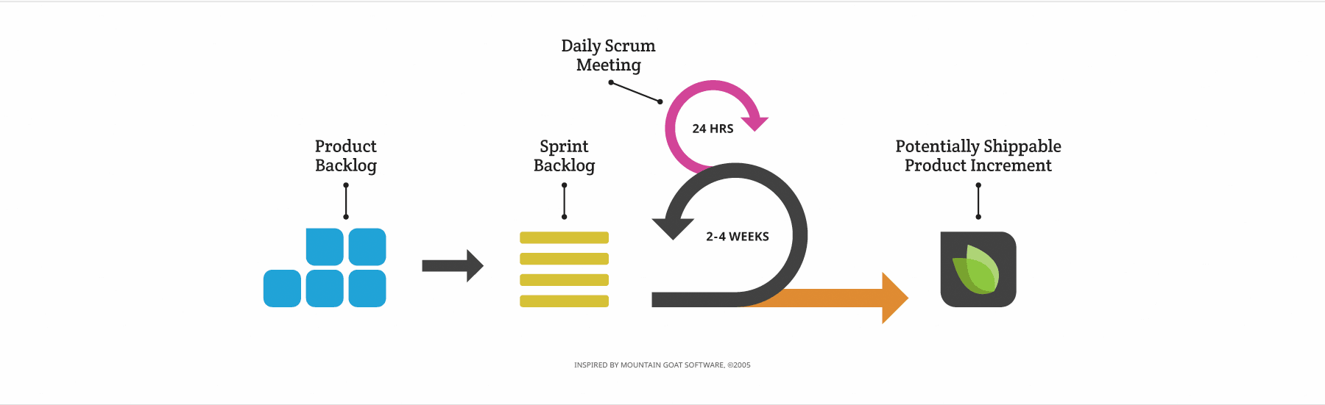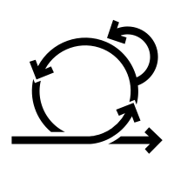When Jeff Sutherland created the scrum process in 1993, he borrowed the term "scrum" from an analogy put forth in a 1986 study by Takeuchi and Nonaka, published in the Harvard Business Review. In that study, Takeuchi and Nonaka compare high-performing, cross-functional teams to the scrum formation used by Rugby teams. Scrum is the leading agile development methodology, used by Fortune 500 companies around the world.[9]

Figure 13: Scrum Methodology Overview

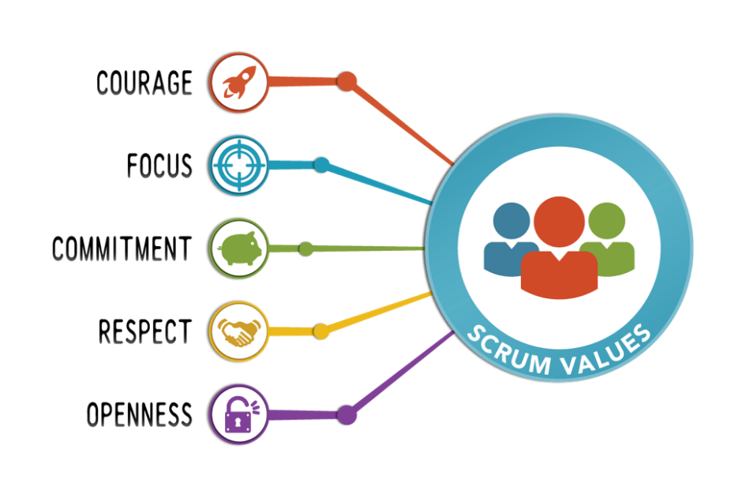The Scrum Alliance exists to transform the way we tackle complex projects, bringing the Scrum framework and agile principles beyond software development to the broader world of work.[10]

Figure 14: Scrum Values

#### The Scrum Team

|  |
| --- |
| Product Owner: **Mrs. Ridha Leila** |
| Product owner is the champion for his product. He is focused on understanding business and market requirements, then prioritizing the work to be done by the engineering team accordingly.  Product owner is not a project manager. Product owner is not managing the status of the program. He focusses on ensuring the development team delivers the most value to the business. |
| Scrum Master: **Mr. Ben Ahmed Zied** |
| An effective scrum master deeply understands the work being done by the team and can help the team optimize their delivery flow. As the facilitator-in-chief, they schedule the needed resources (both human and logistical) for sprint planning, stand-up, sprint review, and the sprint retrospective.  Scrum masters also look to resolve impediments and distractions for the development team, insulating them from external disruptions whenever possible. |
| Development Team: **Sadok Laouissi** |
| Development team is the champion for sustainable development practices. The most effective development team is tight-knit and co-located. Team members have differing skill sets, and cross-train each other so no one person becomes a bottleneck in the delivery of work. All members of the team help one another to ensure a successful sprint completion. |

Table 1: The Scrum Team

#### Scrum Events

Prescribed events are used in Scrum to create regularity and to minimize the need for meetings not defined in Scrum.[11]

* Sprint Planning:

Sprint Planning is time-boxed to a maximum of eight hours for a one-month Sprint. For shorter Sprints, the event is usually shorter.

Sprint Planning answers the following:

Topic One: What can be done this Sprint?

Topic Two: How will the chosen work get done?

* Daily Scrum Meeting

The Daily Scrum is a 15-minute time-boxed event for the Development Team to synchronize activities and create a plan for the next 24 hours.

During the meeting, the Development Team members explain:

What did I do yesterday that help the Development Team meet the Sprint Goal?

What will I do today to help the Development Team meet the Sprint Goal?

Do I see any impediment that prevents me or the Development Team from meeting the Sprint Goal?

* Sprint Review

A Sprint Review is held at the end of the Sprint to inspect the Increment and adapt the Product Backlog if needed. Based on that and any changes to the Product Backlog during the Sprint, attendees collaborate on the next things that could be done to optimize value.

* Sprint retrospective

The Sprint Retrospective is an opportunity for the Scrum Team to inspect itself and create a plan for improvements to be enacted during the next Sprint.

The Sprint Retrospective occurs after the Sprint Review and prior to the next Sprint Planning.

The purpose of the Sprint Retrospective is to:

Inspect how the last Sprint went with regards to people, relationships, process, and tools.

Identify and order the major items that went well and potential improvements.

Create a plan for implementing improvements to the way the Scrum Team does its work.

#### Scrum Artifacts

* Product Backlog

The Product Backlog is an ordered list of everything that might be needed in the product and is the single source of requirements for any changes to be made to the product. The Product Owner is responsible for the Product Backlog, including its content, availability, and ordering.

* Sprint Backlog

The Sprint Backlog is the set of Product Backlog items selected for the Sprint, plus a plan for delivering the product Increment and realizing the Sprint Goal. The Sprint Backlog is a forecast by the Development Team about what functionality will be in the next Increment and the work needed to deliver that functionality into a “Done” Increment. The Sprint Backlog makes visible all the work that the Development Team identifies as necessary to meet the Sprint Goal.

## Project Management

### Product Backlog

|  |  |  |  |  |
| --- | --- | --- | --- | --- |
| ID | As a(n) | I want to | So that I can | Priority |
|  | Administrator | Authenticate | access the platform | 17 |
|  | Administrator | Recover password | authenticate | 45 |
|  | Administrator | Add categories | Add its products | 1 |
|  | Administrator | Edit categories | Maintain the app design & functionalities | 2 |
|  | Administrator | Delete Categories | Restrict categories shown | 3 |
|  | Administrator | View Categories | Chose which to update/delete | 4 |
|  | Administrator | View Complaints | Update complaint state | 39 |
|  | Administrator | Update complaint state | (user) Visualize complaint progress | 40 |
|  | Administrator | View Users | View users’ global data | 18 |
|  | Administrator | View Allergens | Visualize allergens data | 6 |
|  | Administrator | Add Allergens | Add allergens to products | 7 |
|  | Administrator | Associate allergens to ingredients | (user) Visualize allergens in ingredients | 8 |
|  | Administrator | Edit Allergens | Change allergens data | 9 |
|  | Administrator | Delete Allergens | Disable allergen | 10 |
|  | Administrator | View Products | Visualize Products data | 24 |
|  | Administrator | Delete Products | Delete unwanted Products | 25 |
|  | Administrator | Enable/disable Product | Un/Restrict for users | 26 |
|  | Administrator | Add Product | (user) Gets latest products | 27 |
|  | Administrator | Update Product | Update products data | 47 |
|  | Administrator | Associate ingredients to products | (user) Gets product’s ingredients | 28 |
|  | Administrator | Add ingredients | Associate ingredients to products | 12 |
|  | Administrator | View ingredients | View ingredients’ data | 13 |
|  | Administrator | Edit ingredients | Edit ingredients’ data | 14 |
|  | Administrator | Delete ingredients | Delete unused ingredients | 15 |
|  | User | Authenticate | Access the mobile App | 19 |
|  | User | Sign up | Create an account | 20 |
|  | User | Validate account | Enable account | 21 |
|  | User | Take diagnosis | Associate to a skin type | 41 |
|  | User | Add personal allergens | Check product’s compatibility | 11 |
|  | User | Update profile information | Edit user’s profile | 22 |
|  | User | Update password | Secure account | 23 |
|  | User | Recover password | authenticate | 46 |
|  | User | Add search history | View account history | 36 |
|  | User | Delete search history | Remove unwanted search | 37 |
|  | User | View search history | Track account activity | 38 |
|  | User | Add complaint | Adapt user experience | 43 |
|  | User | View complaints | Visualize complaint progress | 44 |
|  | User | Add to favourite | Save preferred products | 34 |
|  | User | Delete from favourite | Remove unwanted products | 35 |
|  | User | View Favourite List | Get favourite products | 48 |
|  | User | View all categories | Get products based on selected category | 5 |
|  | User | View all products types | Get products based on selected types | 31 |
|  | User | View all products | View products data | 30 |
|  | User | Search all products | Find wanted products | 29 |
|  | User | Filter products | Get products based on selected filters | 32 |
|  | User | View product details | View product’s data | 33 |
|  | User | View product ingredients | Visualize product’s ingredients | 16 |
|  | User | View suggestions | Get similar, popular and newest products | 42 |

Table 2: Product Backlog

### Sprint Planning

|  |  |  |  |
| --- | --- | --- | --- |
| Sprint Number | Duration | Start Date | Finish Date |
| Sprint 1 : Categories Management | 15 days | 18/03/2021 | 02/04/2021 |
| Sprint 2 : Allergens Management | 17 days | 05/04/2021 | 22/04/2021 |
| Sprint 3 : Ingredients Management | 21 days | 23/04/2021 | 14/05/2021 |
| Sprint 4 : Users Management | 25 days | 17/05/2021 | 11/06/2021 |
| Sprint 5 : Products Management | 25 days | 14/06/2021 | 09/07/2021 |
| Sprint 6 : Favorite & History Management | 26 days | 12/07/2021 | 09/08/2021 |
| Sprint 7: Complaints & Sugguestions Management | 27 days | 10/08/2021 | 08/09/2021 |

Table 3: Sprints Planning

(To see Gantt Diagram of this project “See Appendix A")

## Conclusion

During this sprint, I described the functional and non-functional requirement of the project as well as the Software methodology chosen to implement it. I presented both the global use case diagram and class diagram of the project and finally the product’s Backlog and the sprint adapted for the project.

On the next chapter, I am going to present the state of the art of the cosmetic field.



# Chapter III: State of the art

## Introduction

On this part, we are going to explore the cosmetic field, types, packaging and the current situation worldwide and in Tunisia.

## Cosmetic Field

### Chemical Products

##### Definition:

Any substance or preparation intended to be put in contact with the superficial parts of the human body (epidermis, looting system, nails, lips, eyes, ...) for the sole or principal purpose of cleaning them, perfume, alter their appearance and protect them and keep them in good condition. (Manu, 2019)

##### What exactly is a chemical in cosmetics?

This expression is often used by the general public to designate a product of synthesis or in the broader sense, something that would have undergone a transformation by Man. Yet chemical reactions also occur in contact with several natural products that are not processed. For example, by mixing lemon and chalk (which is a limestone rock), you can get CO2. (Manu, 2019)

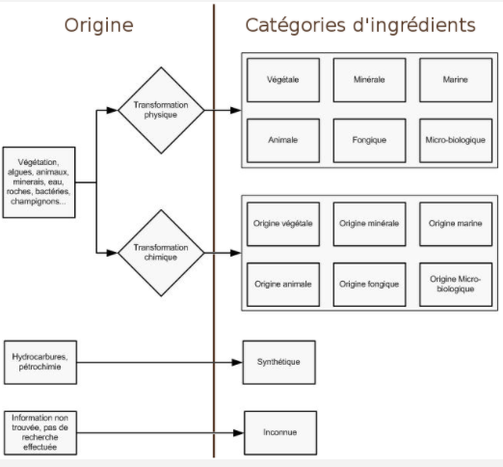

Figure 15: Ingredient Transformations Categories

### Natural Products

Natural cosmetics are very close to “native” products, such as traditional herbal medicine, which uses raw materials that are almost raw. They undergo mainly primary mechanical and chemical transformations, such as distillation, extraction, cooking or filtration, fermentation and oxidation, percolation, desiccation, leaving few residues, which are easily recyclable and biodegradable. Schematically, natural and organic cosmetic products by extension contain a majority of ingredients from the plant world (plants, fruits, flowers, etc.) exploited in different forms (essential oils, vegetable oils, powders, etc.), but also substances of animal origin produced naturally and without mistreatment to obtain them (honey, beeswax, milk, eggs) and some mineral resources (clay, silica, etc.).

### Bio Products

There is no official definition of organic cosmetics. What is commonly referred to as “organic cosmetics” refers to a family of products composed of natural or natural ingredients (in varying proportions depending on the brand), unlike “conventional” cosmetic products. made in large part from synthetic ingredients. Organic cosmetics limits or excludes the use of substances that may cause harmful effects on the user (allergies, cancer, etc.) or on nature (testing on animals, use of polluting manufacturing processes, etc.). (F, 2008)

“Organic cosmetics” are derived from organic farming which is based on the rational management of the soil fraction, respecting the biological cycles and the environment, taking into account ecological knowledge, for quality production, balanced, more autonomous, more economical and non-polluting. (Techno-science, s.d.)

## Packaging

Packaging is the first in contact with the consumer, an indispensable link for establishing a bond of trust and quality. Its primary role is to allow the protection, transport, and storage of creams and other perfumes. It must also embody the product it contains, its brand, and trigger the act of purchase. In addition to these technical and marketing functions, its use as a vector of information to the customer (regulatory information in particular). For all these reasons, packaging development is integrated from the first stages of development of a cosmetic product. Innovation is everywhere: choice of materials, choice of format, design, decor, process etc. The constraints are numerous since the designer must integrate in the development: the use of the product by the consumer, the production and logistics stages and the recyclability of materials. (Masson, 2020)

## Current Situation

### Cosmetic sector worldwide

The global cosmetics market is growing rapidly, on average double the world's GNP over the past two decades. 4500 USD of beauty and cosmetic products are sold worldwide every second, the equivalent of 138 billion dollars per year. France is the world leader in cosmetics with exports of $4.7 billion outside the European Union.

The cosmetics industry includes perfumery (perfumes, eau de toilette, toiletries), toiletries (soaps, shower gels, deodorants, toothpastes...), hair products (shampoos, lacquers, gels, styling foams, colouring...) and cosmetics (makeup, skincare creams, baby products, sunscreens...)[1]. The global cosmetics market remains dynamic despite a difficult economic context. A market particularly stimulated by the makeup segment that is constantly innovating to offer new trends and new "looks" to consumers. The global makeup market is worth $55 billion in 2018. Asia and Western Europe still dominate the market by more than 50% of its overall value, closely followed by North America. Europe is in 2nd position and represents a value of more than 12 billion dollars. In the following figure, we will present the major cosmetics brands in the world according to their 2017 valuation.[2]

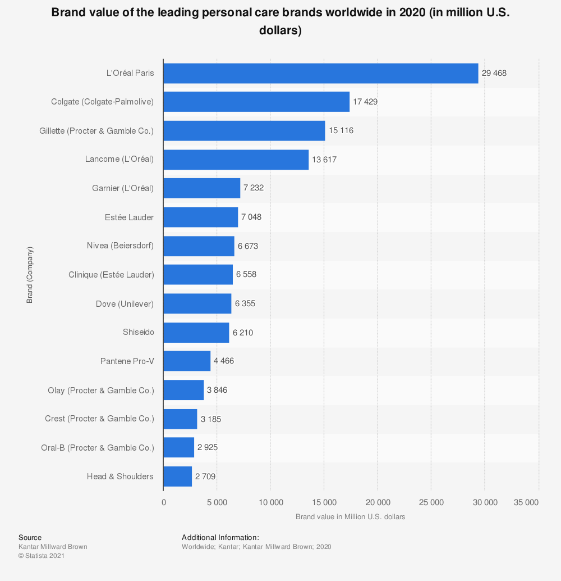

Figure 16: The world's most powerful personal care brands in 2020

The beauty market is divided between the major historical players that shine worldwide, and alongside which many SMEs are developing: L'Oréal is the world leader in the cosmetics market, with a turnover of $29.4 billion in 2020. Estée Lauder and Nivea ranked sixth and seventh, with revenues of $7.0 billion and $6.6 billion, respectively.

In the following figure, we will present the countries where the consumption is significant in terms of the level of use of cosmetic products (Turnover per person generated by the sale of beauty products in 2017).

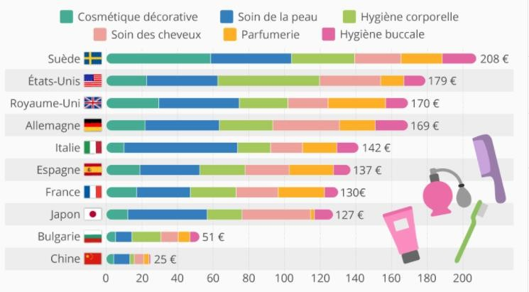

Figure 17: Countries with the highest spending on beauty products in 2017

With the birth of a true ecological consciousness among consumers, the debates on paraben, endocrine disruptors and potentially carcinogenic ingredients, the beauty market is one of the sectors most affected by the wave of «natural» and the “better to use” trend. Thus, although the majority of buyers continue to use conventional cosmetics, they increasingly favour ecological, healthy and natural products, as well as the various certifications (organic, vegan, etc.) that did not exist until 20 years ago: Global revenues for natural cosmetics increased by 8.8% between 2018 and 2019.The global market for natural cosmetics could reach $48 billion in 2024.

The beauty and cosmetics sector has been booming for several years, especially on the web. Every year, sales of cosmetics in stores decrease in favour of online sales, the beauty sector is the 4th e-commerce market in terms of number of customers.

Online beauty sales increased by 73% in 2020, compared to the previous year, over the same period. In France, online beauty sales account for more than 7% of the market. This is less than in the US and UK where e-commerce accounts for about 15% of sales. Between 2016 and 2017, sales of make-up products on the Internet jumped by 44%, 29% for beauty treatments and 22% for perfumes. 58% of women say they have ordered cosmetics on the web. More than half of them make purchases on their smartphones.

While consumers, and especially “millennials” (18 – 34 years), are increasingly turning to e-commerce to buy cosmetics, the in-store experience is still privileged because it offers the opportunity to test the products on site. As a result, 80.7% of global beauty sales are still in stores.

For example, a 2017 study for Facebook found that 72% of women who buy a beauty product are influenced by their “online experience”, meaning all digital marketing and communication channels: e-commerce, blog and social networks (Instagram and YouTube lead).

The power relationships between traditional players and small independent brands differ greatly on the Internet and at the point of sale. Thus, pure players (companies operating only on the web) do not fail to compete with the behemoths of the beauty industry: In store, the 20 leading brands of the sector share 96% of sales of cosmetics. On the web, they account for only 14% of transactions, with the remaining 86% split between independent brands.[3]

In conclusion, the figures of the beauty sector prove that the market still has beautiful days before it. Driven by very active influencers and listened to on social networks, but also because they save time and energy, online transactions of cosmetics tend to generalize. In-store shopping is still the norm, in that it allows you to test a product before you buy it. But new technologies such as augmented reality, which makes it possible to virtually try a product, could well help reverse the trend. In addition to e-commerce, there are several growth drivers for the beauty market. First, the growing demand for organic and natural products. Then, the personalization that allows to adapt a cosmetic product according to the type of skin, the weather or the state of fatigue of the consumer; a trend strongly linked to the rise of home-made cosmetics. Criteria that encourage brands to be more transparent and traceable in the composition of their products.

### Cosmetic sector in Tunisia

Over the past 10 years, the perfumery and cosmetics sector has been a booming market: the growth in demand for finished cosmetic and dermo-cosmetic products is around 12% per year.[4]

The cosmetics industry includes all manufacturers of products used for body, beauty and toilet care. These include perfumes, shampoos, gels, make-up, toothpastes, sunscreens, foams, gels, colorations, etc. These are toiletries, hair products and cosmetics.

In Tunisia, the participation of this sector in the economy is still low, representing only 2% of the exports of the chemical industries sector and the sector includes 83 companies divided into several segments of activities including 10 totally exporting.

The cosmetics sector Tunisia is currently facing problems and difficulties resulting in particular from the tax measures decreed by the Finance Act of 2018 and the non-tariff barriers that the Ministry of Commerce continues to impose, as well as some business practices outside of regular channels (smuggling, counterfeiting, and parallel market). To this is added a parallel trade that continues to develop.

The age group of women aged between 18 and 35 is the largest consumer of these products to meet the needs of social valorisation and importance of look. They buy perfumes, moisturizing creams, shampoos and skincare products. Regarding the dominant preference for the brand, Tunisian women express a trend for the products of major brands specializing in cosmetics regardless of their price. But for the majority of the population, the budget for these products is still very limited.

Tunisians generally allocate a monthly budget between 20DT and 30DT per month. This shows that the budget devoted to the consumption of hygiene and beauty products remains relatively low in the structure of Tunisian spending. Cosmetics are still perceived as “secondary” compared to commodities.[5]

Despite rising commodity prices, the price of perfumes remains relatively affordable. Tunisian manufacturers want to impose themselves on the local market by drawing the attention of consumers to the products offered at the expense of expensive foreign brands. It is a laborious adventure that is not always successful. The Tunisian manufacturer is called upon to make huge sums of money in order to be able to carve out a place for itself in a vast and diversified market that is experiencing stiff competition from all sides.

## Conclusion

We discovered the cosmetic field on this chapter as well as its ingredients, packaging and the current situation worldwide and in Tunisia. This field’s potential is increasing drastically, and most consumers are tending to use natural and bio products.

On the next chapter, we are going to present the work environment, Hardware and software and the technologies used for the implementation.

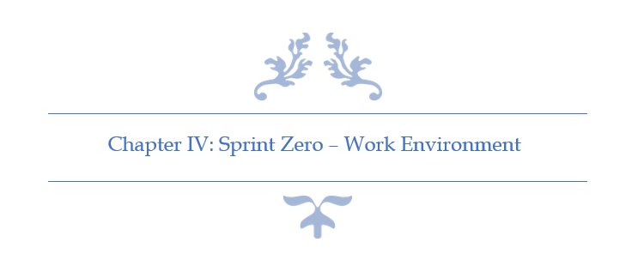

# Chapter IV: Sprint Zero - Work Environment

## Introduction

In this chapter I am going to present the different tools and technology used. First, I am going to describe the development environment (Hardware and Software) as well as the implementation features. Then, I am going to present the application’s physical and logical architecture.

## Work Environment

### Hardware Environment

Table 4: Hardware Environment Characteristics

To develop the application, we used as hardware environment 2 laptops and 2 desk- computers which have the following characteristic:

|  |  |  |
| --- | --- | --- |
| Hardware | Laptop | Desktop |
| Mark | HP-Pavilion Gaming 15 | Dell |
| Processor | 2.2 GHz Intel Core i7 | 2.5 GHz Intel Core i7 |
| Storage | 250 To SSD & 1 To HDD | 1 To HDD |
| RAM | 20 Go | 16 Go |
| Operating System | Windows 10 | Windows 10 |

### Software Environment

#### Android Developers Blog: Android Studio 4.1Android Studio v4.2

Android Studio is the official integrated development environment (IDE) for Google's Android operating system, built on JetBrains' IntelliJ IDEA software and designed specifically for Android development. (DBpedia, s.d.)

Figure 18: Android Studio Logo

#### Visual Studio Code v1.55.2

Visual Studio Code is a lightweight but powerful source code editor. It comes with built-in support for JavaScript, TypeScript and Node.js. (Microsoft, s.d.)

Figure 19: VS Code Logo

#### In Praise of Postman - SymbioticsPostman v8.3.1

Postman is a collaboration platform for API development. Postman's features simplify each step of building an API and streamline collaboration so we can create better APIs—faster. (Postman, s.d.)

Figure 20: Postman Logo

#### WampServer v3.2.0

WampServer refers to a software stack for the Microsoft Windows operating system, created by Romain Bourdon and consisting of the Apache web server, OpenSSL for SSL support, MySQL database and PHP programming language. (Wikipedia, s.d.)

Figure 21: WampServer Logo

#### Visual Paradigm Online

Visual Paradigm is a leading and globally recognized provider for Business and IT Transformation software solutions. It enables organizations to improve business and IT agility and foster innovation through popular open standards. (Visual Paradigm Online, s.d.)

Figure 22: Visual Paradigm Online Logo

#### Kits de ressources et exemples de conception pour les applications Windows - UWP applications | Microsoft DocsAdobe XD

Adobe XD (also known as Adobe Experience Design) is a vector-based user experience design tool for web apps and mobile apps, developed and published by Adobe Inc. (Wikipedia, s.d.)

Figure 23: Adobe XD Logo

#### Adobe Photoshop

Photoshop is a computer-assisted editing, processing and drawing software, launched in 1990 on MacOS and then in 1992 on Windows. Published by Adobe, it is mainly used for the processing of digital photographs, but also for the ex-nihilo creation of images. (Wikipe, s.d.)

Figure 24: Adobe Photoshop Logo

### Project Management Tools

#### GitHub Desktop

GitHub Desktop is an application that enables you to interact with GitHub using a GUI instead of the command line or a web browser. GitHub Desktop encourages you and your team to collaborate using best practices with Git and GitHub. (Github, s.d.)

Figure 25: GitHub Desktop Logo

#### TeamGantt

TeamGantt’s free gantt chart software lets you keep all your tasks, documents, and conversations in a single centralized hub. (TeamGantt, s.d.)

Figure 26: TeamGantt Online Logo

### Choice of implementation

#### Programming language

##### Histoire du langage Dart. Dart (initialement appelé Dash) est un… | by Kabirou Agouda | MediumDart

Dart is a programming language designed for client development, such as for the web and mobile apps. It is developed by Google and can also be used to build server and desktop applications. (Gentile, 2020)

Figure 27: Dart Logo

##### TypeScript

TypeScript is a strongly typed programming language which builds on JavaScript giving us better tooling at any scale.

TypeScript may be used to develop JavaScript applications for both client-side and server-side execution (as with Node.js). (Tutorials Point, s.d.)

Figure 28: TypeScript Logo

#### Database

##### MySQL

MySQL is a freely available open-source Relational Database Management System (RDBMS) that uses Structured Query Language (SQL).

Figure 29: MySQL Logo

SQL is the most popular language for adding, accessing and managing content in a database. (Site Ground, s.d.)

#### Framework

##### Angular

Angular is a platform and framework for building single-page client applications using HTML and TypeScript. Angular is written in TypeScript. It implements core and optional functionality as a set of TypeScript libraries that you import into your applications. (Angular, s.d.)

Figure 30: Angular Logo

##### Node JS

Node.js is an open-source, cross-platform, back-end JavaScript runtime environment that runs on the V8 engine and executes JavaScript code outside a web browser. Node.js lets developers use JavaScript to write command line tools and for server-side scripting—running scripts server-side to produce dynamic web page content before the page is sent to the user's web browser. (Wikipedia, s.d.)

Figure 31: Node JS Logo

##### Flutter

Flutter is Google’s free and open-source UI framework for creating native mobile applications. Released in 2017, Flutter allows developers to build mobile applications for both iOS and Android with a single codebase and programming language. This capability makes building iOS and Android apps simpler and faster. (Perfecto, 2021)

Figure 32: Flutter Logo

The Flutter framework consists of both a software development kit (SDK) and their widget-based UI library. This library consists of various reusable UI elements, such as sliders, buttons, and text inputs. (Perfecto, 2021)

Developers building mobile applications with the Flutter framework will do so using a programming language called Dart. With a syntax like JavaScript, Dart is a typed object programming language that focuses on front-end development. (Perfecto, 2021)

#### REST API vs. SOAP

REST operates through a solitary, consistent interface to access named resources. It’s most commonly used when you’re exposing a public API over the Internet. SOAP, on the other hand, exposes components of application logic as services rather than data. Additionally, it operates through different interfaces. To put it simply, REST accesses data while SOAP performs operations through a more standardized set of messaging patterns. Still, in most cases, either REST or SOAP could be used to achieve the same outcome (and both are infinitely scalable), with some differences in how you’d configure it. (ALTVATER, 2017)

#### Data Format

JSON (JavaScript Object Notation) is a lightweight data-interchange format. It is easy for humans to read and write. It is easy for machines to parse and generate. JSON is a text format that is completely language independent but uses conventions that are familiar to programmers of the C-family of languages, including C, C++, C#, Java, JavaScript, Perl, Python, and many others. These properties make JSON an ideal data-interchange language. (JSON, s.d.)

Figure 33: JSON Logo

## Application Architecture

### Physical Architecture

My application is based on 3-tiers Architecture as explained in the following figure. The first part is the Website. It’s the project’s operation room. Only Admins have access to the website through his own credentials. It can manage the main parts shown in the mobile app. The second part is the Server which contains the servers web and the application’s back office and contains all the controller. It is also the link between the application’s different parts. The third and the last part is the mobile app which contains products & categories stored in the web server and created through the administration website. The web server communicates with both parts through its own routes.

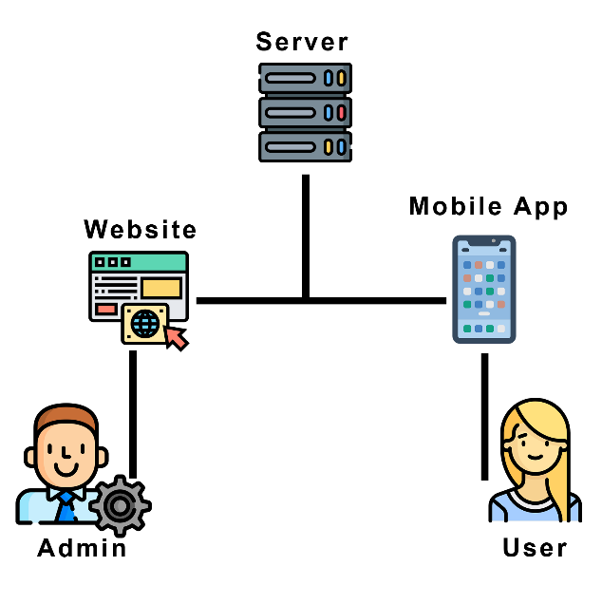

Figure 34 : Application's Physical Architecture

### Logical Architecture

In this project I used MEAN Stack but instead of MongoDB I used MySQL (MySQL, ExpressJS, Angular, NodeJS) for the back-office part and Flutter for the front-office.

First, I used MVVM (Model, View, View Model) for the administration dashboard (Angular Project) which allows us to enable the two-way data binding between the View and the View Model.

Second, I used “BloC” architecture for the mobile app (Flutter) which helps organize data flow. It allows us to keep different layers of our application separate which makes it easy to test and reuse elements in different parts of code.

And last, I used “Single Threaded Event Loop” architecture for the web server (NodeJS) which allows us to handle multiple concurrent clients based on its JavaScript event-based model.

The following figure explains the Pattern used in my situation.

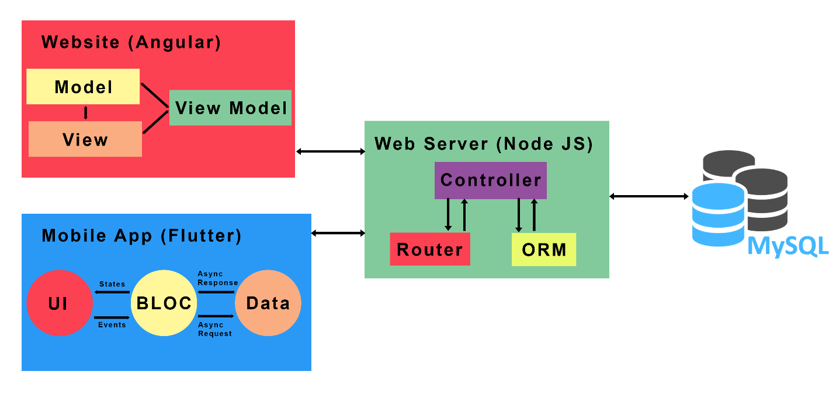

Figure 35 : Logical Architecture

The following figure describe the security middleware used in the Node.js server.

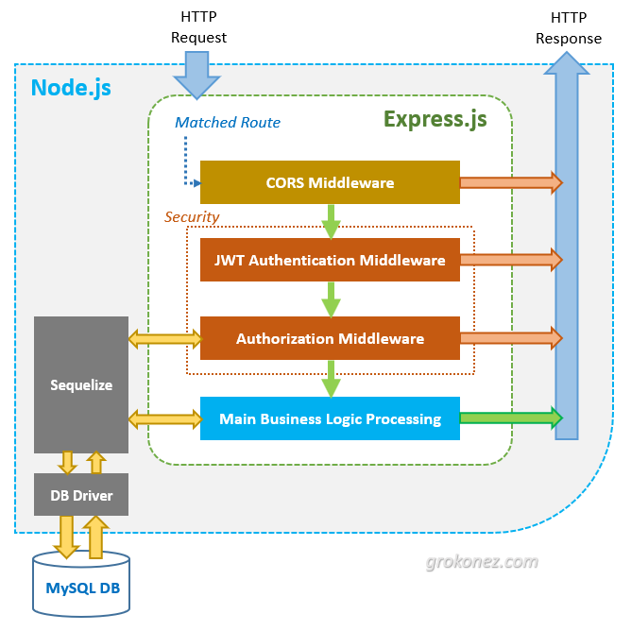

Figure 36: Security Middleware

## Conclusion

In this chapter, I described the hardware and software platforms on which I built our applications. Then, I presented the different technologies used in the realization. Also, I presented the application’s physical and logical architecture.

On the next chapter, I am going to start the development of the first sprint.

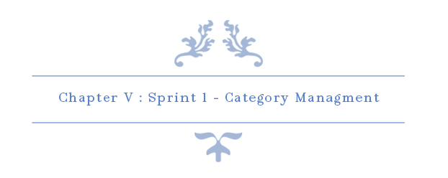

# Chapter V: Sprint 1 – Category Management

## Introduction

The purpose of this sprint is to discover, design, develop and test all features related to Categories.

## Sprint Backlog

### Sprint Scope

In this sprint, our main goal is to implement category service which allows the user to search for products based on their categories and it also allows the administrator to add, edit and delete categories.

### Tasks Planning

|  |  |  |  |  |  |  |  |  |  |  |  |  |
| --- | --- | --- | --- | --- | --- | --- | --- | --- | --- | --- | --- | --- |
|  |  | Day number | | | | | | | | | | |
| User stories# | Tasks | 1 | 2 | 3 | 4 | 5 | 6 | 7 | 8 | 9 | 10 |
| 3  &  4  &  5  &  6 | Database design and implementation | 6 | 0 | 0 | 2 | 0 | 0 | 2 | 0 | 0 | 0 |
| API implementation | 0 | 6 | 2 | 2 | 0 | 2 | 4 | 2 | 2 | 0 |
| Persistence development | 0 | 0 | 4 | 2 | 5 | 1 | 2 | 0 | 0 | 0 |
| Front end development | 0 | 0 | 0 | 2 | 2 | 3 | 0 | 4 | 2 | 4 |
| Test | 2 | 2 | 2 | 0 | 1 | 2 | 0 | 2 | 2 | 0 |
| Documentation | 0 | 0 | 0 | 0 | 0 | 0 | 0 | 0 | 2 | 4 |
| User stories# | Tasks | 11 | 12 | 13 | 14 | 15 |
| 40 | Database design and implementation | 4 | 4 | 0 | 2 | 0 |
| API implementation | 2 | 2 | 4 | 2 | 3 |
| Persistence development | 0 | 0 | 2 | 2 | 2 |
| Front end development | 0 | 0 | 0 | 2 | 1 |
| Test | 2 | 2 | 2 | 0 | 2 |
| Documentation | 0 | 0 | 0 | 0 | 0 |

Table 5: Tasks Planning - Sprint 1

## Analysis

### Categories Management Use Case Refinement

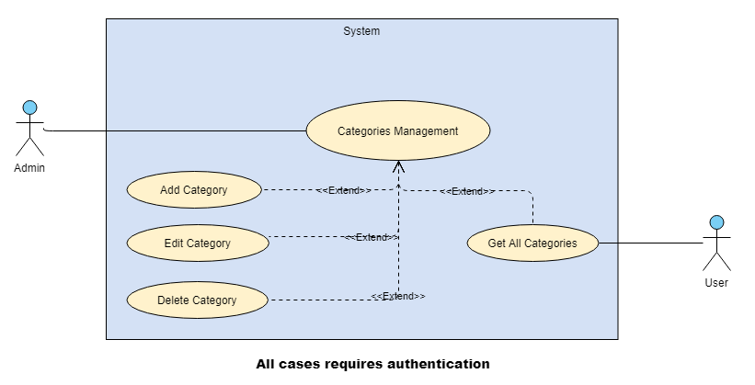

Figure 37: Categories Management Use Case Refinement

#### Use case “Add Category”

##### Textual description of the use case “Add Category”

The below table explain the “success” scenario of adding a new category.

|  |  |
| --- | --- |
| Use Case | Add Category |
| Actor | Admin |
| Pre-condition | The administrator must be authenticated. |
| Post-condition | New category inserted. |
| Nominal Scenario | * The admin clicks on “Categories” dropdown on the sidebar. * The admin clicks on “Add Category” button on the sidebar. * The system shows the desired interface. * The admin fills the form and clicks on “Confirm” button. |

Table 6: Textual description of the use case “Add Category”

##### Sequence diagram of the use case “Add Category”

A sequence diagram shows object interactions arranged in time sequence. It depicts the objects and classes involved in the scenario and the sequence of messages exchanged between the objects needed to carry out the functionality of the scenario. Sequence diagrams are typically associated with use case realizations in the Logical View of the system under development. Sequence diagrams are sometimes called **event diagrams** or **event scenarios**.

A sequence diagram shows, as parallel vertical lines (*lifelines*), different processes or objects that live simultaneously, and, as horizontal arrows, the messages exchanged between them, in the order in which they occur. This allows the specification of simple runtime scenarios in a graphical manner.

The below figure is the sequence diagram of add Category:

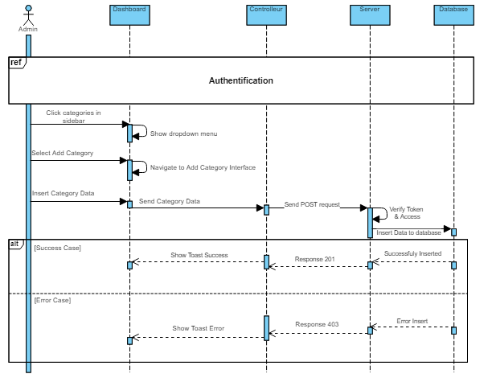

Figure 38: Add Category Sequence Diagram

##### Screen Captures

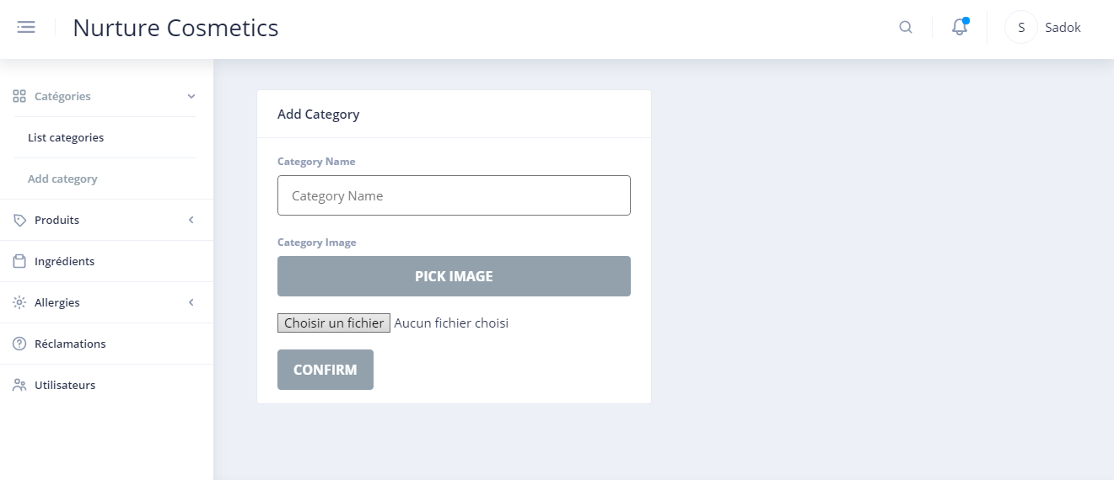

Figure 39: Screen Capture Add Category Interface

#### Use case “Edit Category”

##### Textual description of the use case “Edit Category”

The below table explain the “success” scenario of editing a category.

|  |  |
| --- | --- |
| Use Case | Edit Category |
| Actor | Admin |
| Pre-condition | The administrator must be authenticated. |
| Post-condition | Category updated. |
| Nominal Scenario | * The admin clicks on “Categories” dropdown on the sidebar. * The admin clicks on “List Categories” button on the sidebar. * The system shows the desired interface. * The admin clicks on “pencil” button on the desired category. * The admin fills the form and clicks on “Check-mark” button. |

Table 7: Textual description of the use case “Edit Category”

##### Sequence diagram of the use case “Edit Category”

The below figure is the sequence diagram of Edit Category:

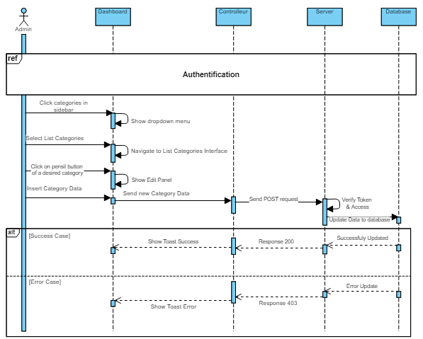

Figure 40: Edit Category Sequence Diagram

##### Screen Captures

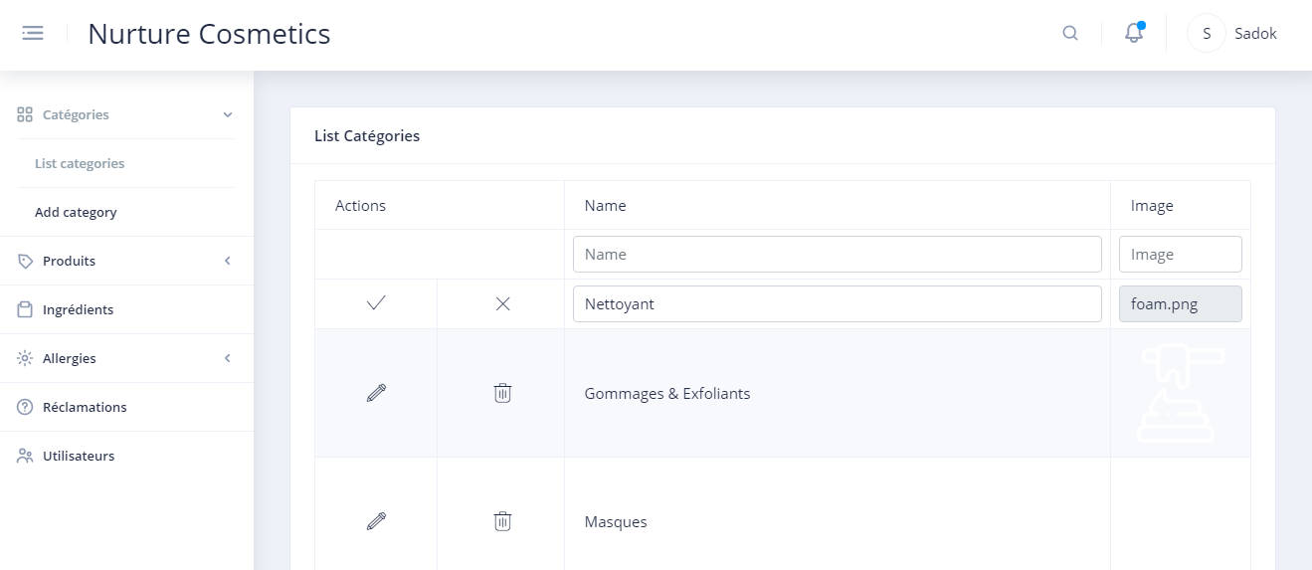

Figure 41: Screen Capture Edit Category Interface

#### Use case “Delete Category”

##### Textual description of the use case “Delete Category”

The below table explain the “success” scenario of deleting a category.

|  |  |
| --- | --- |
| Use Case | Delete Category |
| Actor | Admin |
| Pre-condition | The administrator must be authenticated. |
| Post-condition | Category deleted. |
| Nominal Scenario | * The admin clicks on “Categories” dropdown on the sidebar. * The admin clicks on “List Categories” button on the sidebar. * The system shows the desired interface. * The admin clicks on “close” icon on the desired category. * The admin confirms delete request. |

Table 8: Textual description of the use case “Delete Category”

##### Sequence diagram of the use case “Delete Category”

The below figure is the sequence diagram of Delete Category:

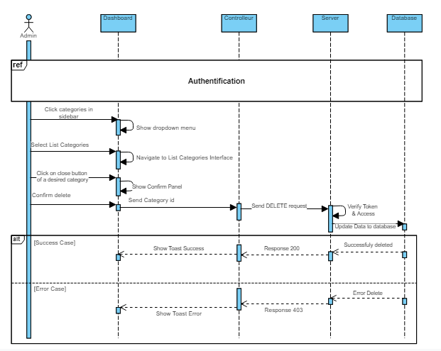

Figure 42: Delete Category Sequence Diagram

##### Screen Captures

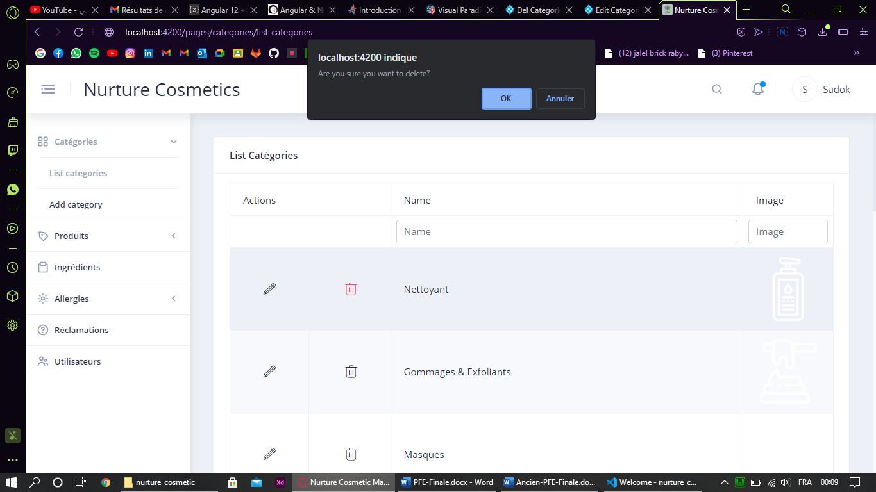

Figure 43: Screen Capture Delete Category

#### Use case “List All Categories (Admin)”

##### Textual description of the use case “List All Categories (Admin)”

The below table explain the “success” scenario of get all categories.

|  |  |
| --- | --- |
| Use Case | List All Categories |
| Actor | Admin |
| Pre-condition | The administrator must be authenticated. |
| Nominal Scenario | * The admin clicks on “Categories” dropdown on the sidebar. * The admin clicks on “List Categories” button on the sidebar. * The system shows the desired interface. |

Table 9: Textual description of the use case “List Categories”

##### Screen Captures

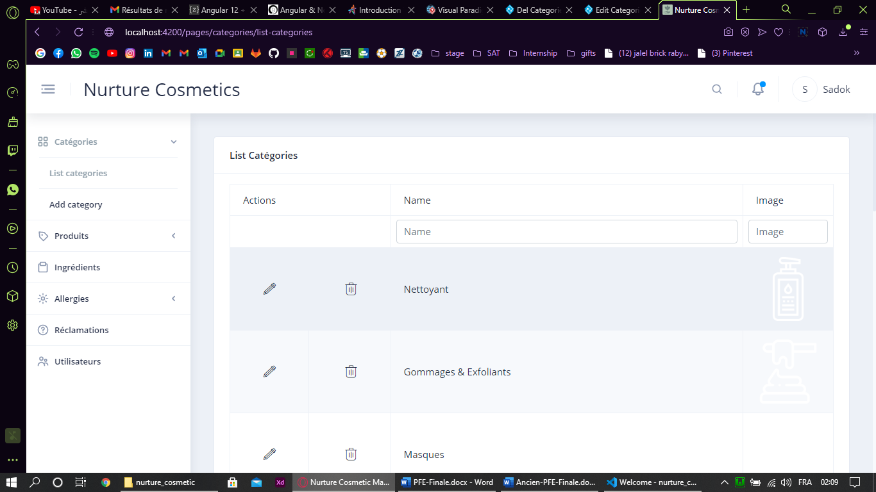

Figure 44: Screen Capture List Categories Interface

#### Use case “List All Categories (User)”

##### Textual description of the use case “List All Categories (User)”

The below table explain the “success” scenario of get all categories.

|  |  |
| --- | --- |
| Use Case | List All Categories |
| Actor | User |
| Pre-condition | The user must be authenticated. |
| Nominal Scenario | * The system shows all categories on home screen. |

Table 10: Textual description of the use case “List Categories (User)”

##### Screen Captures

The pictures below show the design made using Adobe XD and the realisation:

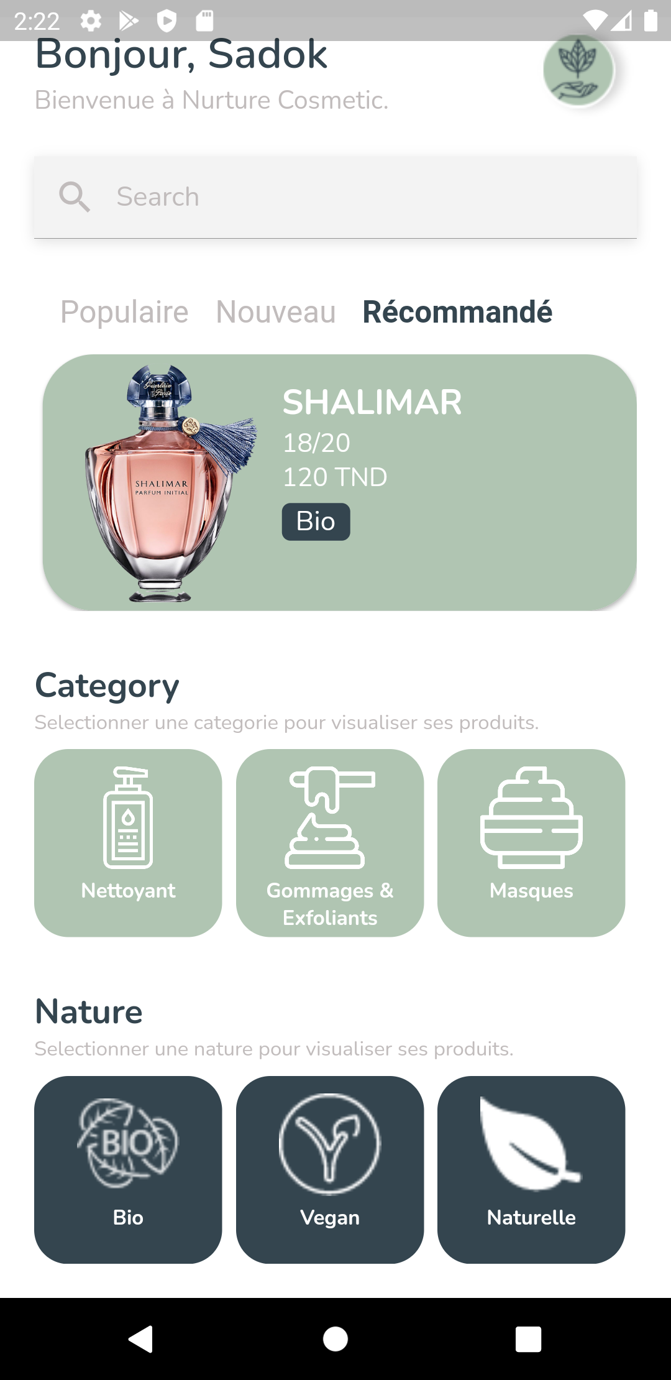

Figure 45: Home Screen Implementation

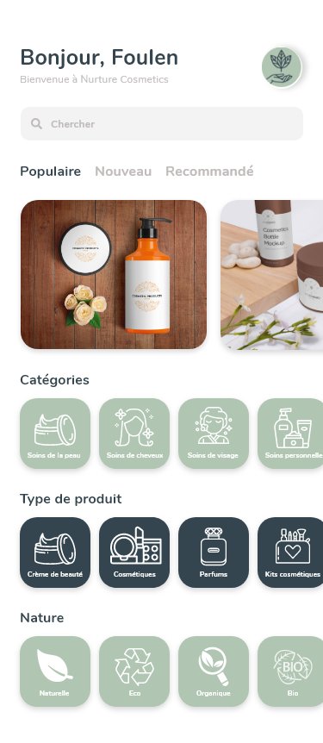

Figure 46: Home Screen Design

## Conclusion

All categories’ features are now implemented and tested.

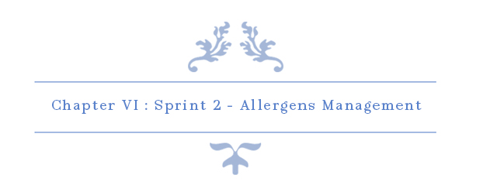

# Chapter VI: Sprint 2 – Allergens Management

## Introduction

On this sprint our main objective is to implement all allergens methods such as Create, Update, Delete, View… Allergen’s service is very important for this project because it allows users to select their personal allergens which help them with the search for products.

## Sprint Backlog

### Sprint Scope

On this sprint, our main task is the management of allergens and their association with ingredients.

### Tasks Planning

|  |  |  |  |  |  |  |  |  |  |  |  |  |  |  |  |  |  |  |
| --- | --- | --- | --- | --- | --- | --- | --- | --- | --- | --- | --- | --- | --- | --- | --- | --- | --- | --- |
|  |  | Day number | | | | | | | | | | | | | | | | |
| User stories# | Tasks | 1 | 2 | 3 | 4 | 5 | 6 | 7 | 8 | 9 | 10 | 11 | 12 | 13 | 14 | 15 | 16 | 17 |
| 10—14  &  29 | Database design and implementation | 4 | 4 | 2 | 0 | 0 | 0 | 1 | 1 | 0 | 0 | 0 | 0 | 0 | 0 | 0 | 0 | 0 |
| API implementation | 2 | 2 | 4 | 2 | 2 | 4 | 3 | 1 | 4 | 5 | 2 | 2 | 0 | 0 | 1 | 0 | 0 |
| Persistence development | 0 | 0 | 0 | 4 | 4 | 2 | 2 | 3 | 1 | 3 | 1 | 0 | 0 | 0 | 0 | 4 | 1 |
| Front end development | 0 | 0 | 0 | 0 | 0 | 0 | 0 | 0 | 1 | 0 | 2 | 2 | 3 | 4 | 2 | 3 | 4 |
| Test | 2 | 2 | 2 | 2 | 1 | 2 | 2 | 3 | 0 | 0 | 3 | 2 | 1 | 1 | 4 | 1 | 3 |
| Documentation | 0 | 0 | 0 | 0 | 0 | 0 | 0 | 0 | 0 | 0 | 0 | 2 | 4 | 3 | 1 | 0 | 0 |

Table 11: Tasks Planning - Sprint 2

## Analysis

### Allergens Management Use Case Refinement

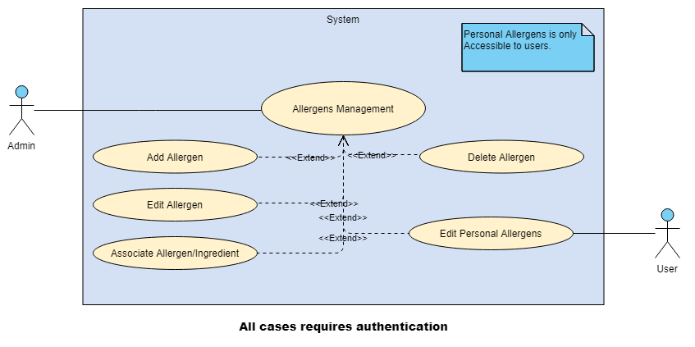

Figure 47: Allergens Management Use Case Refinement

#### Use case “Add Allergen”

##### Textual description

The below table explain the “success” scenario of adding a new allergen.

|  |  |
| --- | --- |
| Use Case | Add Allergen |
| Actor | Admin |
| Pre-condition | The administrator must be authenticated. |
| Post-condition | New Allergen inserted. |
| Nominal Scenario | * The admin clicks on “Allergens” dropdown on the sidebar. * The admin clicks on “Add Allergen” button on the sidebar. * The system shows the desired interface. * The admin fills the form and clicks on “Confirm” button. |

Table 12: Textual description of the use case “Add Allergen”

##### Screen Capture

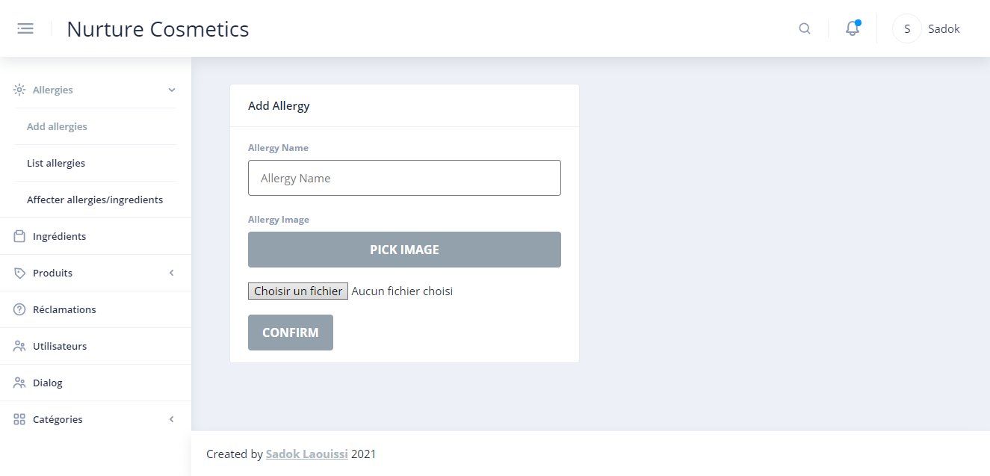

Figure 48: Screen Capture Add Allergen Interface

#### Use case “Edit Allergen”

##### Textual description

The below table explain the “success” scenario of editing an allergen.

|  |  |
| --- | --- |
| Use Case | Edit Allergen |
| Actor | Admin |
| Pre-condition | The administrator must be authenticated. |
| Post-condition | Allergen updated. |
| Nominal Scenario | * The admin clicks on “Allergens” dropdown on the sidebar. * The admin clicks on “List Allergens” button on the sidebar. * The system shows the desired interface. * The admin clicks on “pencil” button on the desired allergen. * The admin fills the form and clicks on “Check-mark” button. |

Table 13: Textual description of the use case “Edit Allergen”

##### Screen Capture

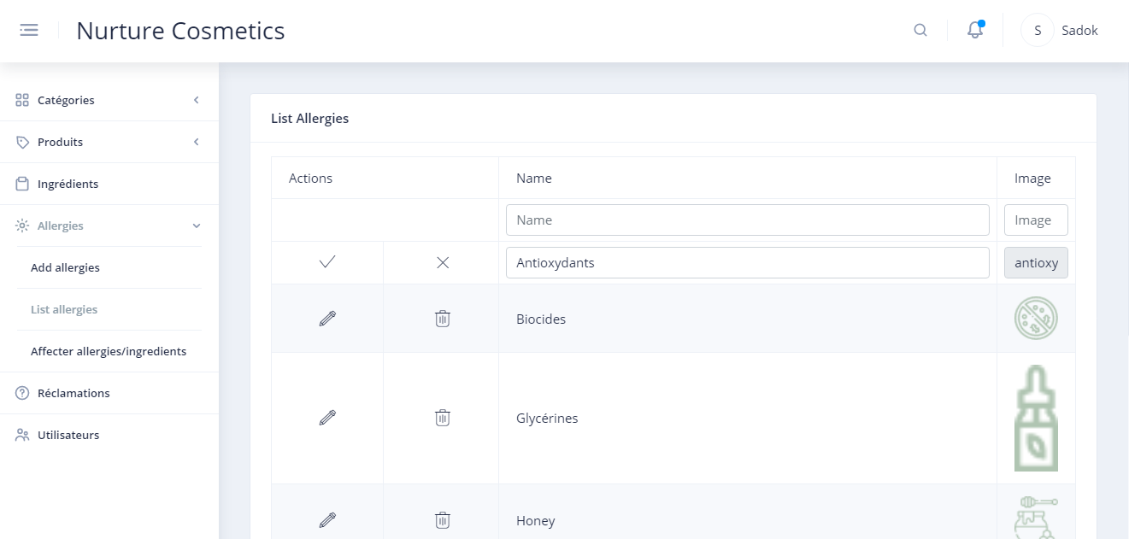

Figure 49: Screen Capture Edit Allergen

#### Use case “Delete Allergen”

##### Textual description

The below table explain the “success” scenario of deleting an allergen.

|  |  |
| --- | --- |
| Use Case | Delete Category |
| Actor | Admin |
| Pre-condition | The administrator must be authenticated. |
| Post-condition | Allergen deleted. |
| Nominal Scenario | * The admin clicks on “Allergens” dropdown on the sidebar. * The admin clicks on “List Allergens” button on the sidebar. * The system shows the desired interface. * The admin clicks on “trash” icon on the desired allergen. * The admin confirms delete request. |

Table 14:Textual description of the use case “Delete Allergen”

##### Screen Capture

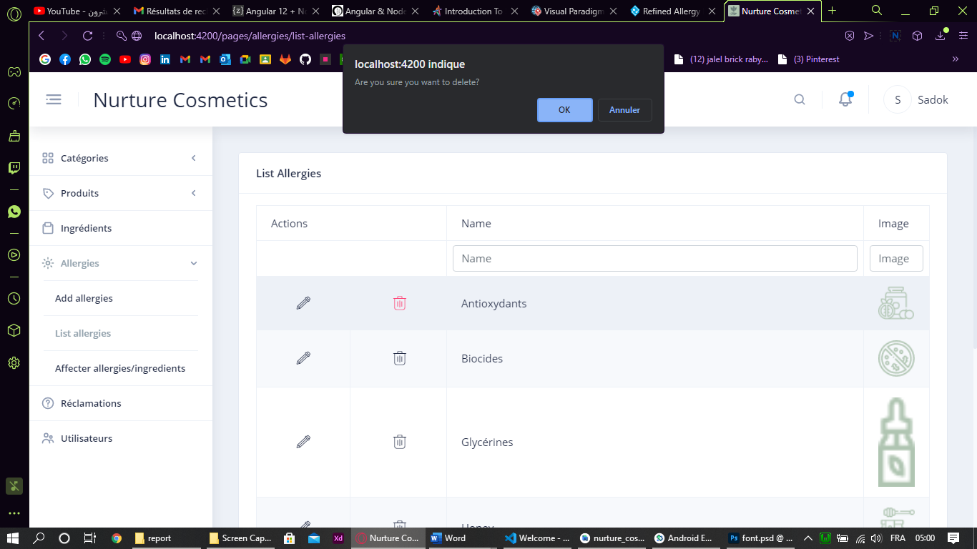

Figure 50: Screen Capture Delete Allergen

#### Use case “Associate Ingredient/Allergen”

##### Textual description

The below table explain the “success” scenario of association an ingredient to an allergen.

|  |  |
| --- | --- |
| Use Case | Associate Ingredient/Allergen |
| Actor | Admin |
| Pre-condition | The administrator must be authenticated. |
| Post-condition | Ingredient associated to/removed from allergen. |
| Nominal Scenario | * The admin clicks on “Allergens” dropdown on the sidebar. * The admin clicks on “Associate Ingredient/Allergen” button on the sidebar. * The system shows the desired interface. * The admin clicks on “Select Allergen” dropdown and select the desired allergen. * The system shows its provoking ingredients and all other ingredients. * The admin clicks on plus icon to add other ingredients or trash icon to remove from its current ingredients. |

Table 15: Textual Description Associate Ingredient/allergen

##### Sequence diagram of the use case Associate Ingredient/Allergen

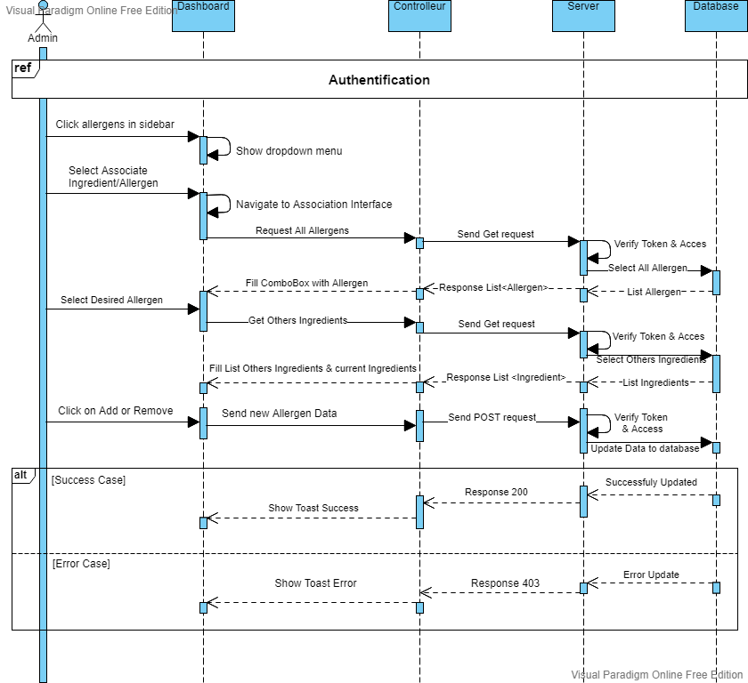

Figure 51: Sequence diagram of the use case "Associate Ingredient/Allergen"

##### Screen Capture

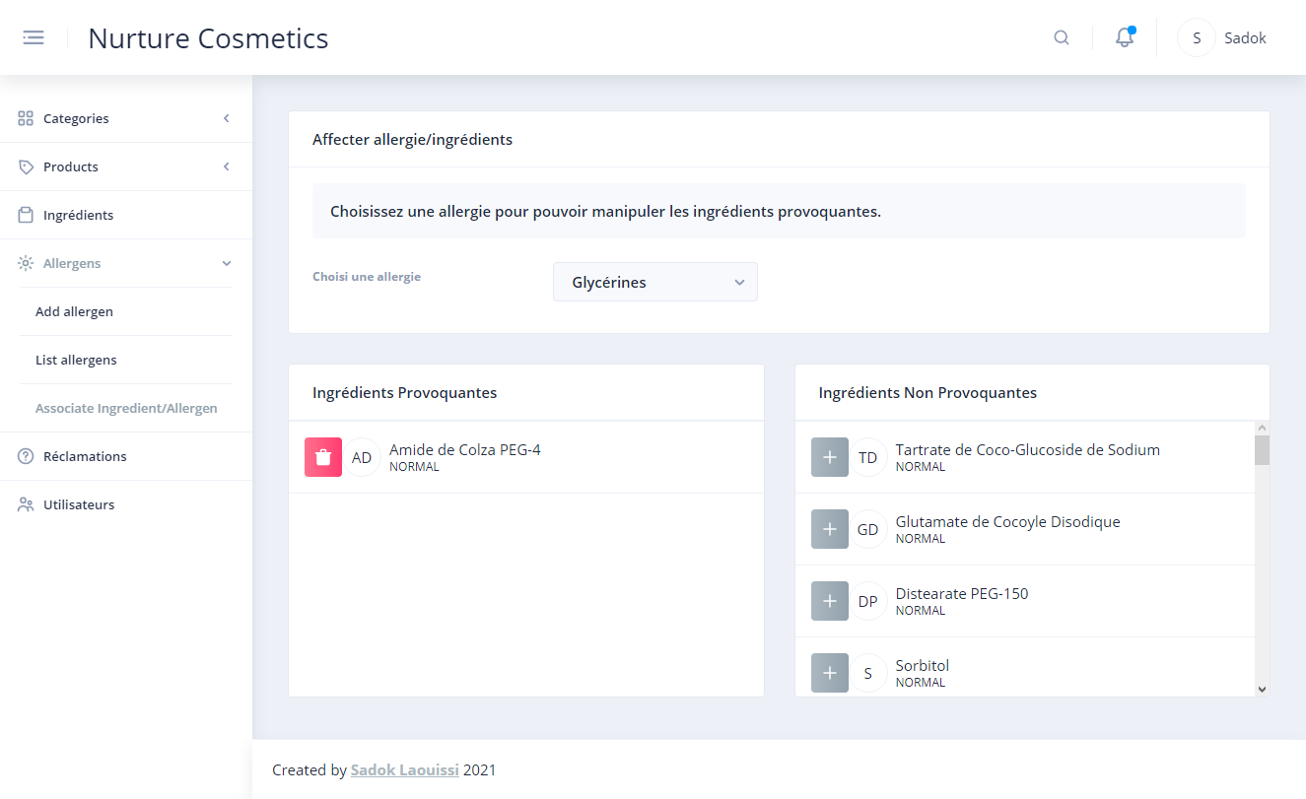

Figure 52: Screen Capture Associate Ingredient/Allergen Interface

#### Use case “Edit Personal Allergen”

##### Textual description

The below table explain the “success” scenario of association an ingredient to an allergen.

|  |  |
| --- | --- |
| Use Case | Edit Personal Allergen |
| Actor | User |
| Pre-condition | The user must be authenticated or new account verified. |
| Post-condition | User’s allergens updated. |
| Nominal Scenario 1  (Case Authenticated) | * The user clicks on “Drawer Icon” button. * The system shows the drawer. * The user clicks on “Parameters” button. * The system shows the Parameters Interface. * The user clicks on “Mon Compte” button. * The system shows the Account Interface. * The user clicks on “Modifier allergens” button. * The system shows Allergen Interface. * The user clicks on “clipboard” icon. * The system shows All Allergen with select box. * The user selects its own allergen. |
| Nominal Scenario 2  (Case Account Verified) | * The system shows All Allergen with select box. * The user selects its own allergen. |

Table 16 : Textual description Edit Personal Allergen

##### Sequence diagram

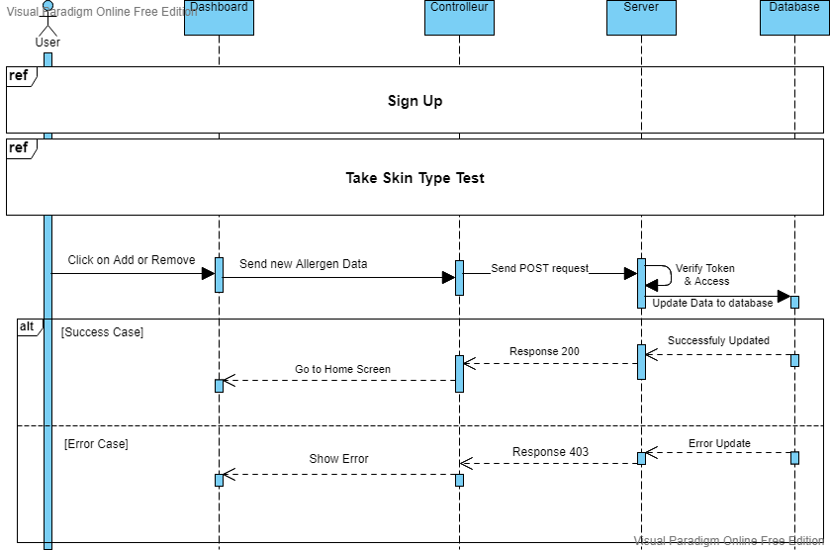

Figure 53: Sequence Diagram Edit Personal Allergen Scenario 2

##### Screen Capture



Figure 54: Personal Allergen Implementation

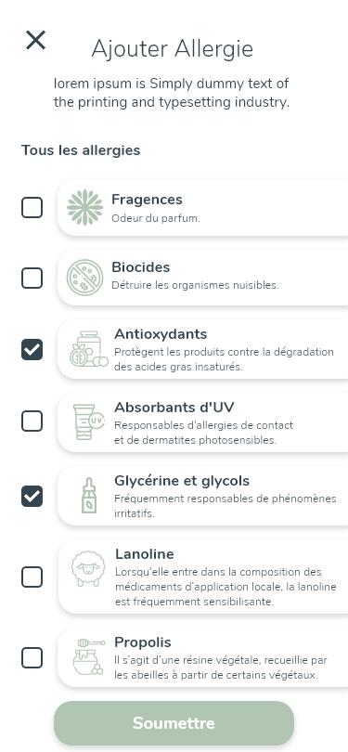

Figure 55: Design Adobe XD: Personal Allergens

## Conclusion

In this sprint, we made it possible to users to edit their personal allergies so they can see which product is convenient for them based on allergens in product’s ingredients. On the next sprint, we are going to implement ingredients management.

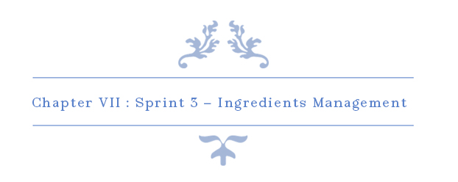

# Chapter VII: Sprint 3 – Ingredients Management

## Introduction

The search by personal allergens is based on ingredients’ allergens so this sprint is important for the rest of the project.

## Sprint Backlog

### Sprint Scope

The main goal of this sprint is to implement the management of the ingredients for the back office and the visualisation for the app users.

### Tasks Planning

|  |  |  |  |  |  |  |  |  |  |  |  |  |
| --- | --- | --- | --- | --- | --- | --- | --- | --- | --- | --- | --- | --- |
|  |  | Day number | | | | | | | | | | |
| User stories# | Tasks | 1 | 2 | 3 | 4 | 5 | 6 | 7 | 8 | 9 | 10 |
| 21 -- 24 | Database design and implementation | 0 | 0 | 0 | 2 | 2 | 0 | 2 | 0 | 0 | 0 |
| API implementation | 6 | 6 | 2 | 2 | 0 | 2 | 4 | 2 | 2 | 0 |
| Persistence development | 0 | 0 | 4 | 2 | 5 | 1 | 2 | 0 | 0 | 0 |
| Front end development | 0 | 0 | 0 | 2 | 2 | 3 | 0 | 4 | 2 | 4 |
| Test | 2 | 2 | 2 | 0 | 1 | 2 | 0 | 2 | 2 | 0 |
| Documentation | 0 | 0 | 0 | 0 | 0 | 0 | 0 | 0 | 2 | 4 |

|  |  |  |  |  |  |  |  |  |  |  |  |  |  |
| --- | --- | --- | --- | --- | --- | --- | --- | --- | --- | --- | --- | --- | --- |
|  |  | Day number | | | | | | | | | | | |
| User stories# | Tasks | 11 | 12 | 13 | 14 | 15 | 16 | 17 | 18 | 19 | 20 | 21 |
| 46 | Database design and implementation | 2 | 0 | 0 | 2 | 0 | 2 | 0 | 0 | 0 | 0 | 0 |
| API implementation | 0 | 2 | 2 | 2 | 6 | 4 | 2 | 2 | 2 | 0 | 0 |
| Persistence development | 5 | 1 | 4 | 2 | 0 | 2 | 0 | 0 | 0 | 0 | 0 |
| Front end development | 2 | 3 | 0 | 2 | 0 | 0 | 4 | 4 | 2 | 4 | 4 |
| Test | 1 | 2 | 2 | 0 | 2 | 0 | 2 | 2 | 2 | 0 | 0 |
| Documentation | 0 | 0 | 0 | 0 | 0 | 0 | 0 | 0 | 2 | 4 | 4 |

Table 17: Tasks Planning - Sprint 3

## Analysis

### Ingredients Management Use Case Refinement

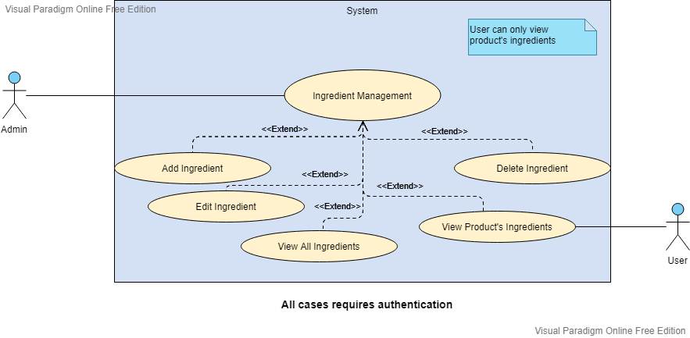

Figure 56 : Ingredients Management Use Case Refinement

#### Use case “View All Ingredients”

##### Textual description

The below table explain the “success” scenario of visualising ingredients.

|  |  |
| --- | --- |
| Use Case | Add Allergen |
| Actor | Admin |
| Pre-condition | The administrator must be authenticated. |
| Nominal Scenario | * The admin clicks on “Ingredients” on the sidebar. * The system shows the desired interface. |

Table 18: Textual description of the use case “View All Ingredients”

##### Screen Capture

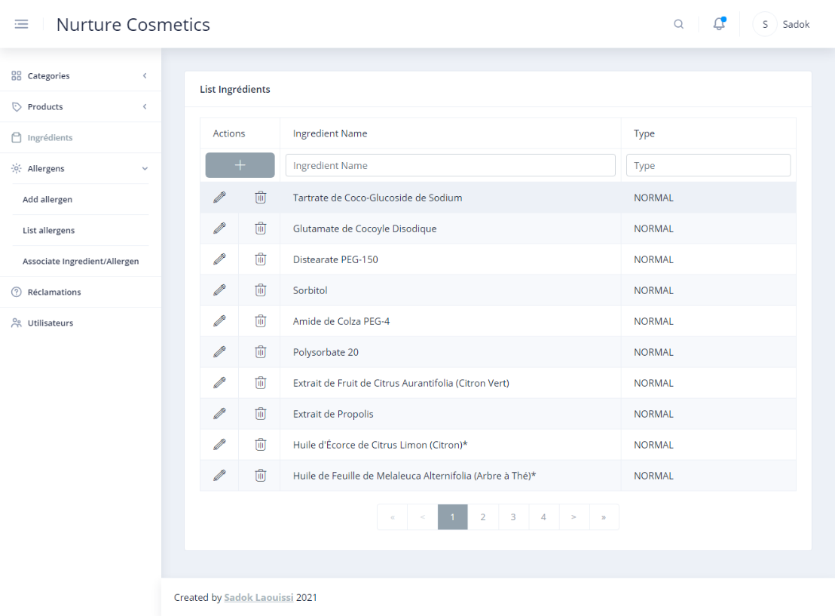

Figure 57: Screen Capture Ingredients Interface

#### Use case “Add Ingredient”

##### Textual description

The below table explain the “success” scenario of adding ingredient.

|  |  |
| --- | --- |
| Use Case | Add Ingredient |
| Actor | Admin |
| Pre-condition | The administrator must be authenticated. |
| Post-condition | New ingredient added. |
| Nominal Scenario | * The admin clicks on “Ingredients” on the sidebar. * The system shows the desired interface. * The admin clicks on plus button. * The system shows a new field data * The user inserts ingredient name and select the type. * The user confirm insert. * The system shows a toast based on result. |

Table 19: Textual description of the use case “Add Ingredient”

##### Sequence diagram

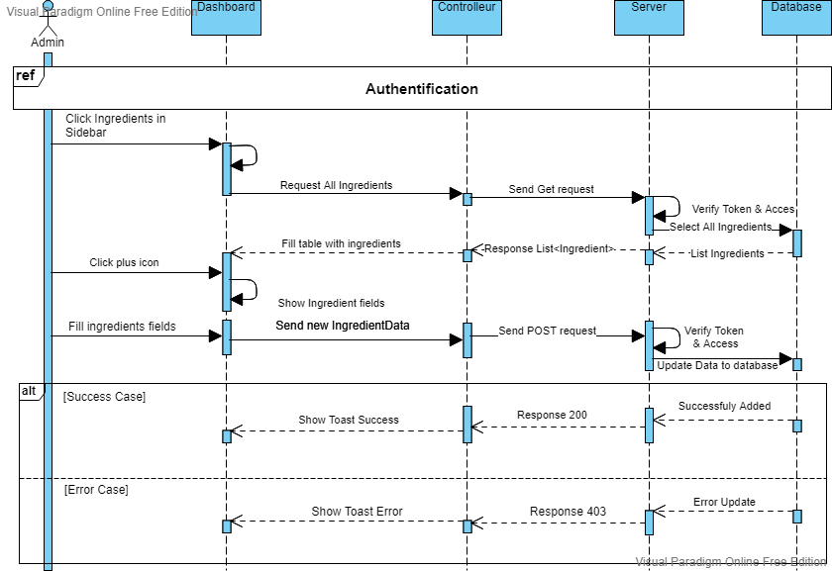

Figure 58: Sequence diagram Add Ingredient

##### Screen Capture

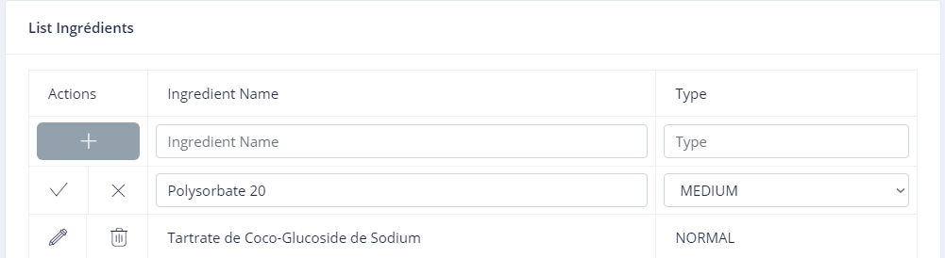

Figure 59: Screen Capture Add Ingredient

#### Use case “Edit Ingredient”

##### Textual description

The below table explain the “success” scenario of editing an ingredient.

|  |  |
| --- | --- |
| Use Case | Edit Ingredient |
| Actor | Admin |
| Pre-condition | The administrator must be authenticated. |
| Post-condition | Ingredient edited. |
| Nominal Scenario | * The admin clicks on “Ingredients” on the sidebar. * The system shows the desired interface. * The admin clicks on pencil icon on desired ingredient. * The system shows a current field data * The user edits ingredient name and select the type. * The user confirms editing. * The system shows a toast based on result. |

Table 20: Textual description of the use case “Edit Ingredient”

##### Screen Capture

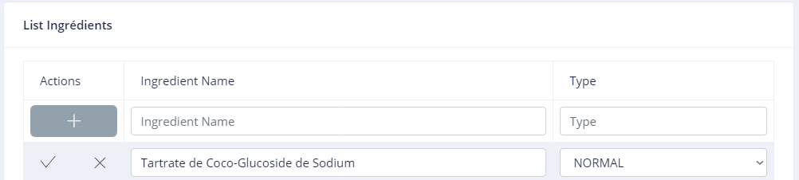

Figure 60: Screen Capture Edit Ingredient

#### Use case “Delete Ingredient”

##### Textual description

The below table explain the “success” scenario of deleting an ingredient.

|  |  |
| --- | --- |
| Use Case | Delete Ingredient |
| Actor | Admin |
| Pre-condition | The administrator must be authenticated. |
| Post-condition | Ingredient deleted. |
| Nominal Scenario | * The admin clicks on “Ingredients” on the sidebar. * The system shows the desired interface. * The admin clicks on trash icon on desired ingredient. * The system shows confirmation popup. * The user confirms delete. * The system shows a toast based on result. |

Table 21: Textual description of the use case “Delete Ingredient”

##### Screen Capture

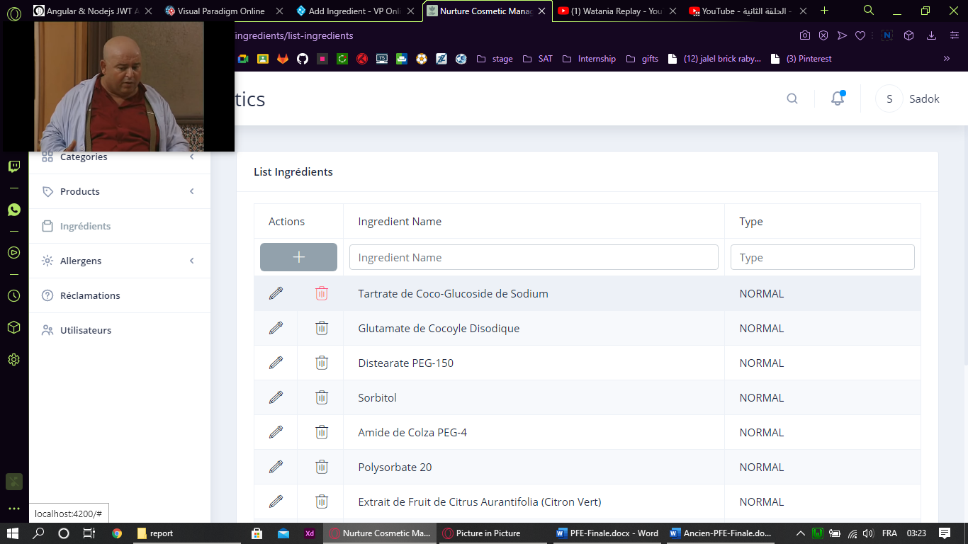

Figure 61: Screen Capture Delete Ingredient

#### Use case “View Product Ingredients”

##### Textual description

The below table explain the “success” scenario of viewing product’s ingredients.

|  |  |
| --- | --- |
| Use Case | View Product Ingredients |
| Actor | User |
| Pre-condition | The user must be authenticated. |
| Nominal Scenario | * The user clicks on desired product. * The system shows product details. * The user swipe left on “Plus Informations”. * The system shows product’s ingredients. |

Table 22: Textual description of the use case “View Product's Ingredients”

##### Screen Captures

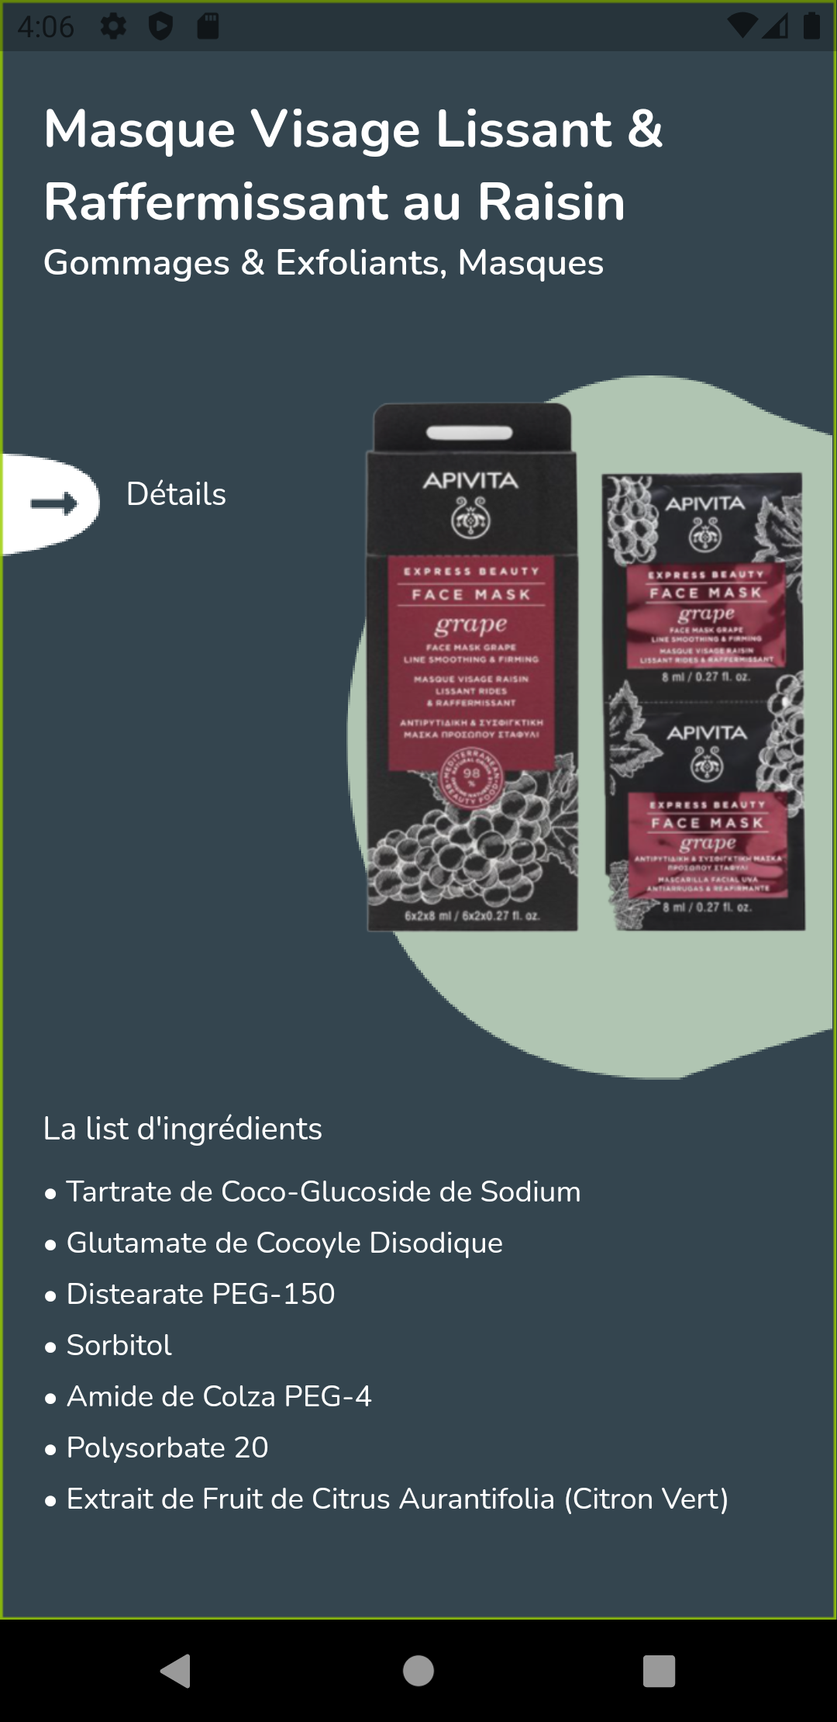

Figure 62: Ingredients Screen Realisation

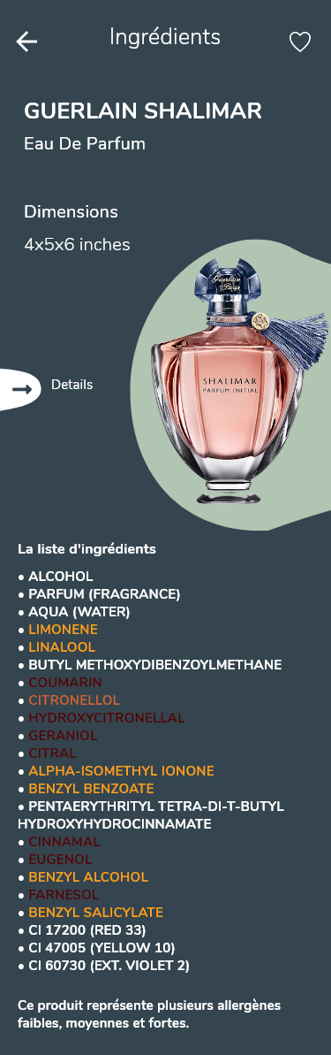

Figure 63: Design Adobe XD Ingredients Screen

## Conclusion

Ingredients management is now done and users will be able to view product’s ingredients. The next sprint we are going to implement user’s services.

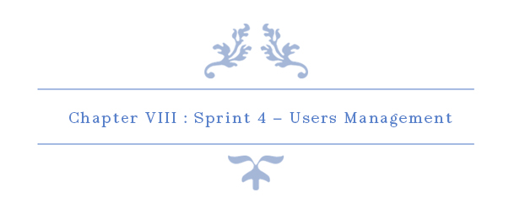

# Chapter VIII: Sprint 4 – Users Management

## Introduction

On this chapter, our main goal is to implement all user’s management functions. This is the most crucial sprint on this project.

## Sprint Backlog

### Sprint Scope

In this sprint, our sprint backlog’s scope is to implements major function such as authenticate and sign up, as well as other functions. By the end of this sprint, Users management should be completed. This sprint backlog has 10 stories for 25 days. There is a detailed descriptive table below to explain the process.

### Tasks Planning

|  |  |  |  |  |  |  |  |  |  |  |  |  |  |  |
| --- | --- | --- | --- | --- | --- | --- | --- | --- | --- | --- | --- | --- | --- | --- |
|  |  | Day number | | | | | | | | | | | | |
| User stories# | Tasks | 1 | 2 | 3 | 4 | 5 | 6 | 7 | 8 | 9 | 10 | 11 | 12 |
| 1  &  2  &  9 | Database design and implementation | 0 | 0 | 0 | 2 | 2 | 0 | 2 | 0 | 0 | 0 | 1 | 0 |
| API implementation | 3 | 4 | 2 | 2 | 0 | 2 | 4 | 2 | 2 | 0 | 0 | 0 |
| Persistence development | 5 | 0 | 4 | 2 | 5 | 1 | 2 | 0 | 0 | 0 | 1 | 0 |
| Front end development | 0 | 0 | 0 | 2 | 2 | 3 | 0 | 4 | 2 | 4 | 3 | 4 |
| Test | 0 | 4 | 2 | 0 | 1 | 2 | 0 | 2 | 2 | 0 | 0 | 0 |
| Documentation | 0 | 0 | 0 | 0 | 0 | 0 | 0 | 0 | 2 | 4 | 3 | 4 |

|  |  |  |  |  |  |  |  |  |  |  |  |  |  |  |  |
| --- | --- | --- | --- | --- | --- | --- | --- | --- | --- | --- | --- | --- | --- | --- | --- |
|  |  | Day number | | | | | | | | | | | | | |
| User stories# | Tasks | 13 | 14 | 15 | 16 | 17 | 18 | 19 | 20 | 21 | 22 | 23 | 24 | 25 |
| 25—28  &  30—32 | Database design and implementation | 2 | 0 | 0 | 4 | 0 | 7 | 0 | 1 | 0 | 0 | 0 | 0 | 0 |
| API implementation | 0 | 0 | 0 | 2 | 6 | 0 | 2 | 6 | 2 | 0 | 3 | 7 | 0 |
| Persistence development | 5 | 0 | 2 | 0 | 0 | 0 | 0 | 1 | 0 | 0 | 0 | 0 | 1 |
| Front end development | 2 | 4 | 4 | 0 | 0 | 0 | 4 | 0 | 2 | 4 | 4 | 1 | 5 |
| Test | 1 | 0 | 2 | 2 | 2 | 1 | 2 | 0 | 2 | 0 | 1 | 0 | 0 |
| Documentation | 0 | 4 | 0 | 0 | 0 | 0 | 0 | 0 | 2 | 4 | 0 | 0 | 2 |

Table 23: Tasks Planning - Sprint 4

## Analysis

### Users Management Use Case Refinement

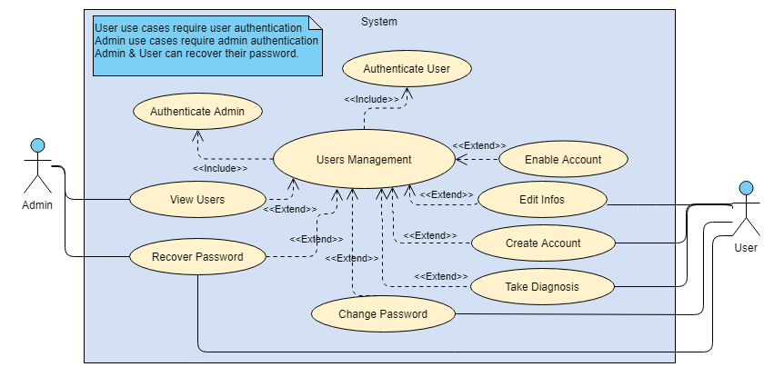

Figure 64: Users Management Use Case Refinement

#### Use Case “Authenticate User”

##### Activity Diagram

Activity diagram is another important diagram in UML to describe the dynamic aspects of the system.

Activity diagram is basically a flowchart to represent the flow from one activity to another activity. The activity can be described as an operation of the system.

The control flow is drawn from one operation to another. This flow can be sequential, branched, or concurrent. Activity diagrams deal with all type of flow control by using different elements such as fork, join, etc (tutorialspoint, s.d.)

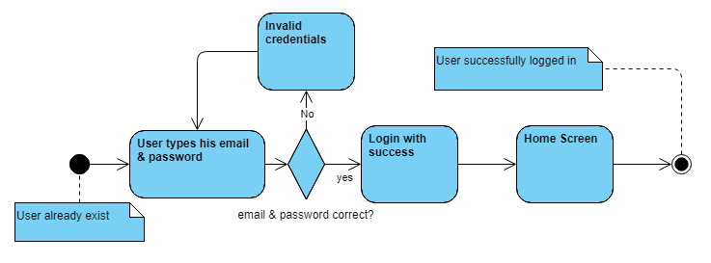

Figure 65: Authentication Activity Diagram

##### Sequence Diagram

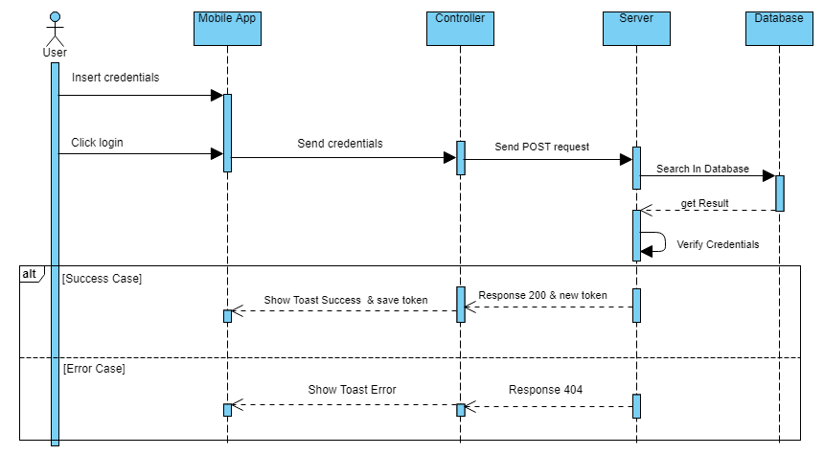

Figure 66: User Authentication Sequence Diagram

##### Screen Capture



Figure 67: Splash Screen Adobe XD

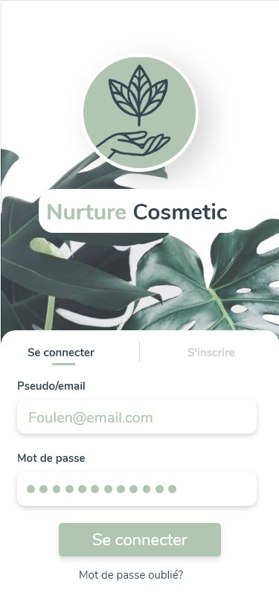

Figure 68: Login Screen Adobe XD

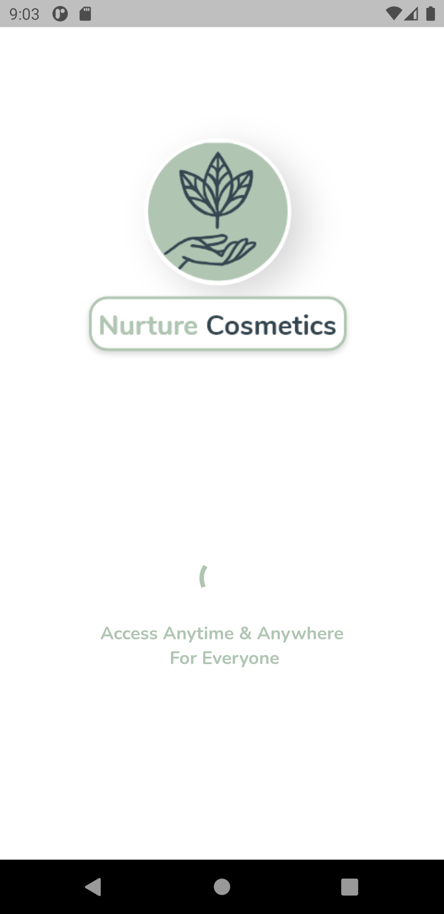

Figure 69: Splash Screen Realisation

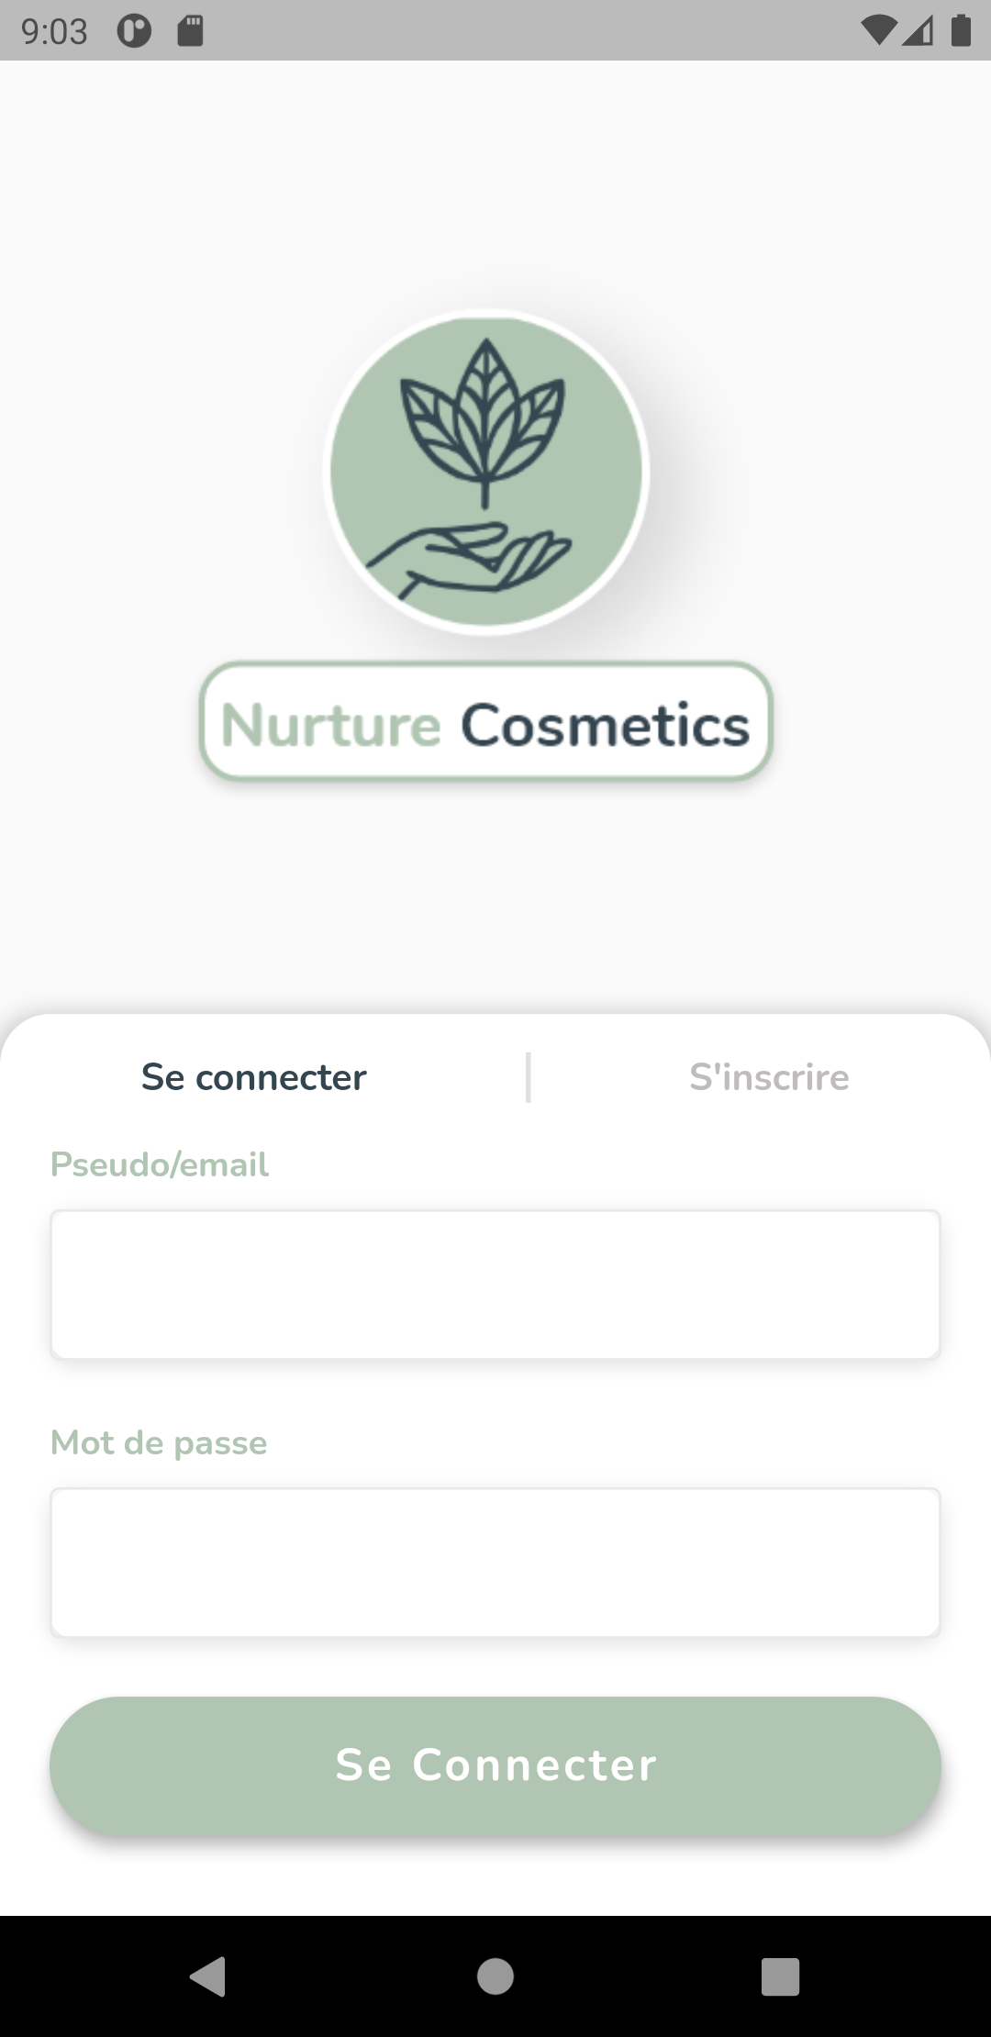

Figure 70: Login Screen Implementation

#### Use Case “Authenticate Admin”

##### Sequence Diagram

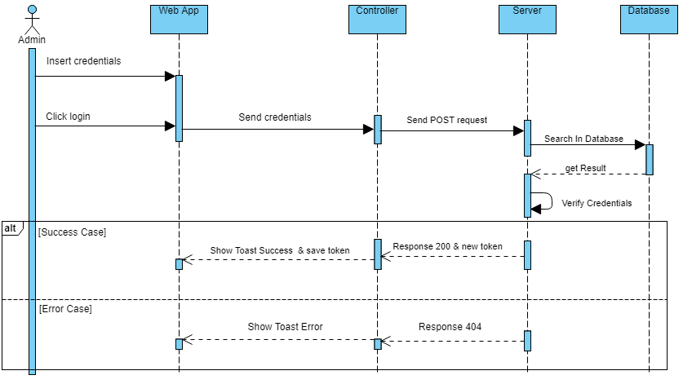

Figure 71: Sequence Diagram Authenticate Admin

##### Screen Capture

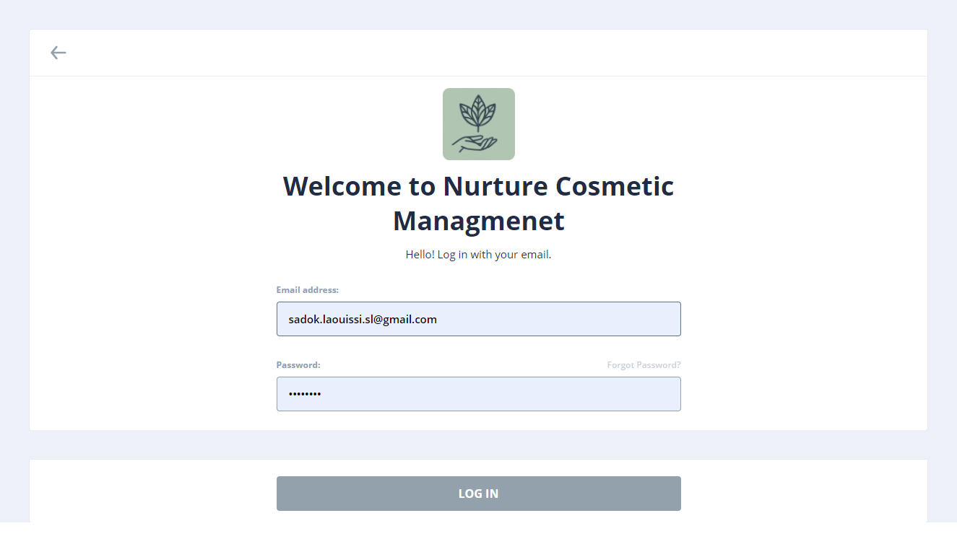

Figure 72: Login Web Realisation

#### Use Case “Create Account”

##### Textual description

The below table explain the “success” scenario of creating a new account.

|  |  |
| --- | --- |
| Use Case | Create Account |
| Actor | User |
| Post-condition | New invalid account created. |
| Nominal Scenario | * The user clicks on “Sign Up” on login screen. * The system shows the desired interface. * The user fills the form and confirm. * The system creates a new account and move to the next step. |

Table 24: Textual description of the use case “Create Account”

##### Sequence Diagram

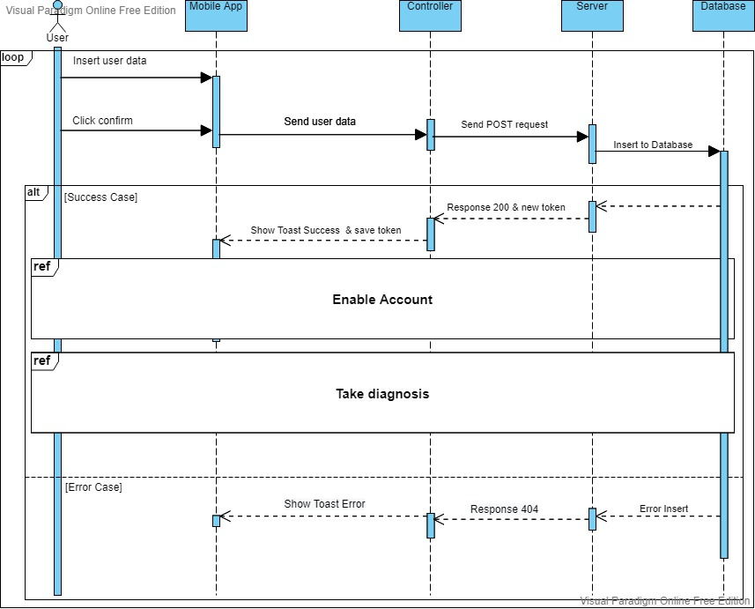

Figure 73: Sequence Diagram Create Account

##### Activity Diagram

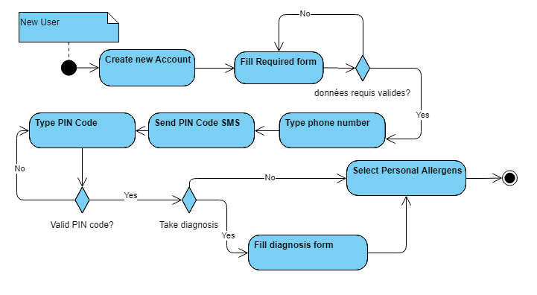

Figure 74: Activity Diagram Create Account Scenario

##### State Transition Diagram

A state-transition diagram presents a sequence of states that an object goes through during its lifecycle. It is used to describe the changes of states for an object or for a component.

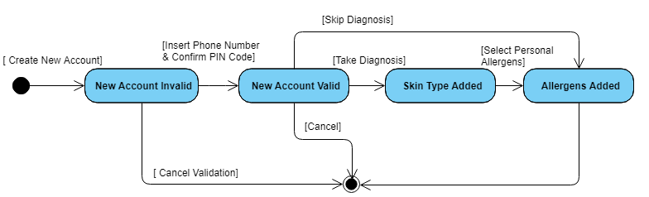

Figure 75: State Transition Diagram Account

##### Screen Capture

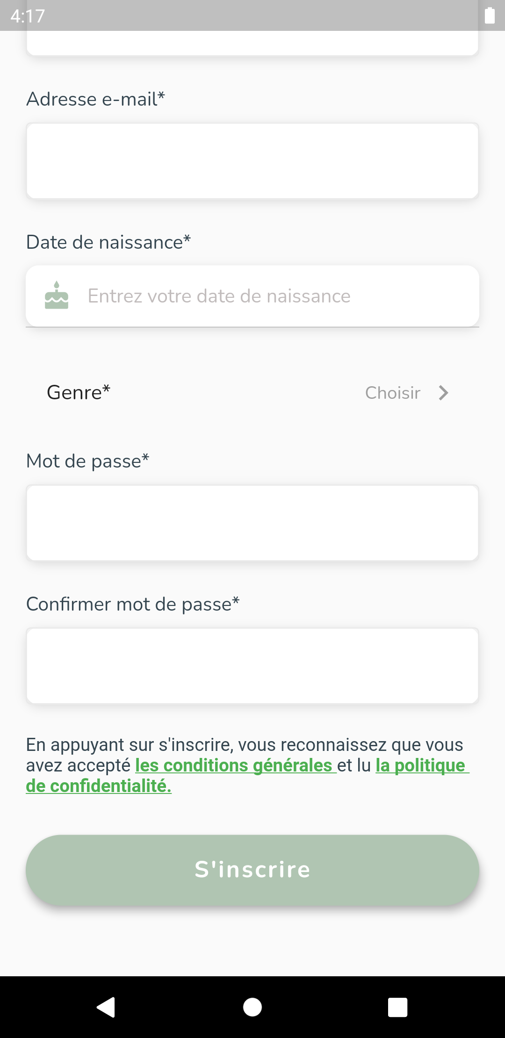

Figure 76: Create Account Realisation Part 2

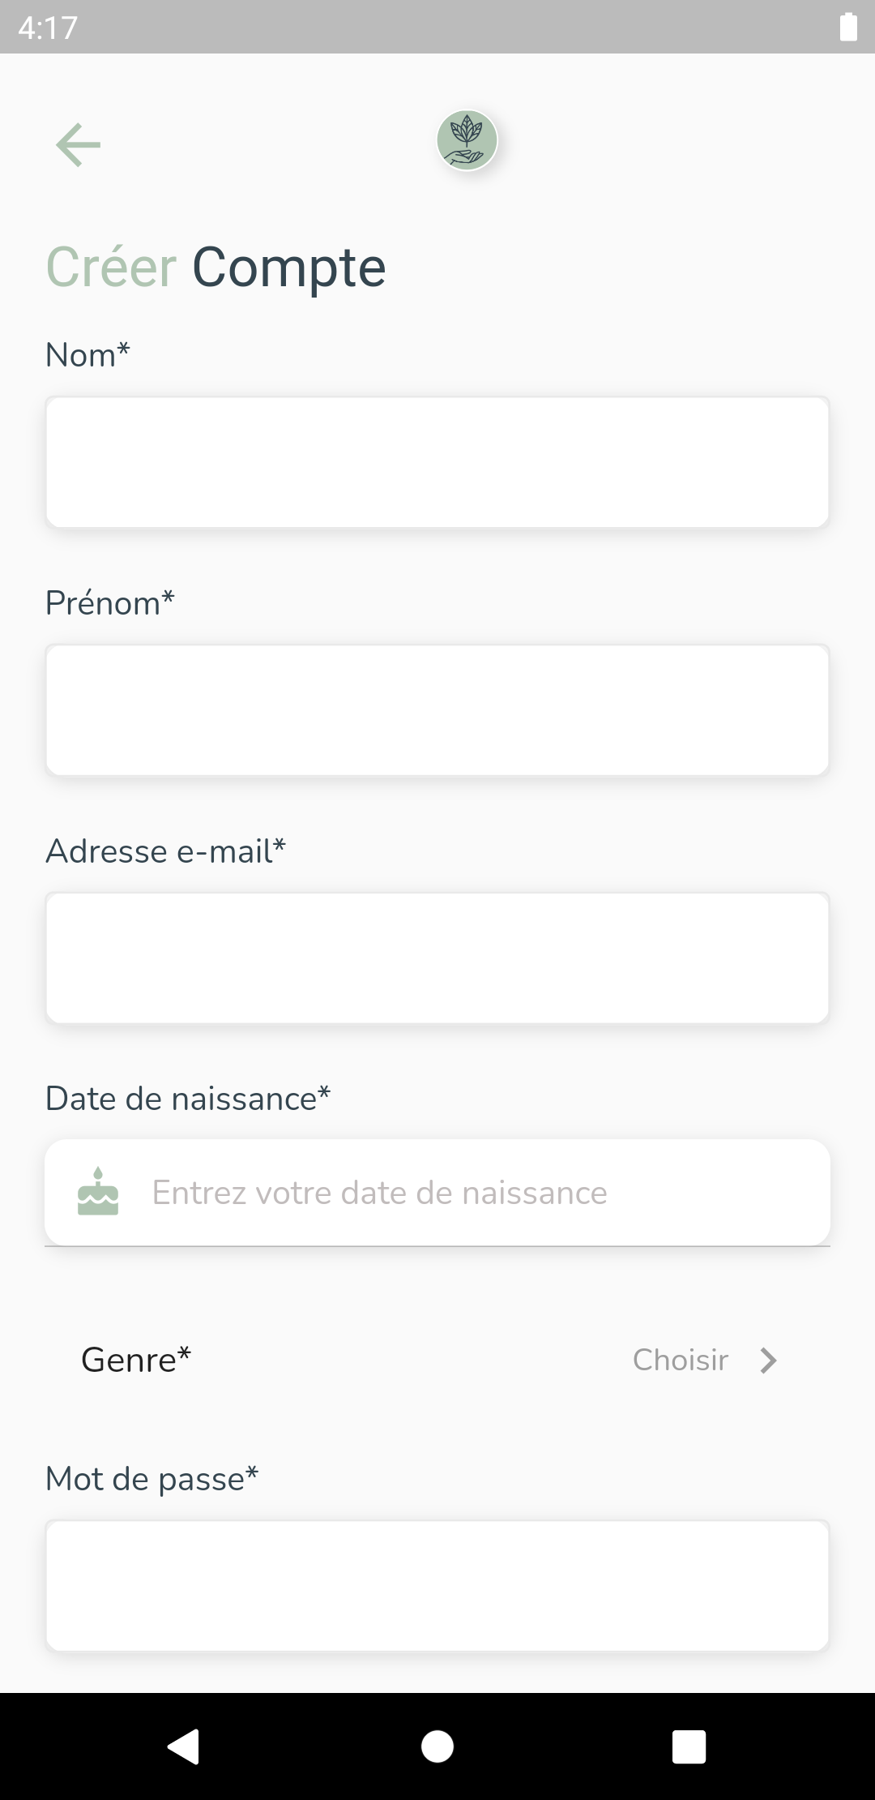

Figure 77: Create Account Realisation Part 1

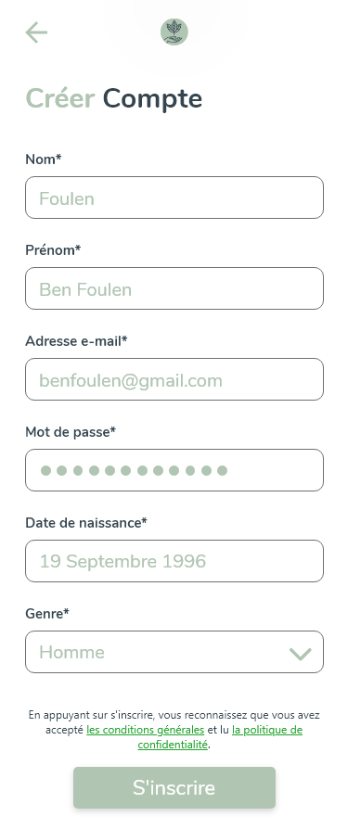

Figure 78: Create Account Screen Adobe XD

#### Use Case “Enable Account”

##### Textual description

The below table explain the “success” scenario of enabling an account.

|  |  |
| --- | --- |
| Use Case | Enable Account |
| Actor | User |
| Pre-condition | Invalidated new account. |
| Post-condition | Valid account. |
| Nominal Scenario | * The system shows the phone number screen. * The user inserts his phone number. * The system shows the PIN Code interface and send the PIN Code to user’s phone inserted. * The user inserts the PIN Code. |

Table 25: Textual description of the use case “Enable Account”

##### Sequence Diagram

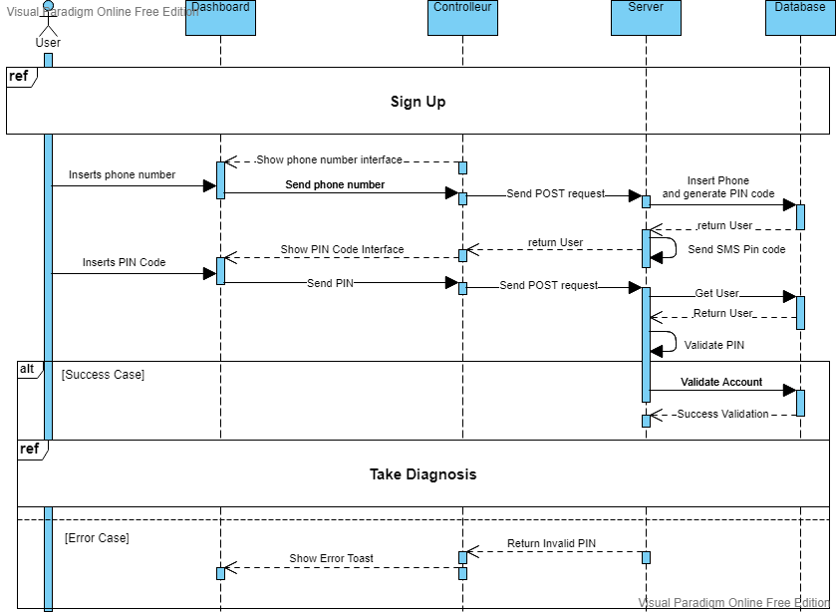

Figure 79: Sequence Diagram Enable Account

##### Screen Capture

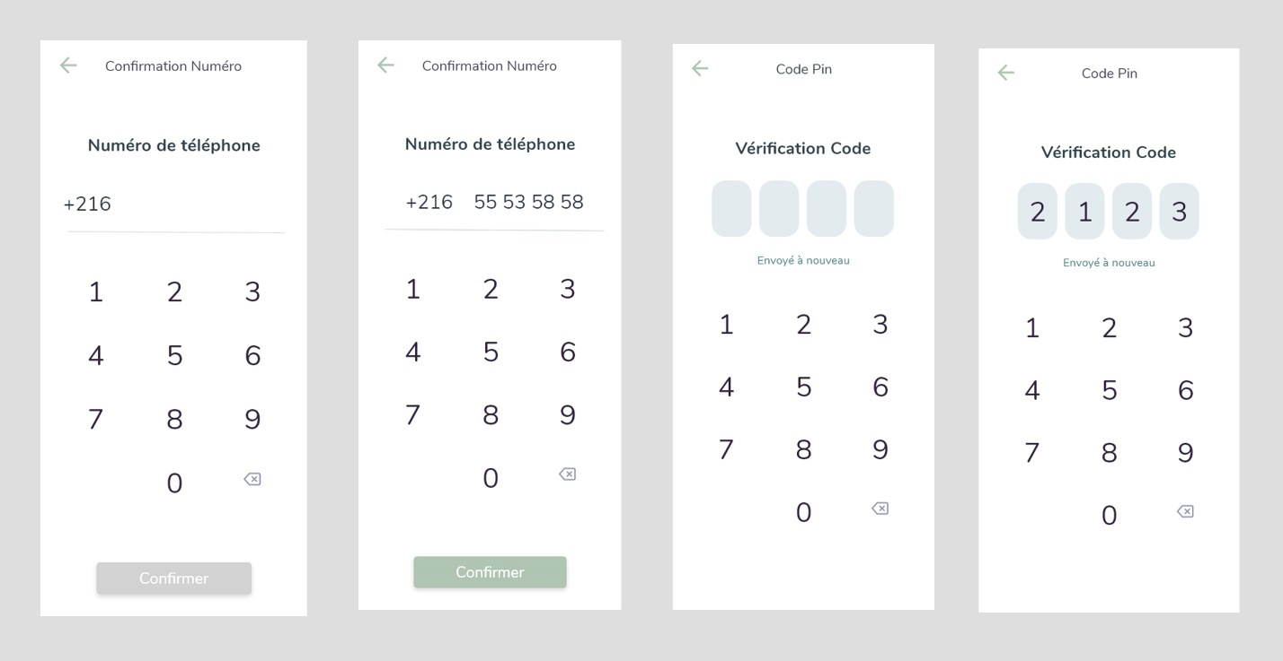

Figure 80: Enable Account Story XD Design

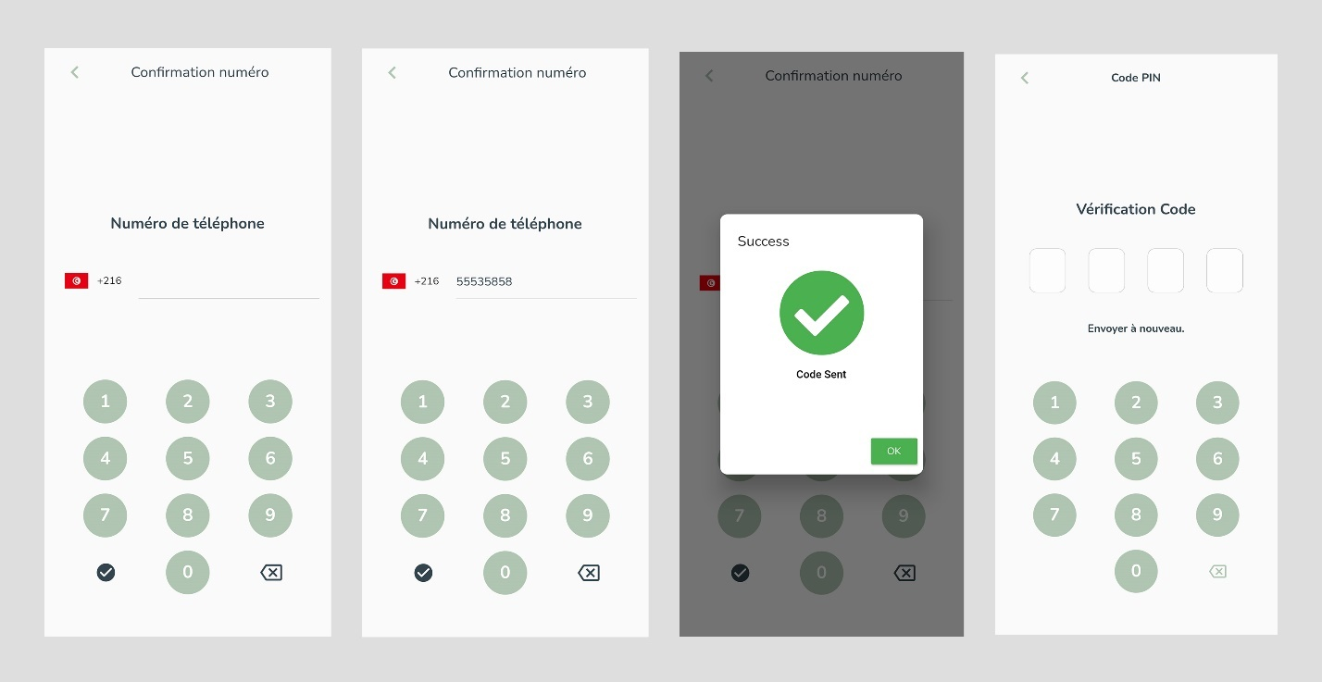

Figure 81: Enable Account Realisation

#### Use Case “Edit Info”

##### Textual description

The below table explain the “success” scenario of editing account info.

|  |  |
| --- | --- |
| Use Case | Edit Info |
| Actor | User |
| Post-condition | User data edited. |
| Nominal Scenario | * The user open drawer. * The system shows drawer. * The user selects “Parameters”. * The system shows drawer. * The user selects “Mon Compte”. * The system shows Account options. * The user selects “Modifier Profile”. * The system shows Edit profile interface. * The user update data and confirms. |

Table 26: Textual description of the use case “Edit Info”

##### Screen Capture

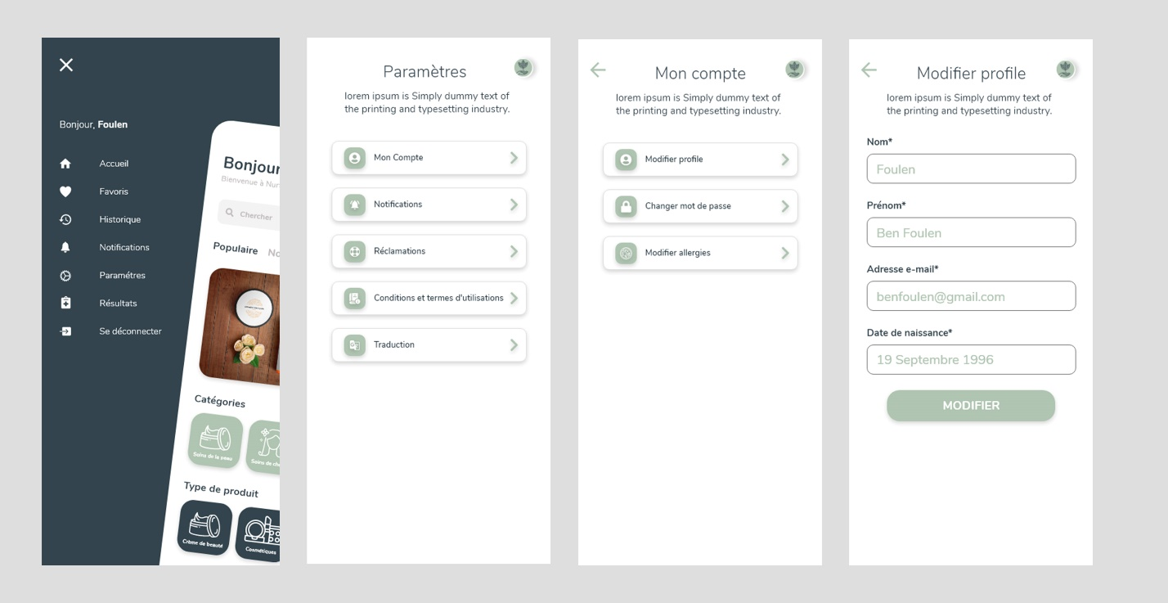

Figure 82: Edit Info Design Adobe XD

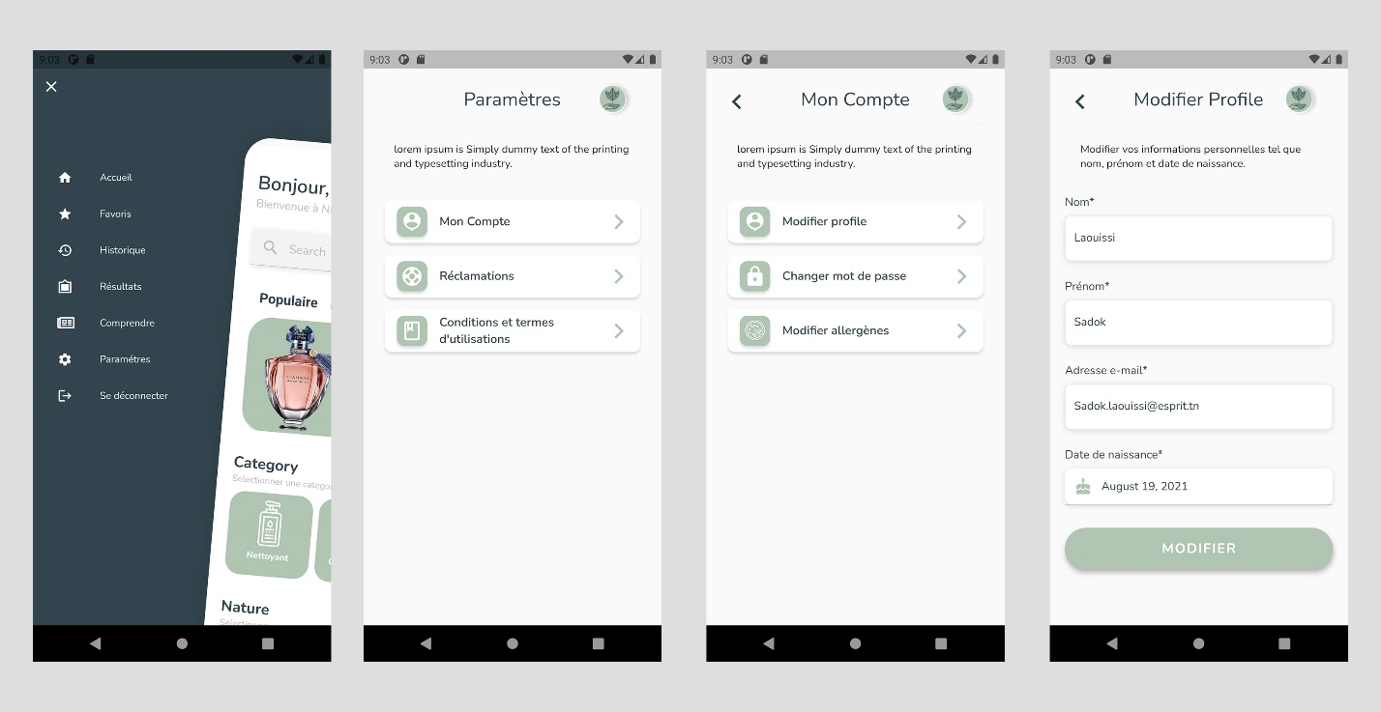

Figure 83: Edit Info Scenario Realisation

#### Use Case “List Users”

##### Textual description

The below table explain the “success” scenario of Listing users.

|  |  |
| --- | --- |
| Use Case | List Users |
| Actor | Admin |
| Pre-condition | The administrator must be authenticated. |
| Nominal Scenario | * The admin clicks on “Users” on the sidebar. * The system shows the desired interface. |

Table 27: Textual description of the use case “List Users”

##### Screen Capture

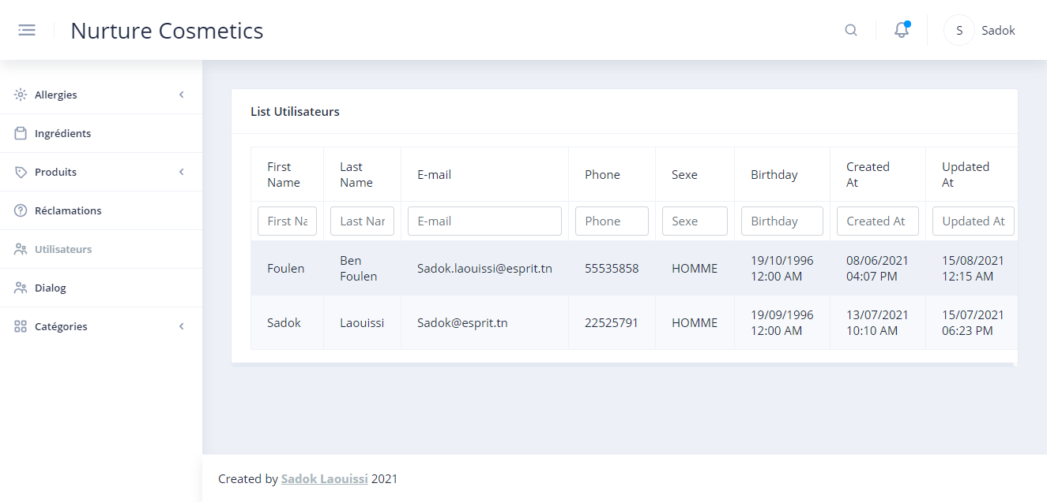

Figure 84: List Users Realisation

#### Use Case “Change Password”

##### Textual description

The below table explain the “success” scenario of Listing users.

|  |  |
| --- | --- |
| Use Case | Change Password |
| Actor | User |
| Post-condition | User password edited. |
| Nominal Scenario | * The user open drawer. * The system shows drawer. * The user selects “Parameters”. * The system shows drawer. * The user selects “Mon Compte”. * The system shows Account options. * The user selects “Changer mot de passe”. * The system shows Change Password interface. * The user update data and confirms. |

Table 28: Textual description of the use case “Change Password”

##### Screen Capture

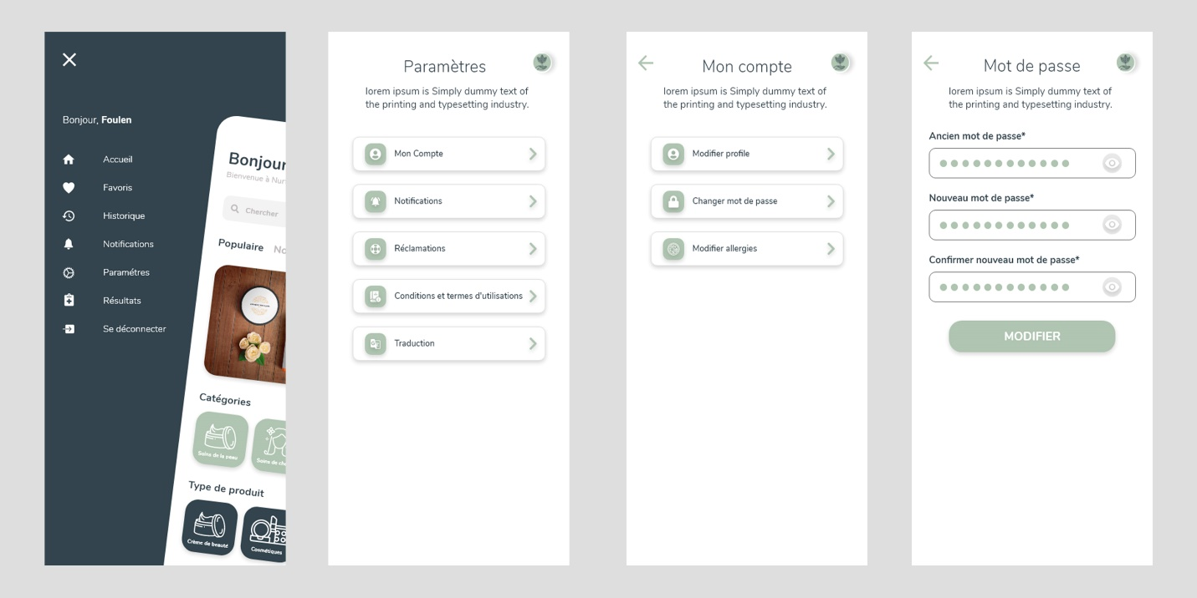

Figure 85: Change Password Scenario Design XD

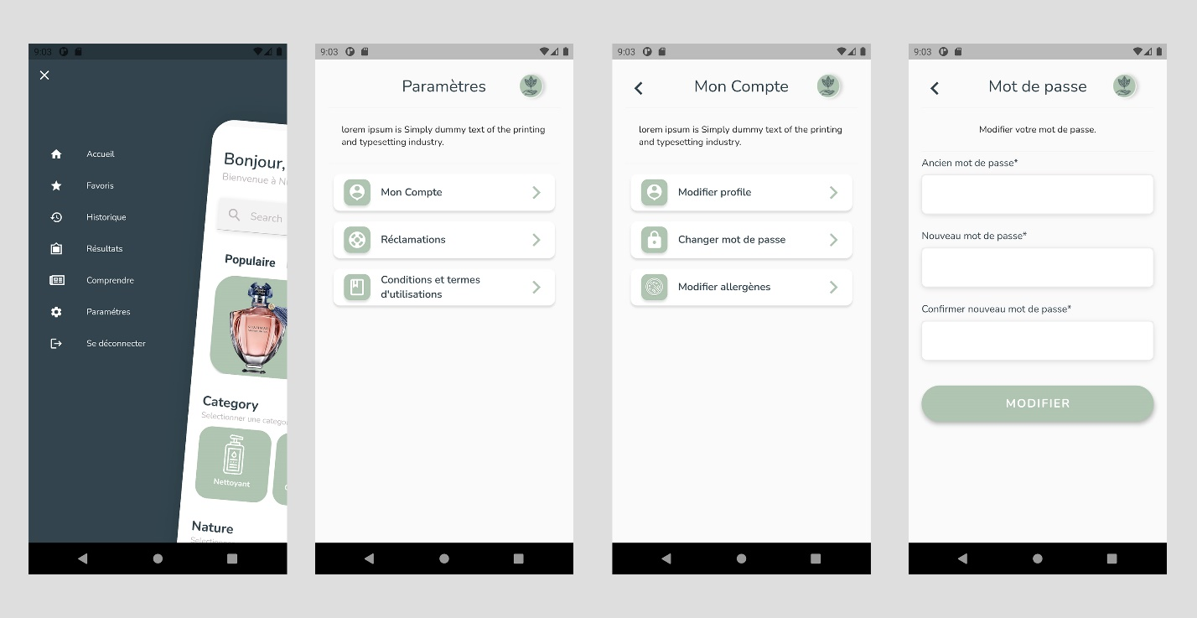

Figure 86: Change Password Scenario Realisation

#### Use Case “Recover Password Admin”

##### Textual description

The below table explain the “success” scenario of recovering password.

|  |  |
| --- | --- |
| Use Case | Recover Password Admin |
| Actor | Admin |
| Post-condition | Admin password edited. |
| Nominal Scenario | * The user clicks on “Forget Password”. * The system shows Recover Password Screen. * The user fills email. * The system checks admin with email and send pin code. * The system shows Pin Password Screen. * The user inserts the pin code. * The system checks pin code inserted and redirect to New Password Screen. * The user update password and confirms. |

Table 29: Textual description of the use case “Recover Password Admin”

##### Screen Capture

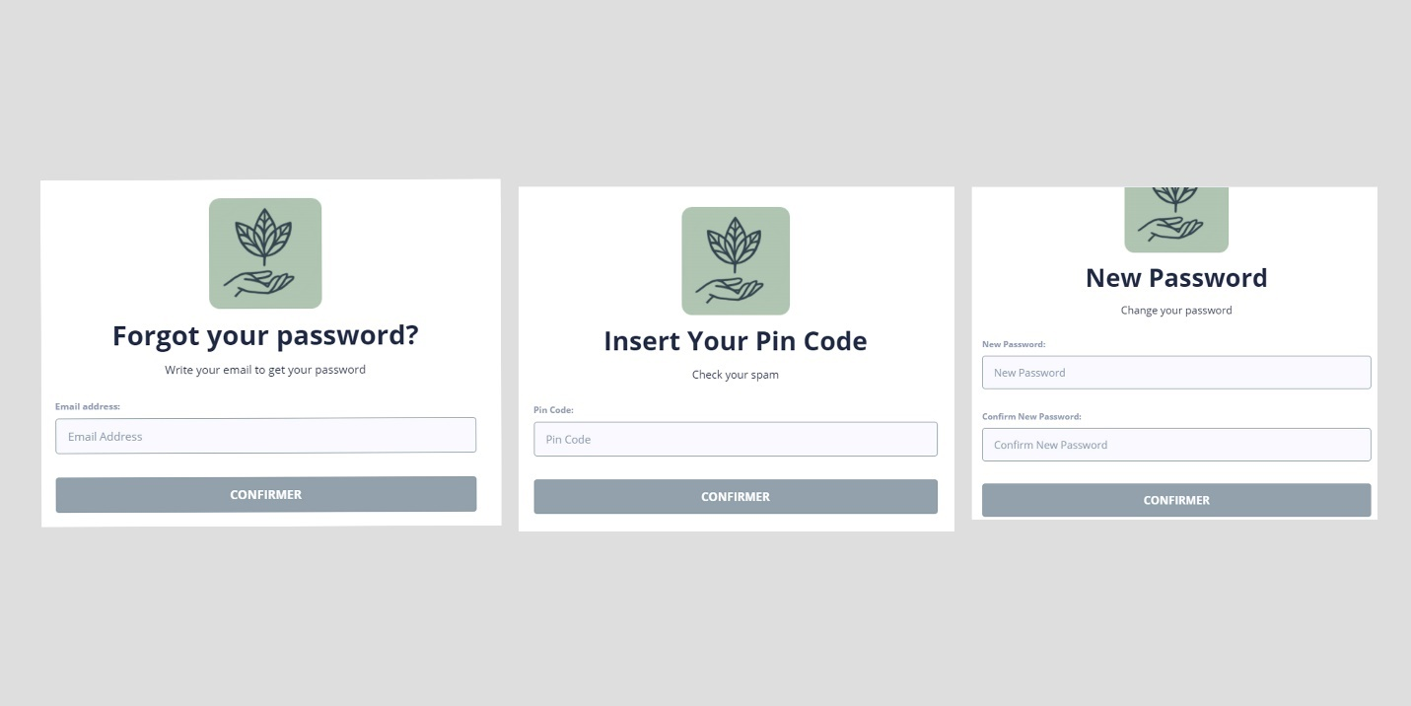

Figure 87: New Password Admin Realisation

#### Use Case “Take Diagnosis”

##### Textual description

The below table explain the “success” scenario of taking skin type test.

|  |  |
| --- | --- |
| Use Case | Take Diagnosis |
| Actor | User |
| Pre-condition | Valid Account. |
| Post-condition | User skin type updated. |
| Nominal Scenario | * The user clicks on “Take Test”. * The system shows Take Test Form. * The user fills information. * The system shows test result. |

Table 30: Textual description of the use case “Take Diagnosis”

##### Screen Capture

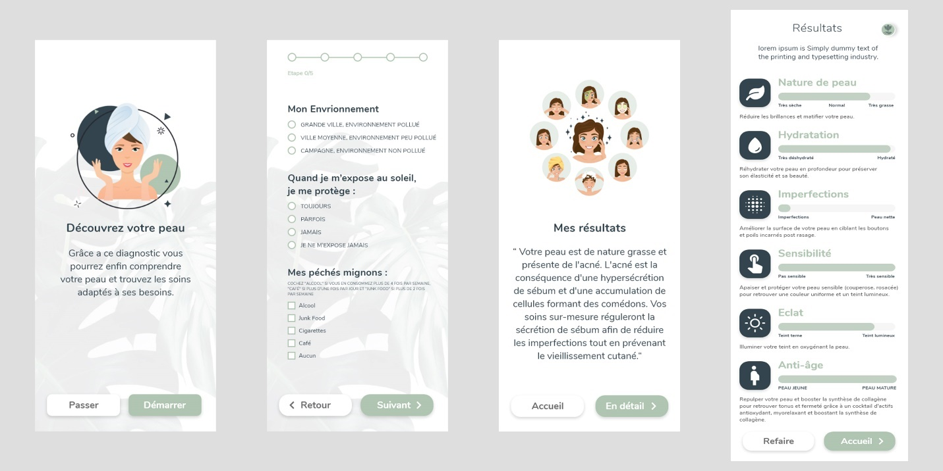

Figure 88: Take Diagnosis Scenario Adobe XD

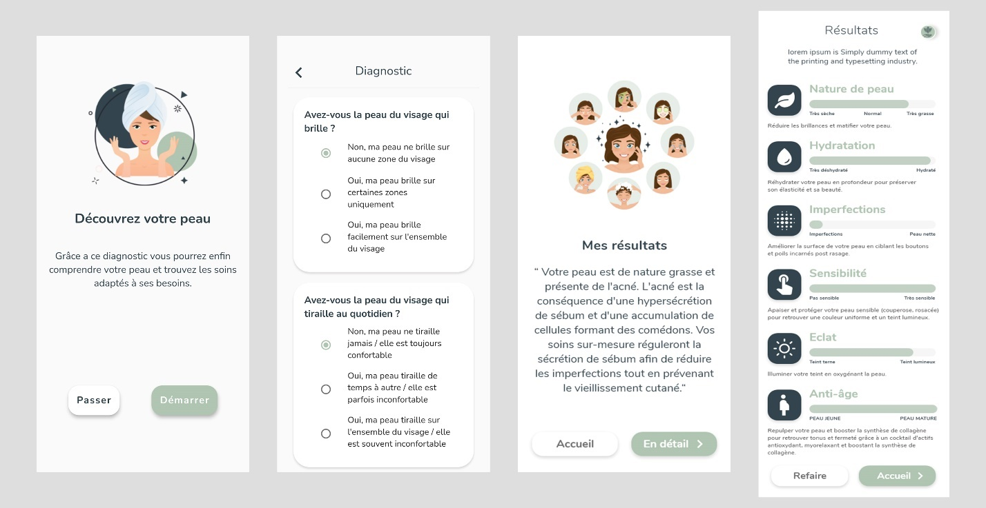

Figure 89: Take Diagnosis Scenario Realisation

## Conclusion

In this chapter, I managed to create a system that allows users to create, secure and access their accounts as well as to estimate their skin type based on a form which will be used to suggest products.

In the next chapter, I am going to implements products services.

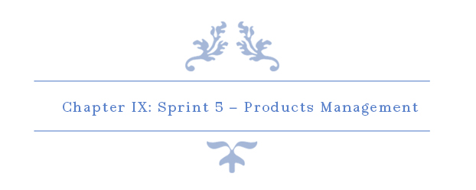

# Chapter IX: Sprint 5 – Products Management

## Introduction

The goal of this chapter is to facilitate the management of products for admin and also to allow users to view inserted products.

## Sprint Backlog

### Sprint Scope

The main purpose of this sprint is to implement a system that allows admins to add, edit, and delete products… which will be shown in the user app. The app user can view search and filter products. This sprint has 11 tasks in 25 days.

### Tasks Planning

|  |  |  |  |  |  |  |  |  |  |  |  |  |  |  |
| --- | --- | --- | --- | --- | --- | --- | --- | --- | --- | --- | --- | --- | --- | --- |
|  |  | Day number | | | | | | | | | | | | |
| User stories# | Tasks | 1 | 2 | 3 | 4 | 5 | 6 | 7 | 8 | 9 | 10 | 11 | 12 |
| 15 —20 | Database design and implementation | 0 | 0 | 0 | 2 | 2 | 0 | 2 | 0 | 0 | 0 | 1 | 0 |
| API implementation | 3 | 4 | 2 | 2 | 0 | 2 | 4 | 2 | 2 | 0 | 0 | 0 |
| Persistence development | 5 | 0 | 4 | 2 | 5 | 1 | 2 | 0 | 0 | 0 | 1 | 0 |
| Front end development | 0 | 0 | 0 | 2 | 2 | 3 | 0 | 4 | 2 | 4 | 3 | 4 |
| Test | 0 | 4 | 2 | 0 | 1 | 2 | 0 | 2 | 2 | 0 | 0 | 0 |
| Documentation | 0 | 0 | 0 | 0 | 0 | 0 | 0 | 0 | 2 | 4 | 3 | 4 |

|  |  |  |  |  |  |  |  |  |  |  |  |  |  |  |  |
| --- | --- | --- | --- | --- | --- | --- | --- | --- | --- | --- | --- | --- | --- | --- | --- |
|  |  | Day number | | | | | | | | | | | | | |
| User stories# | Tasks | 13 | 14 | 15 | 16 | 17 | 18 | 19 | 20 | 21 | 22 | 23 | 24 | 25 |
| 41—45 | Database design and implementation | 2 | 0 | 0 | 4 | 0 | 7 | 0 | 1 | 0 | 0 | 0 | 0 | 0 |
| API implementation | 0 | 0 | 0 | 2 | 6 | 0 | 2 | 6 | 2 | 0 | 3 | 7 | 0 |
| Persistence development | 5 | 0 | 2 | 0 | 0 | 0 | 0 | 1 | 0 | 0 | 0 | 0 | 1 |
| Front end development | 2 | 4 | 4 | 0 | 0 | 0 | 4 | 0 | 2 | 4 | 4 | 1 | 5 |
| Test | 1 | 0 | 2 | 2 | 2 | 1 | 2 | 0 | 2 | 0 | 1 | 0 | 0 |
| Documentation | 0 | 4 | 0 | 0 | 0 | 0 | 0 | 0 | 2 | 4 | 0 | 0 | 2 |

Table 31: Tasks Planning - Sprint 5

## Analysis

### Products Management Use Case Refinement

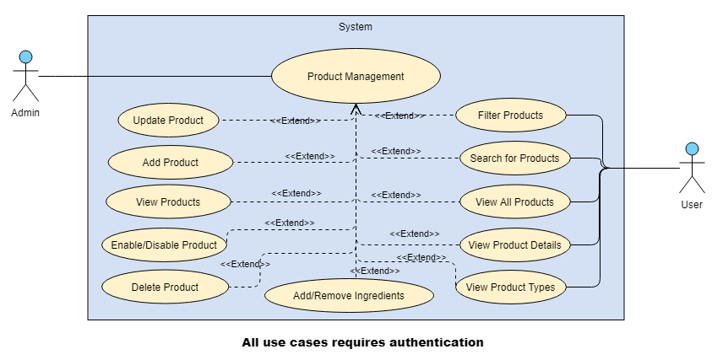

Figure 90: Products Management Use Case Refinement

#### Use Case “Add product”

##### Textual description

The below table explain the “success” scenario of creating a new product.

|  |  |
| --- | --- |
| Use Case | Add product |
| Actor | Admin |
| Post-condition | New product added. |
| Nominal Scenario | * The admin clicks on “Products” dropdown on the sidebar. * The system shows dropdown list. * The admin clicks on “Add Product” dropdown on the sidebar. * The system shows the desired interface. * The admin fills the general form and submit. * The system redirects to the next step. * The admin fills the specification form and submit. * The system redirects to the next step. * The admin fills the description form and submit. * The system redirects to the next step. * The admin insert image and submit. * The system inserts product and redirect to the next step. * (Optional) the user inserts new products or add inserted product’s ingredients |

Table 32: Textual description of the use case “Add Product”

##### Screen Capture

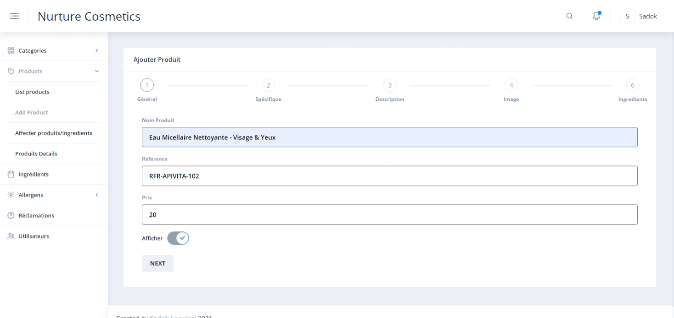

Figure 91: Add Product Step 1

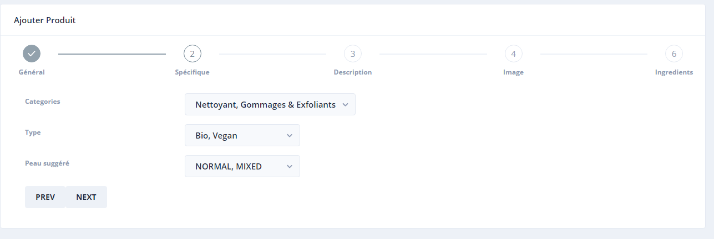

Figure 92: Add Product Step 2

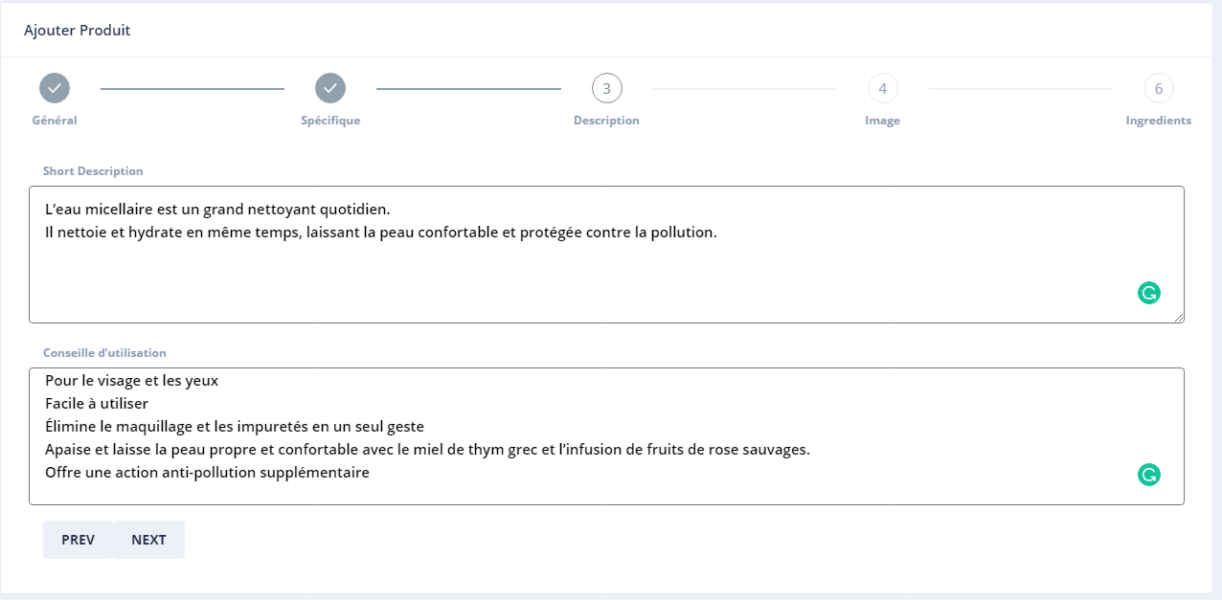

Figure 93: Add Product Step 3

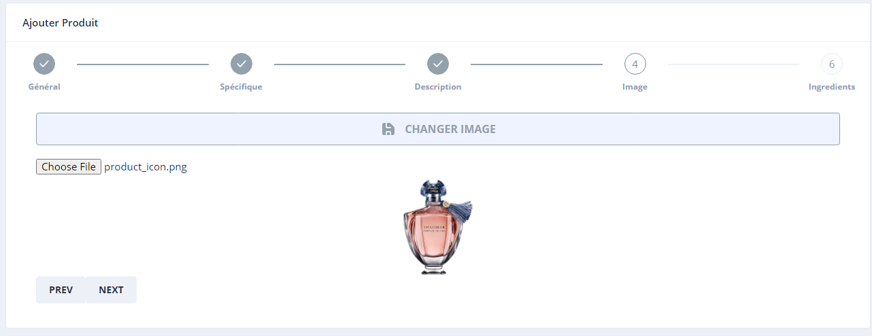

Figure 94: Add Product Step 4

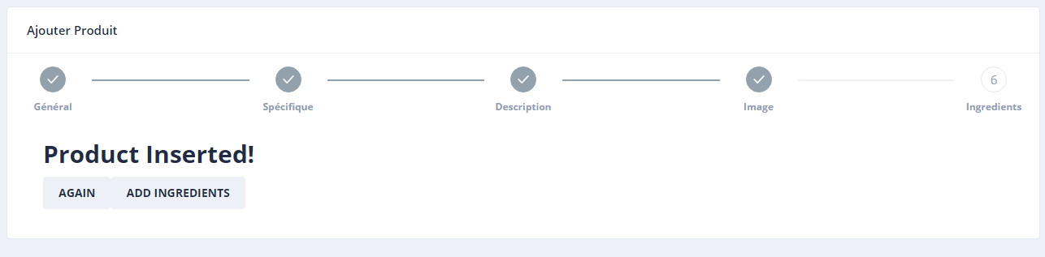

Figure 95: Add Product Step 5

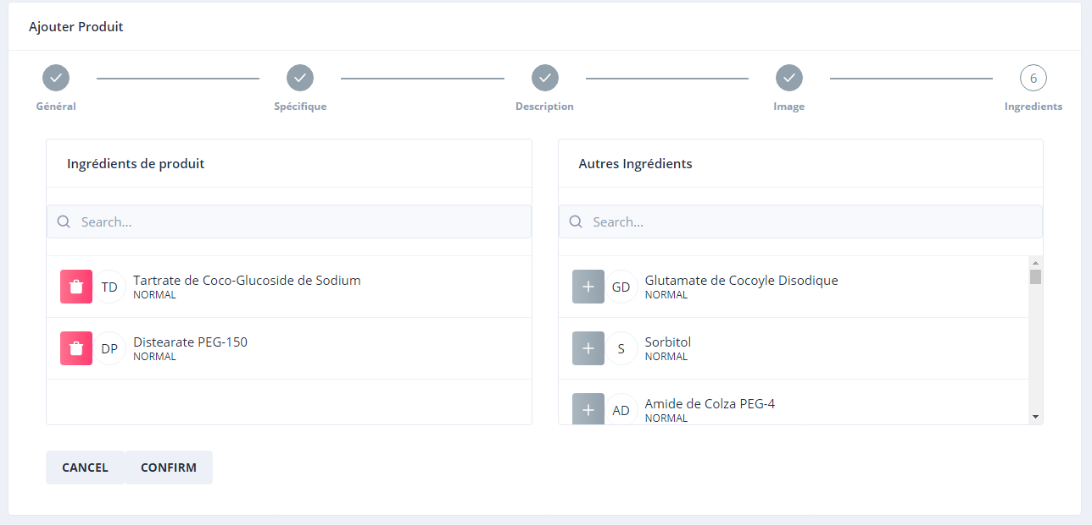

Figure 96: Add Product Step 6 (Optional)

#### Use Case “View Products (Admin)”

##### Textual description

The below table explain the “success” scenario of creating a new product.

|  |  |
| --- | --- |
| Use Case | View Products (Admin) |
| Actor | Admin |
| Nominal Scenario | * The admin clicks on “Products” dropdown on the sidebar. * The system shows dropdown list. * The admin clicks on “List Product” dropdown on the sidebar. * The system shows the desired interface. |

Table 33: Textual description of the use case “List Products”

##### Screen Capture

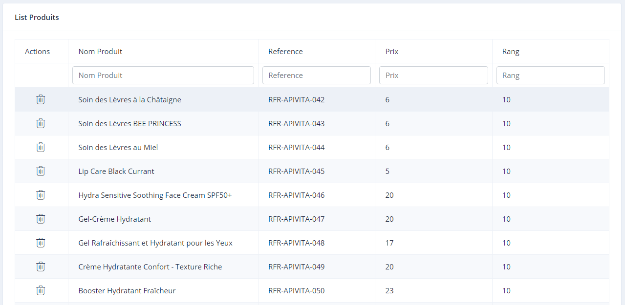

Figure 97: List Products Realisation

#### Use Case “Add/remove Ingredients”

##### Textual description

The below table explain the “success” scenario of editing product’s ingredients.

|  |  |
| --- | --- |
| Use Case | Add/remove Ingredients |
| Actor | Admin |
| Pre-condition | Product Exist. |
| Post-condition | Product’s ingredients updated. |
| Nominal Scenario | * The admin clicks on “Products” dropdown on the sidebar. * The system shows dropdown list. * The admin clicks on “Edit product's ingredients” dropdown on the sidebar. * The system shows the desired interface. * The admin selects a product. * The system fills product’s ingredients list and all others ingredients’ list. * The admin selects ingredients to add or remove. |

Table 34: Textual description of the use case “Add/remove ingredients”

##### Screen Capture

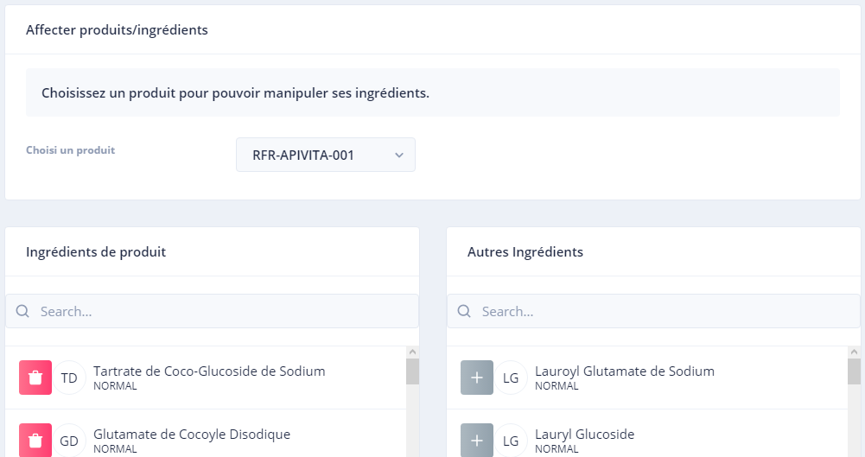

Figure 98: Add/Remove Ingredients Realisation

##### Sequence Diagram

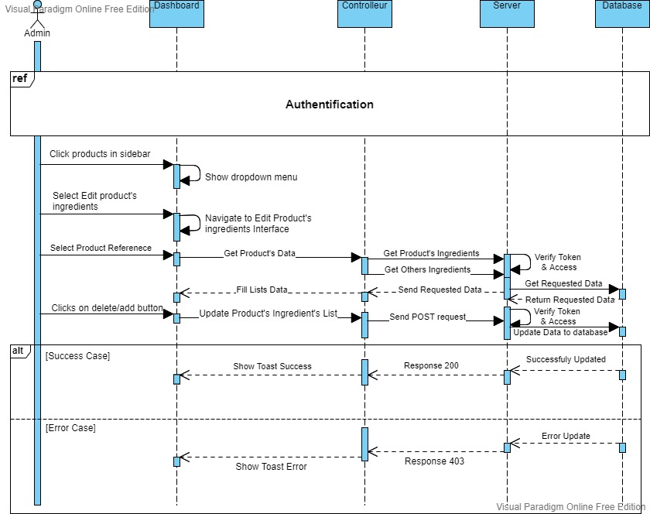

Figure 99: Add/remove Ingredients' Sequence Diagram

#### Use Case “View Products Details”

##### Textual description

The below table explain the “success” scenario of viewing product’s details.

|  |  |
| --- | --- |
| Use Case | View Products Details |
| Actor | User |
| Pre-condition | Product Exist. |
| Nominal Scenario | * The user clicks on a specific product. * The system shows product’s detail screen. |

Table 35: Textual description of the use case “View Products Details”

##### Screen Capture

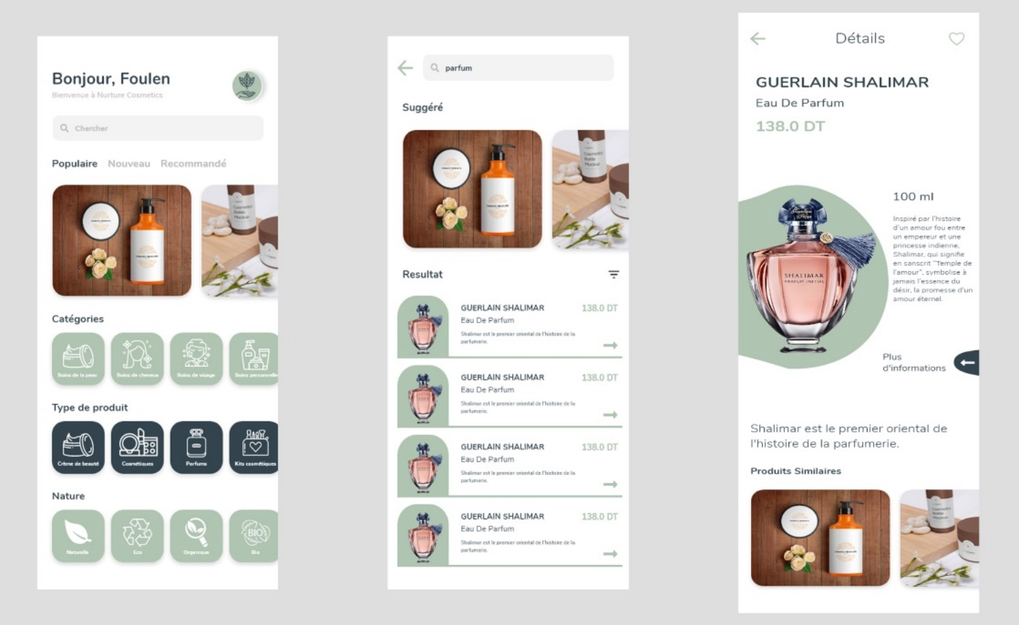

Figure 100: View Product Details Story Adobe XD

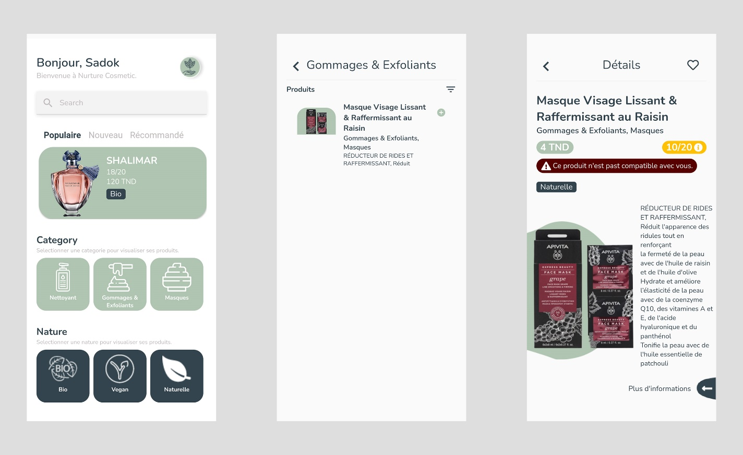

Figure 101: View Product Details Story Realisation

#### Use Case “Search Products”

##### Textual description

The below table explain the “success” scenario of searching products.

|  |  |
| --- | --- |
| Use Case | Search Products |
| Actor | User |
| Pre-condition | Product Exist. |
| Nominal Scenario | * The user clicks on a search bar in home screen. * The system shows search delegate. * The user inserts the key for search. * The system search and return the result. |

Table 36: Textual description of the use case “Search Products”

##### Sequence Diagram

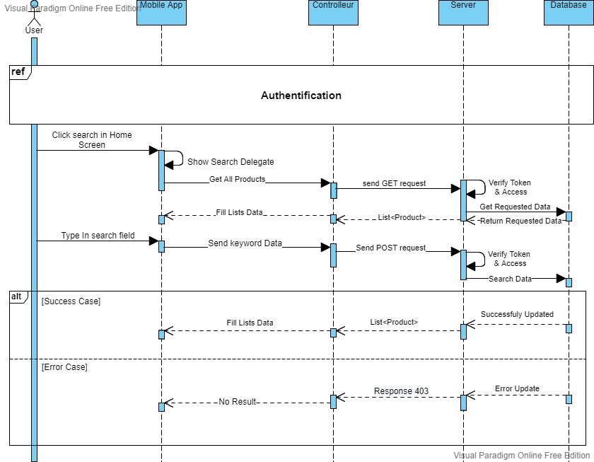

Figure 102: Search Products Sequence Diagram

##### Screen Capture

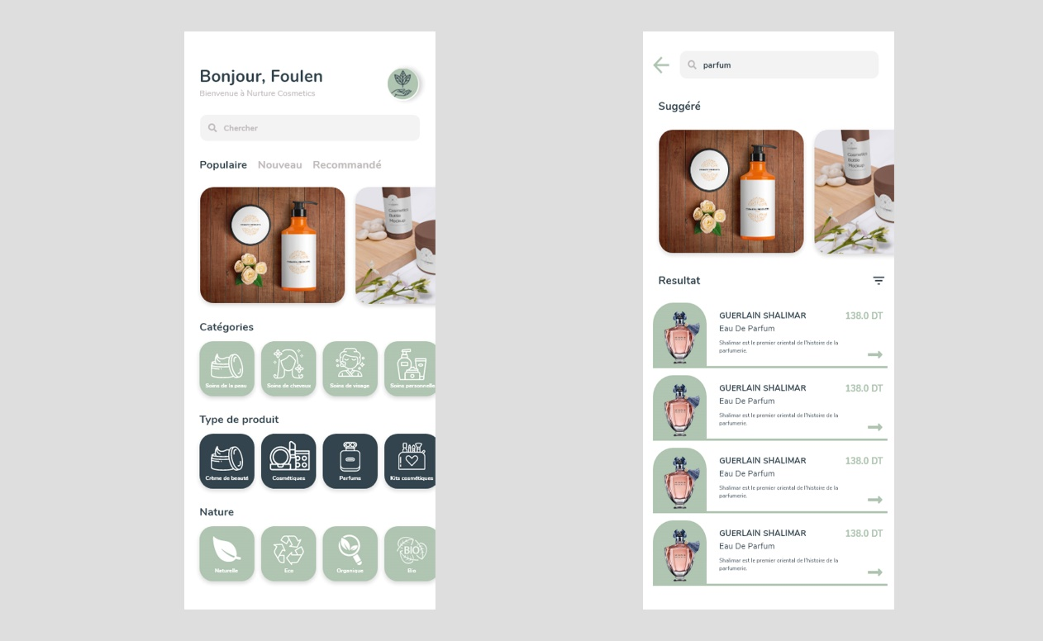

Figure 103: Search Products Story Design XD

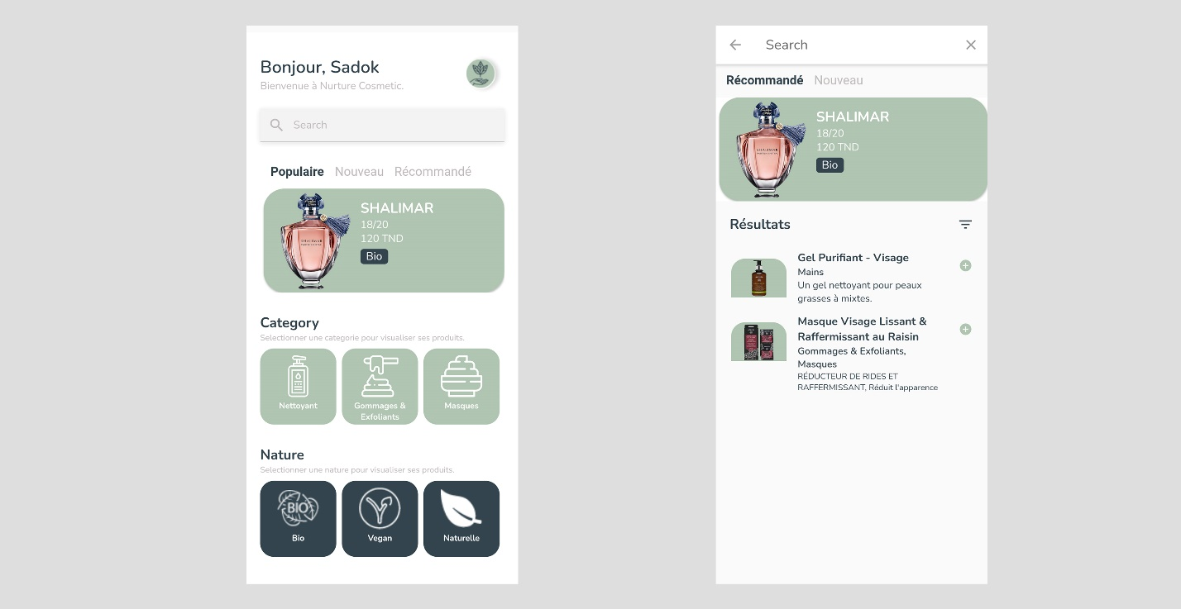

Figure 104: Search Products Realisation

#### Use Case “Filter Products”

##### Textual description

The below table explain the “success” scenario of filtering products.

|  |  |
| --- | --- |
| Use Case | Filter Products |
| Actor | User |
| Post-condition | Products Filtered. |
| Nominal Scenario | * The user clicks on a search bar in home screen. * The system shows search delegate. * The user clicks on filter icons and selects desired Options. * The system search and return the result. |

Table 37: Textual description of the use case “Filter Products”

##### Screen Capture

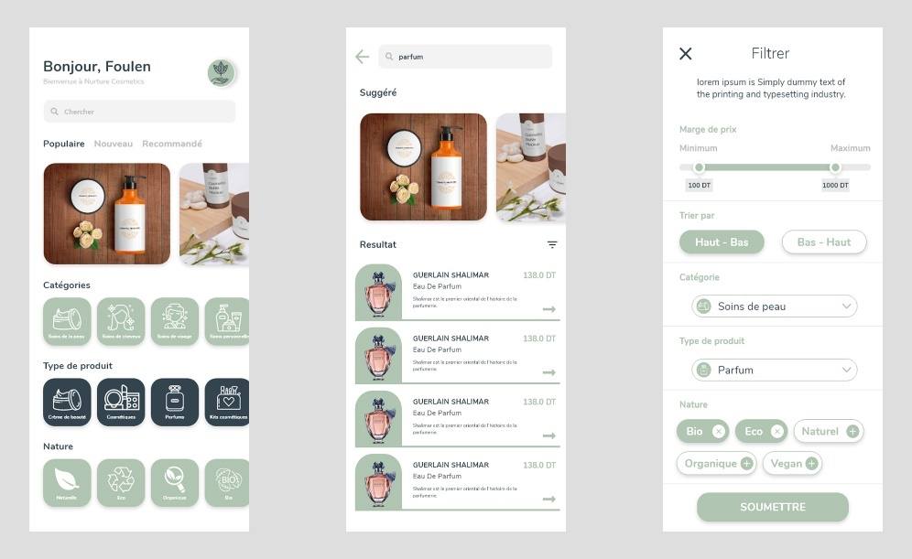

Figure 105: Filter Story Design Adobe XD

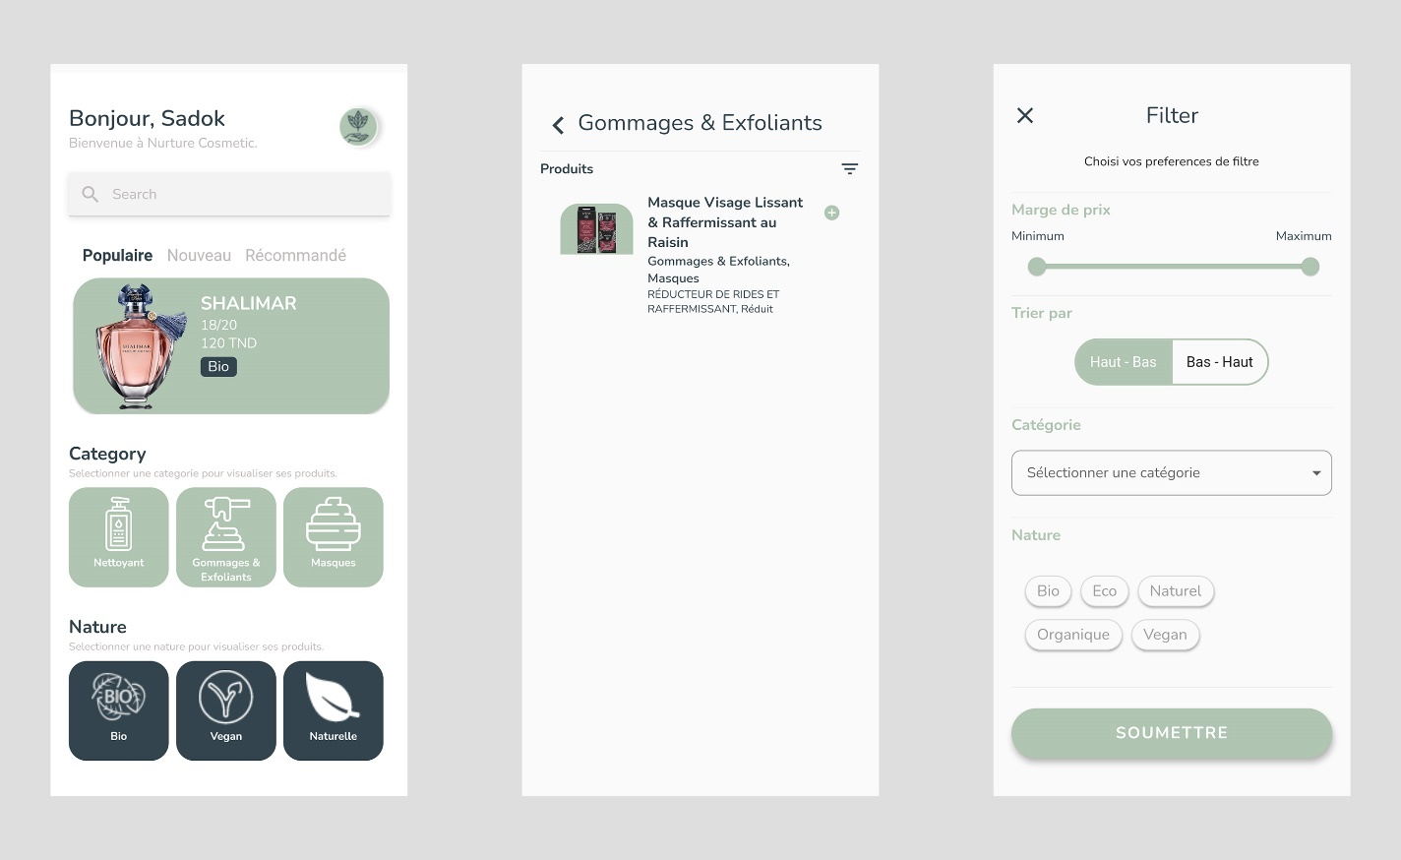

Figure 106: Filter Realisation

## Conclusion

After this sprint, admin is now able to view, edit and delete products as well as associate ingredients to products. Users are now able to access, filter and search for products inserted in the back office (Angular Dashboard).

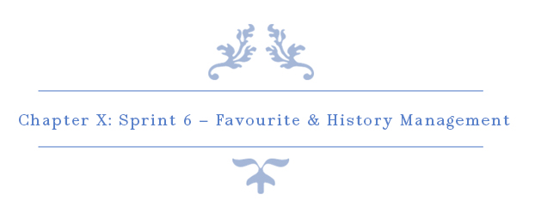

# Chapter X : Sprint 6 – Favourite & History Management

## Introduction

This sprint’s goal is to implements several features about User’s products consulted history as well as User’s favourite products.

## Sprint Backlog

### Sprint Scope

In this sprint, our sprint backlog’s scope is to implements history and favourite main functions such as Add, edit and view. By the end of this sprint, User should be able to add products to their favourite list and view their search history. This sprint backlog has 6 stories for 26 days. There is a detailed descriptive table below to explain the process.

### Tasks Planning

|  |  |  |  |  |  |  |  |  |  |  |  |  |  |  |  |  |
| --- | --- | --- | --- | --- | --- | --- | --- | --- | --- | --- | --- | --- | --- | --- | --- | --- |
|  |  |  | | Day number | | | | | | | | | | | | |
| User stories# | Tasks | 1 | 2 | | 3 | 4 | 5 | 6 | 7 | 8 | 9 | 10 | 11 | 12 | 13 |
| 38 —40 | Database design and implementation | 6 | 0 | | 0 | 2 | 0 | 0 | 2 | 0 | 0 | 0 | 1 | 0 | 0 |
| API implementation | 0 | 6 | | 2 | 2 | 0 | 2 | 4 | 2 | 2 | 0 | 0 | 0 | 0 |
| Persistence development | 0 | 0 | | 4 | 2 | 5 | 1 | 2 | 0 | 0 | 0 | 1 | 0 | 1 |
| Front end development | 0 | 0 | | 0 | 2 | 2 | 3 | 0 | 4 | 2 | 4 | 3 | 4 | 2 |
| Test | 2 | 2 | | 2 | 0 | 1 | 2 | 0 | 2 | 2 | 0 | 0 | 0 | 1 |
| Documentation | 0 | 0 | | 0 | 0 | 0 | 0 | 0 | 0 | 2 | 4 | 3 | 4 | 3 |

|  |  |  |  |  |  |  |  |  |  |  |  |  |  |  |  |
| --- | --- | --- | --- | --- | --- | --- | --- | --- | --- | --- | --- | --- | --- | --- | --- |
|  |  | Day number | | | | | | | | | | | | | |
| User stories# | Tasks | 14 | 15 | 16 | 17 | 18 | 19 | 20 | 21 | 22 | 23 | 24 | 25 | 26 |
| 33—35 | Database design and implementation | 0 | 0 | 0 | 0 | 0 | 0 | 0 | 1 | 0 | 2 | 0 | 0 | 0 |
| API implementation | 2 | 0 | 0 | 3 | 7 | 0 | 0 | 6 | 2 | 4 | 2 | 2 | 0 |
| Persistence development | 0 | 0 | 0 | 0 | 0 | 1 | 0 | 1 | 0 | 2 | 0 | 0 | 0 |
| Front end development | 2 | 4 | 4 | 4 | 1 | 5 | 4 | 0 | 2 | 0 | 4 | 2 | 4 |
| Test | 2 | 0 | 0 | 1 | 0 | 0 | 0 | 0 | 2 | 0 | 2 | 2 | 0 |
| Documentation | 2 | 4 | 4 | 0 | 0 | 2 | 4 | 0 | 2 | 0 | 0 | 2 | 4 |

Table 38: Tasks Planning - Sprint 6

## Analysis

### Favourite Management Use Case Refinement

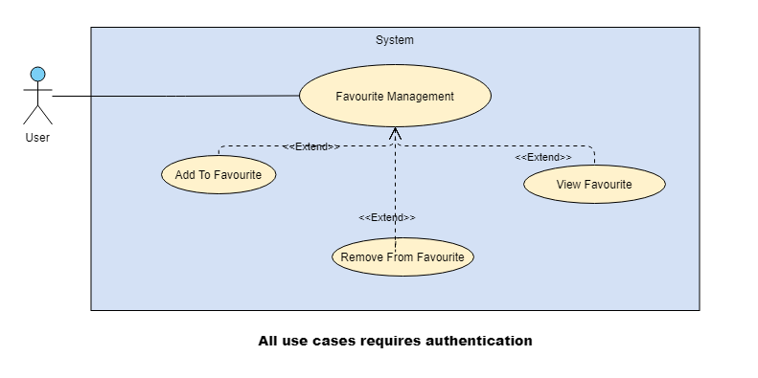

Figure 107: Favourite Management Use Case Refinement Diagram

#### Use case “View Favourite”

##### Textual description

The below table explain the “success” scenario of viewing favourite list.

|  |  |
| --- | --- |
| Use Case | View Favourite |
| Actor | User |
| Pre-condition | User favourites already set. |
| Nominal Scenario | * The user clicks on “Drawer Icon” button. * The system shows the drawer. * The user clicks on “Favoris” button. * The system shows the Users Favourite Interface. |

Table 39: Textual Description Use Case "View Favourite"

##### Screen Capture

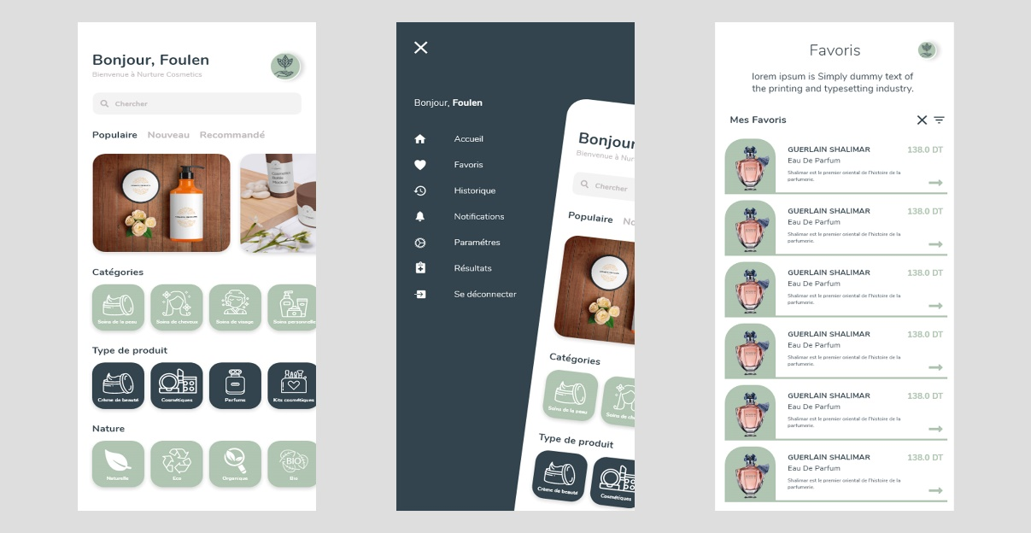

Figure 108: View Favourite Story Design XD

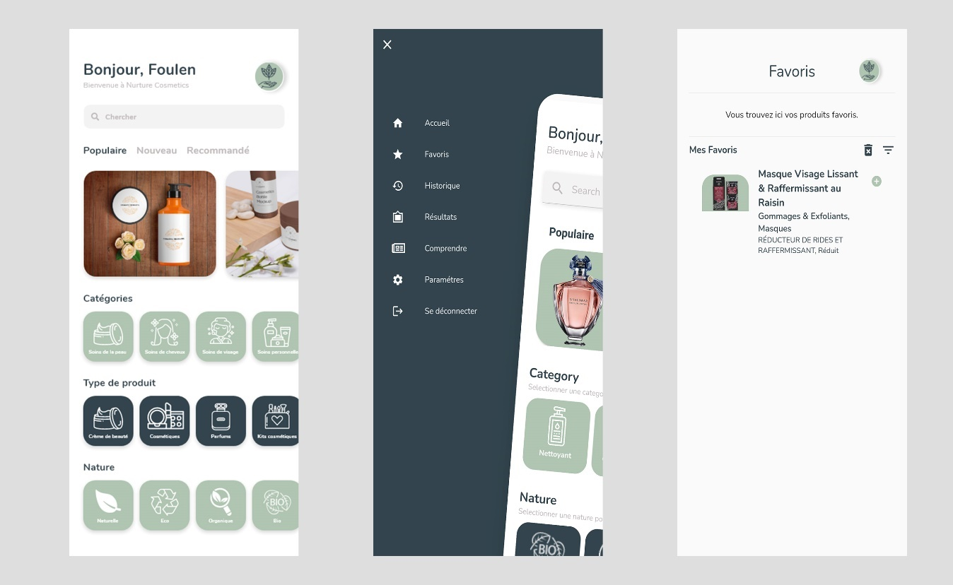

Figure 109: View Favourite Story Realisation

#### Use case “Add to Favourite”

##### Textual description

The below table explain the “success” scenario of adding to favourite list.

|  |  |
| --- | --- |
| Use Case | Add to Favourite |
| Actor | User |
| Post-condition | Product added to favourite list. |
| Nominal Scenario | * The user clicks on a specific product. * The system shows product’s detail screen. * The user clicks on the heart icon on top right corner. * The system adds the product to user’s favourites list. |

Table 40: Textual Description Use Case "Add to Favourite"

### History Management Use Case Refinement

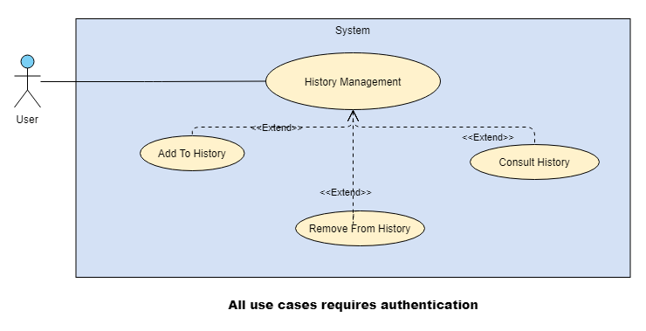

Figure 110: History Management Use Case Refinement Diagram

#### Use case “Add to History”

##### Textual description

The below table explain the “success” scenario of adding to History list.

|  |  |
| --- | --- |
| Use Case | Add to History |
| Actor | User |
| Post-condition | Product added to History list. |
| Nominal Scenario | * The user clicks on a specific product. * The system shows product’s detail screen. * The system adds the product to user’s History list. |

Table 41: Textual Description Use Case "Add to History "

#### Use case “View History”

##### Textual description

The below table explain the “success” scenario of viewing history list.

|  |  |
| --- | --- |
| Use Case | View Favourite |
| Actor | User |
| Pre-condition | User favourites already set. |
| Nominal Scenario | * The user clicks on “Drawer Icon” button. * The system shows the drawer. * The user clicks on “Historique” button. * The system shows the Users History Interface. |

Table 42: Textual Description Use Case "View History"

##### Screen Capture

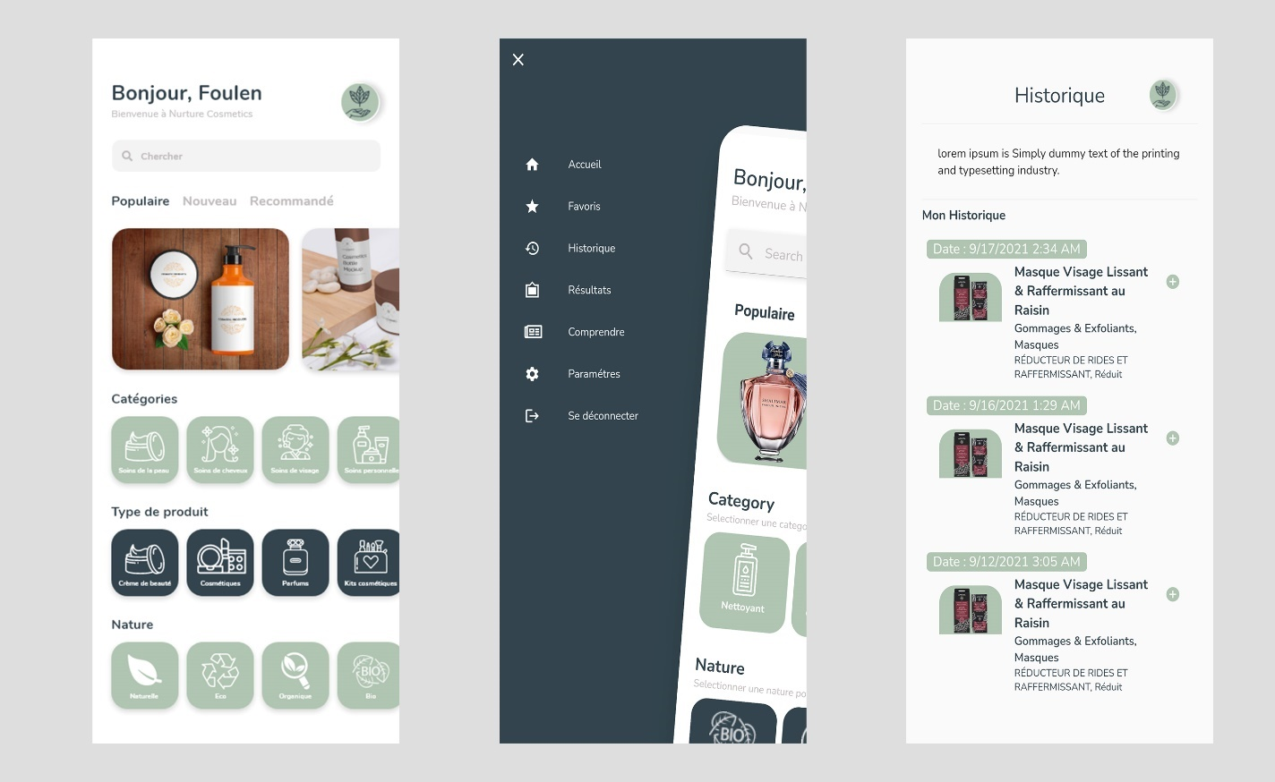

Figure 111: View History Story Implementation

## Conclusion

In this sprint, I managed to implement Favourite and Search History features.

In the final sprint, I’m going to implement Claims management features as well as products suggestions.

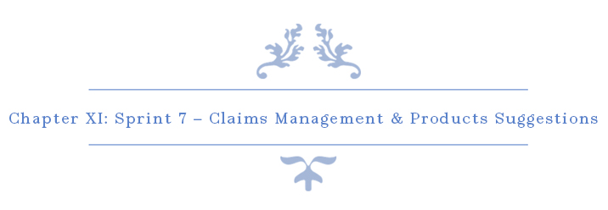

# Chapter XI : Sprint 7 – Claims Management & Products Suggestions

## Introduction

The final sprint is about implementing claims management to allow users to suggest new features or report bugs and also to implement a system that suggest similar products to users based on their preferences.

## Sprint Backlog

### Sprint Scope

In this sprint, our sprint backlog’s scope is to implements claims main functions such as Add, edit and view. By the end of this sprint, User should be able to view similar and suggested products based on their skin type, favourite list and search history. This sprint backlog has 3 stories for 27 days. There is a detailed descriptive table below to explain the process.

### Task Planning

|  |  |  |  |  |  |  |  |  |  |  |  |  |  |  |  |
| --- | --- | --- | --- | --- | --- | --- | --- | --- | --- | --- | --- | --- | --- | --- | --- |
|  |  | Day number | | | | | | | | | | | | | |
| User stories# | Tasks | 1 | 2 | 3 | 4 | 5 | 6 | 7 | 8 | 9 | 10 | 11 | 12 | 13 |
| 7  &  8 | Database design and implementation | 6 | 0 | 0 | 2 | 0 | 0 | 2 | 0 | 0 | 0 | 1 | 0 | 0 |
| API implementation | 0 | 6 | 2 | 2 | 0 | 2 | 4 | 2 | 2 | 0 | 0 | 0 | 0 |
| Persistence development | 0 | 0 | 4 | 2 | 5 | 1 | 2 | 0 | 0 | 0 | 1 | 0 | 1 |
| Front end development | 0 | 0 | 0 | 2 | 2 | 3 | 0 | 4 | 2 | 4 | 3 | 4 | 2 |
| Test | 2 | 2 | 2 | 0 | 1 | 2 | 0 | 2 | 2 | 0 | 0 | 0 | 1 |
| Documentation | 0 | 0 | 0 | 0 | 0 | 0 | 0 | 0 | 2 | 4 | 3 | 4 | 3 |

|  |  |  |  |  |  |  |  |  |  |  |  |  |  |  |  |
| --- | --- | --- | --- | --- | --- | --- | --- | --- | --- | --- | --- | --- | --- | --- | --- |
|  |  | Day number | | | | | | | | | | | | | |
| User stories# | Tasks | 14 | 15 | 16 | 17 | 18 | 19 | 20 | 21 | 22 | 23 | 24 | 25 | 26 |
| 48 | Database design and implementation | 0 | 0 | 0 | 0 | 0 | 0 | 0 | 1 | 0 | 2 | 0 | 0 | 0 |
| API implementation | 2 | 0 | 0 | 3 | 7 | 0 | 0 | 6 | 2 | 4 | 2 | 2 | 0 |
| Persistence development | 0 | 0 | 0 | 0 | 0 | 1 | 0 | 1 | 0 | 2 | 0 | 0 | 0 |
| Front end development | 2 | 4 | 4 | 4 | 1 | 5 | 4 | 0 | 2 | 0 | 4 | 2 | 4 |
| Test | 2 | 0 | 0 | 1 | 0 | 0 | 0 | 0 | 2 | 0 | 2 | 2 | 0 |
| Documentation | 2 | 4 | 4 | 0 | 0 | 2 | 4 | 0 | 2 | 0 | 0 | 2 | 4 |

Table 43: Tasks Planning - Sprint 7

## Analysis

### Claims Management Use Case Refinement

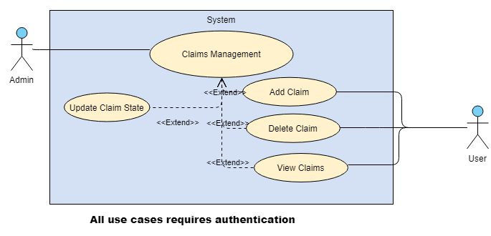

Figure 112: Claims Management Use Case Refinement Diagram

#### Use Case “Add Claim”

##### Textual description

The below table explain the “success” scenario of adding a new claim.

|  |  |
| --- | --- |
| Use Case | Add Claim |
| Actor | User |
| Pre-condition | The user must be authenticated. |
| Post-condition | New Claim Added. |
| Nominal Scenario | * The user clicks on “Drawer Icon” button. * The system shows the drawer. * The user clicks on “Parameters” button. * The system shows the Parameters Interface. * The user clicks on “Réclamations” button. * The system shows Interface. * The user clicks on “Ajouter Réclamation” button. * The system shows New Claim Interface. * The user fills the required data and confirm. * The system inserts the new Claim. |

Table 44: Textual Description of use case "Add Claim"

##### Screen Capture

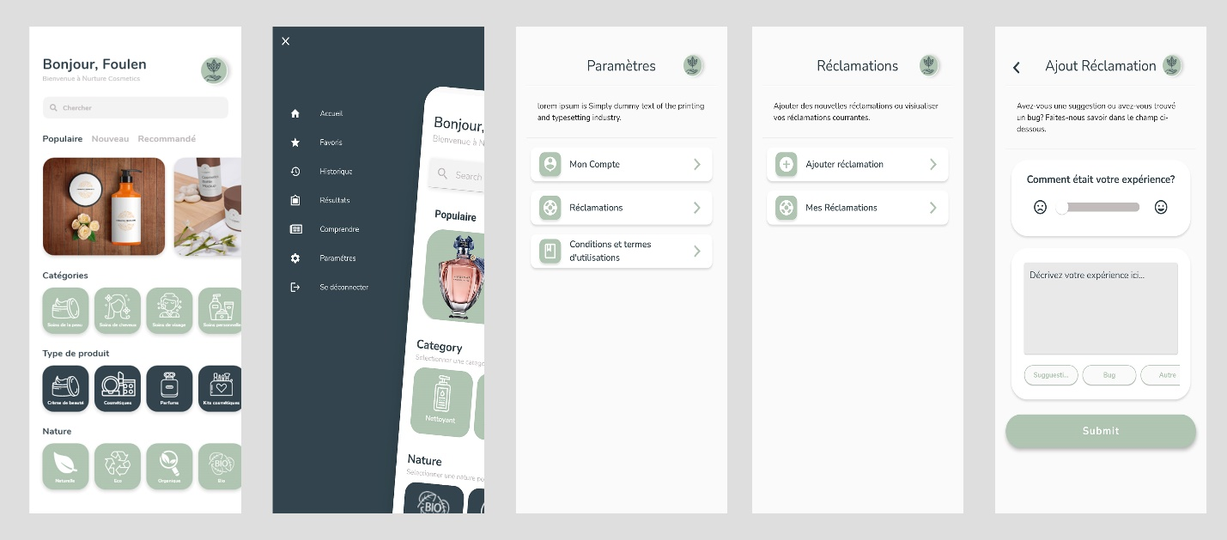

Figure 113 : Add Claim Story Realisation

#### Use Case “View My Claims (User)”

##### Textual description

The below table explain the “success” scenario of viewing user’s claims.

|  |  |
| --- | --- |
| Use Case | View My Claims |
| Actor | User |
| Pre-condition | The user must be authenticated. |
| Nominal Scenario | * The user clicks on “Drawer Icon” button. * The system shows the drawer. * The user clicks on “Parameters” button. * The system shows the Parameters Interface. * The user clicks on “Réclamations” button. * The system shows Interface. * The user clicks on “Mes Réclamation” button. * The system shows User’s Claims Interface. |

Table 45: Textual Description of use case "View My Claims"

##### Screen Capture

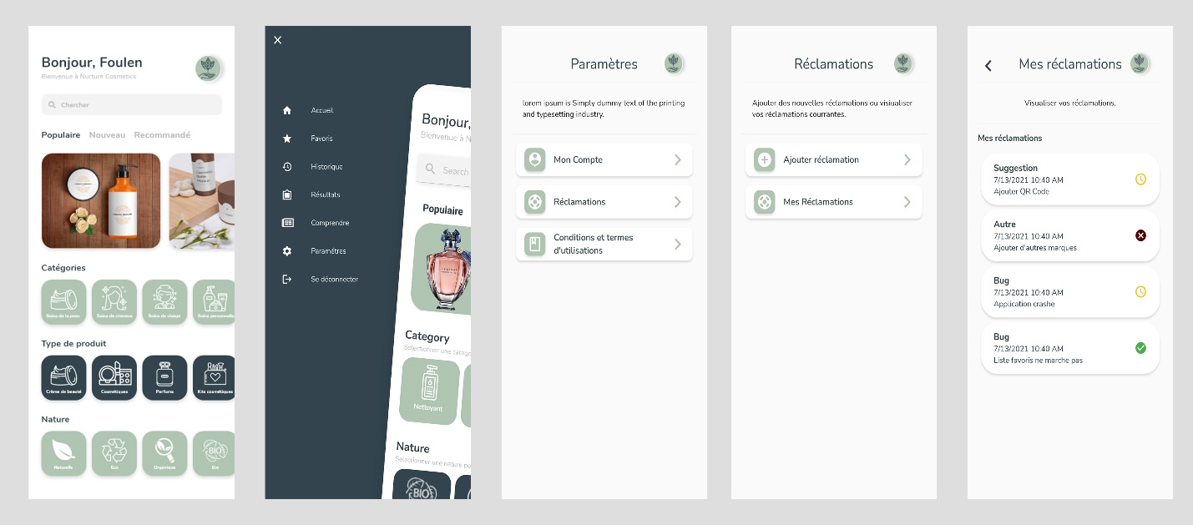

Figure 114: View My claims Story Realisation

#### Use Case “View All Claims (Admin)”

##### Textual description

The below table explain the “success” scenario of viewing all users’ claims.

|  |  |
| --- | --- |
| Use Case | View All Claims |
| Actor | Admin |
| Pre-condition | The admin must be authenticated. |
| Nominal Scenario | * The user clicks on “claims” on the sidebar menu. * The system shows the desired interface. |

Table 46: Textual Description of use case "View All Claims"

##### Screen Capture

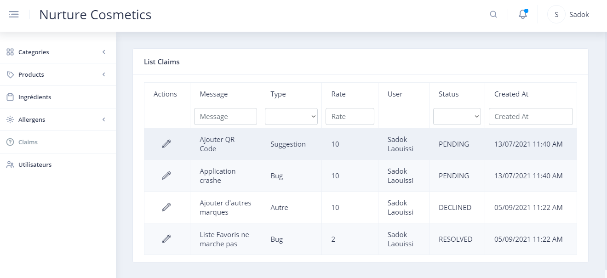

Figure 115: View All Claims Story Realisation

#### Use Case “Update Claim’s State”

##### Textual description

The below table explain the “success” scenario of updating users’ claims state.

|  |  |
| --- | --- |
| Use Case | Update Claim’s State |
| Actor | Admin |
| Pre-condition | The admin must be authenticated. |
| Nominal Scenario | * The admin clicks on “claims” on the sidebar menu. * The system shows the desired interface. * The admin clicks on pencil icon of the desired claim to change state. * The system shows edit dropdown field. * The admin selects the desired state to change. * The system updates the claim’s state and shows a toast. |

Table 47: Textual Description of use case "Update Claim's State"

##### Screen Capture

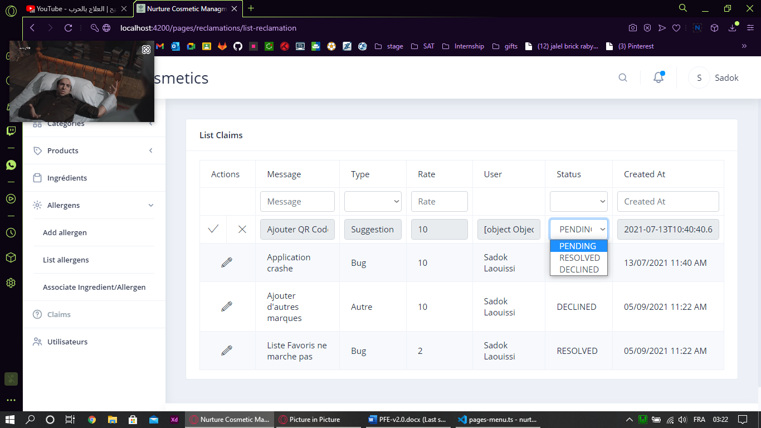

Figure 116: Update Claim's State Realisation

### View Suggestions Use Case Scenario

##### Textual Description

To be able to view suggestions, the app user must be already authenticated and for better results he must have taken the online diagnosis and already has a skin type.

Users can access the suggestion feature in two scenarios:

* Through Home Screen: After successfully logged in, below the search bar, users can access popular, new and recommended products based on their general preferences.
* Through Product Details Screen: After selecting to view a product’s details and in the bottom of the screen there’s a field that shows similar products (Most popular, newest and recommended).

##### Sequence Diagram

The following figure describes the sequence diagram of the first suggestion scenario:

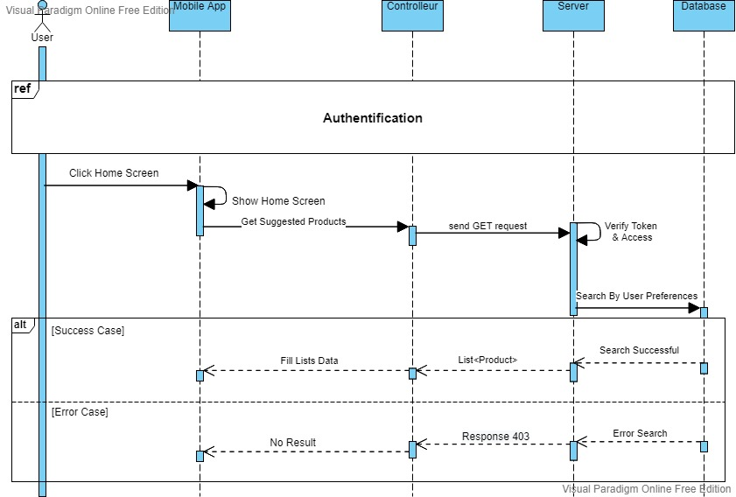

Figure 117: View Suggestion Home Screen Scenario Sequence Diagram

The figure below describes the sequence diagram of the second scenario:

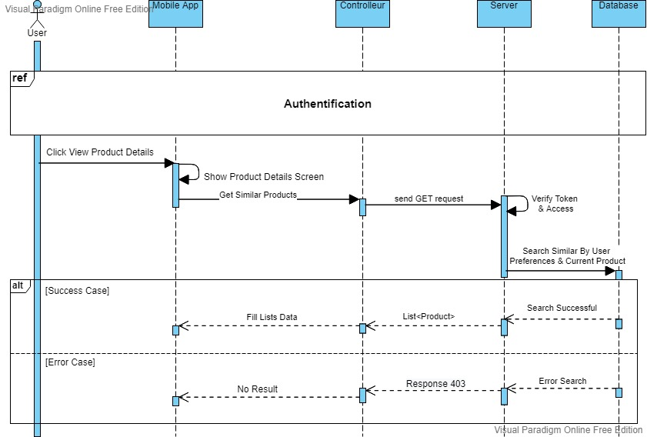

Figure 118: View Suggestion Product Details Screen Scenario Sequence Diagram

## Conclusion

After this sprint, users are now able to view suggested products based on their skin type, personal allergen and search history as well as visualizing similar products of a selected product. Also, users are now able to add, track and delete claims to update the mobile app for better user experience.

# Conclusion & Perspectives

The ignorance of ingredients types and allergens, the lack of transparency over product’s ingredients, and especially the time waste during the search for the perfect product could all be resolved using an informative mobile app about products and their ingredients. That’s the idea behind this project.

To realize this solution, I used the NodeJS framework to build the server of both apps, and I implemented MySQL database using TypeORM and ExpressJS. I created the admin dashboard using AngularJS to manage all resources and finally I created the mobile app using Flutter which will showcase the resources managed in the Back Office. Both of these apps will communicate with the server through its APIs. These are overall the technologies that I used to build the solution of this project.

For better results and improvements, implementing scanning products service would be a good feature. Users could scan a product’s ingredients and it shows the inconvenient ingredients based on their preferences.

# Reflection

When I started this project, I knew nothing about Green Products or even the cosmetic field, it was quite challenging to learn about the process and to find the right framework to work with. But here I am now, documenting my work and planning for new features to improve it.

At the beginning, it was tough to understand the concept of cosmetic products, ingredients, allergies and allergens and how to implement it in our work. I spent a lot of time doing researches and interviewing potential users to improve their user experience for their search of cosmetic products. Information wasn’t easy at all. The concept of bio and natural products is new in Tunisia, developing it using different technologies wasn’t an easy choice.

For sure, I didn’t regret my choice, I feel very mature and more confident after achieving this project, I know I did something very challenging. I believe after this experience; I am going to dig more and more in the healthcare and cosmetic field and why not build something very big and innovative for Tunisia.

I can now look back and realize that this experience has helped me both as a student and as a young software engineer.

# Table of Acronyms and Abbreviations

|  |  |
| --- | --- |
| API | Application Programming Interface |
| JEE | **Java** Platform, **Enterprise Edition** |
| JSON | **JavaScript Object Notation** |
| IaaS | **Infrastructure as a service** |
| SaaS | **Software as a service** |
| PaaS | **Platform as a service** |
| URI | **Uniform Resource Identifier** |
| VM | **Virtual Machine** |
| DB | **Database** |
| XML | **Extensible Markup Language** |
| UI | **User Interface** |
| REST | **Representational State Transfer** |

# References

ALTVATER, A., 2017. *SOAP VS REST.* [Online]   
Available at: https://stackify.com/soap-vs-rest/

Angular, n.d. *Introduction to Angular concepts.* [Online]   
Available at: https://angular.io/guide/architecture

Anon., 2005. *Software and Services in Large Enterprises.* [Online]   
Available at: www.forrester.com/Research/Document/Excerpt/0,7211,38659,00.html

DBpedia, n.d. *Android Studio.* [Online]   
Available at: https://dbpedia.org/page/Android_Studio

F, M., 2008. le Courrier du Livre. In: *Le livre vert de la Cosmétique Bio.* MORILLON F, Le livre vert de la Cosmétique Bio, le Courrier du Livre, Paris, 2008: Chapter 2, 23-56 ed. Paris: s.n., pp. Chapter 2, 23-56.

Gentile, V., 2020. *Dart (programming language).* [Online]   
Available at: https://www.codemotion.com/magazine/Glossary/dart-programming-language/

Github, n.d. *Getting started with GitHub Desktop.* [Online]   
Available at: https://docs.github.com/en/desktop/installing-and-configuring-github-desktop/overview/getting-started-with-github-desktop

JSON, n.d. *Introducing JSON.* [Online]   
Available at: https://www.json.org/json-en.html

Manu, 2019. *Madmoizelle.* [Online]   
Available at: https://www.madmoizelle.com/cosmetiques-naturels-definition-1010199  
[Accessed 12 September 2021].

Masson, A.-M. P.-L. e. C., 2020. Packaging des produits cosmétiques. In: C. V. Editions, ed. *Packaging des produits cosmétiques.* s.l.:Chartres ISBN : 978-2-490639-13-7.

Microsoft, n.d. *Getting Started.* [Online]   
Available at: https://code.visualstudio.com/docs

Perfecto, 2021. *What Is the Flutter Framework?.* [Online]   
Available at: https://www.perfecto.io/blog/what-is-flutter-framework

Postman, n.d. *The Postman API Platform.* [Online]   
Available at: https://www.postman.com/api-platform/

R, S., 2006. La vérité sur les cosmétiques naturels. In: *La vérité sur les cosmétiques naturels.* Paris: s.n., pp. Chapter 1, «Organic cosmetics: where is the difference?» , 15-54.

Site Ground, n.d. *What is SQL and MySQL.* [Online]   
Available at: https://www.siteground.com/tutorials/php-mysql/mysql/

TeamGantt, n.d. [Online]   
Available at: https://www.teamgantt.com

Techno-science, n.d. *Techno-science.* [Online]   
Available at: http://www.techno-science.net/?onglet=glossaire&definition=1046  
[Accessed 7 September 2021].

Tutorials Point, n.d. *TypeScript - Overview.* [Online]   
Available at: https://www.tutorialspoint.com/typescript/typescript_overview.htm

tutorialspoint, n.d. *UML - Activity Diagrams.* [Online]   
Available at: https://www.tutorialspoint.com/uml/uml_activity_diagram.htm  
[Accessed 18 Mars 2021].

Visual Paradigm Online, n.d. *About Us.* [Online]   
Available at: https://online.visual-paradigm.com/fr/about-us/

Wikipedia, n.d. *Adobe XD.* [Online]   
Available at: https://en.wikipedia.org/wiki/Adobe_XD

Wikipedia, n.d. *Node.js.* [Online]   
Available at: https://en.wikipedia.org/wiki/Node.js

Wikipedia, n.d. *Wamp Server.* [Online]   
Available at: https://en.wikipedia.org/wiki/WampServer

Wikipe, n.d. *Adobe Photoshop.* [Online]   
Available at: https://www.wikipe.wiki/wiki/fr/Photoshop

# **Appendix A : Gantt Diagram**

The following figures represents the gantt diagram of the project.

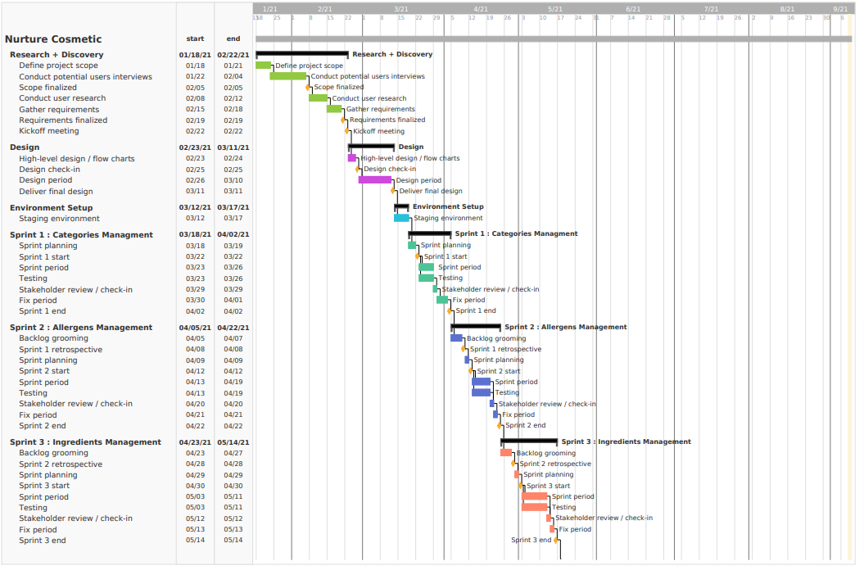

Figure 119: Gantt Diagram Part 1

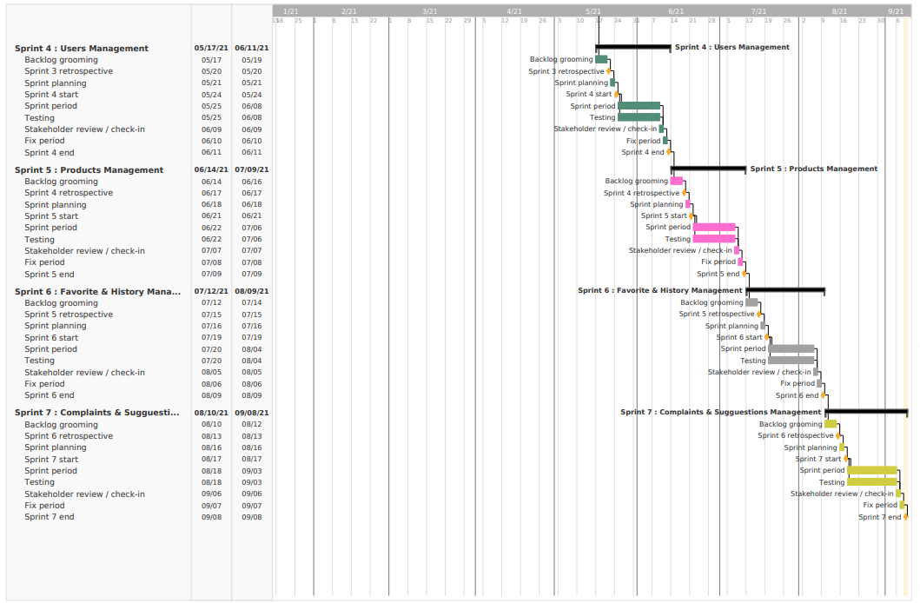

Figure 120: Gantt Diagram Part 2

1. https://chroniques.tn/2014/11/le-secteur-des-industries-cosmetiques-en-tunisie/
2. https://makeup-in.com/05-tendances-fr/le-maquillage-continue-de-tirer-le-marche-des-cosmetiques-dans-le-monde/
3. https://www.alioze.com/chiffres-beaute#:~:text=Selon%20les%20chiffres%20du%20cabinet,5%2C25%20%25%20en%20201
4. https://www.businessfrance.fr/les-cosmetiques-en-tunisie
5. https://chroniques.tn/2014/11/le-secteur-des-industries-cosmetiques-en-tunisie/